NCHL Health Leadership Competency Model™
As shown in the illustration on the next page, the NCHL Health Leadership Competency Model defines the competencies required for outstanding health leadership.
They are:
- Execution.
- Accountability.
- Change Leadership.
- Collaboration.
- Communication Skills.
- Impact and Influence.
- Information Technology Management.
- Initiative.
- Organizational Awareness.
- Performance Measurement.
- Process Management/Organization Design.
- Project Management.
- Transformation.
- Achievement Orientation.
- Analytical Thinking.
- Community Orientation.
- Financial Skills.
- Information Seeking.
- Innovative Thinking.
- Strategic Orientation.
- People.
- Human Resources Management.
- Interpersonal Understanding.
- Professionalism.
- Relationship Building.
- Self-Confidence.
- Self-Development.
- Talent Development.
- Team Leadership.
NCHL Health Leadership Competency Model
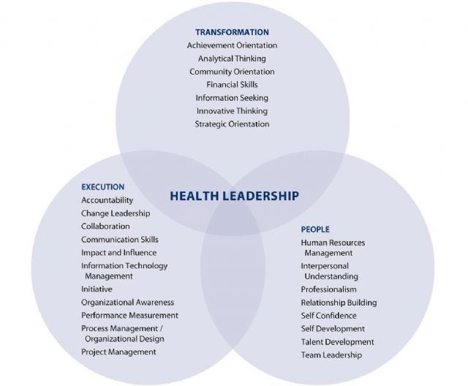
Note: Execution, Transformation, and People are domains or categories for grouping the 26 NCHL competencies.

