**Assignment Two**

**Labour Economics (Economics 3341)**

**Winter 2018**

**Issued: March 21st, 2018**

**Due: March 28th, 2018 on BrightSpace**

**Answer each of the following questions in full sentences. Use a graph if it helps with your explanation.**

1. Explain the issue of “omitted skill variables” in relation to wage discrimination. Explain why you think this is or is not an important.
2. Given the following table, draw and explain the step demand curve for female labour.

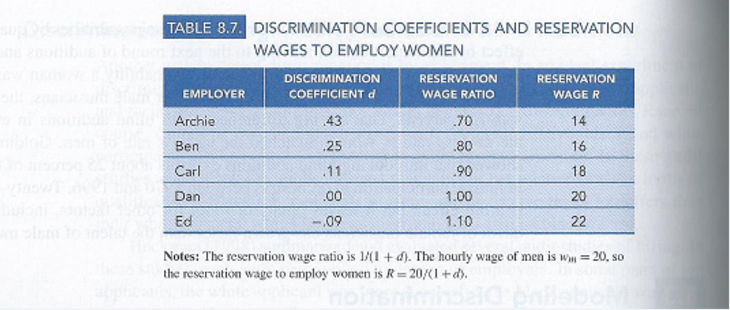

1. Explain Marshall’s Rules of Unions.
2. Explain the Threat Effect of Unions.
3. Explain the Lorenz Curve and the Gini Coefficient. Use a graph and explain why they are important.

**Good Luck**