**Worksheet** [**II – Ignition part 2**](https://sites.google.com/site/srcombexp/home/fse-120-virtual-lab/virtual-laboratory-six-station/ignition-part-2)

**Fire Science Virtual Laboratory**

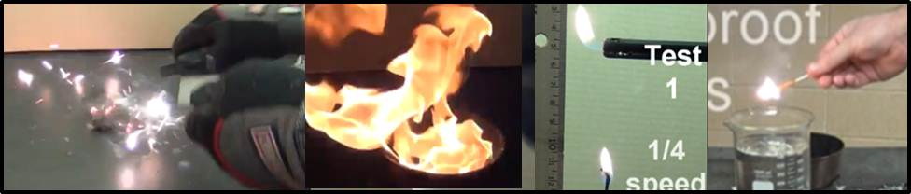

Directions:

The virtual laboratory is located on the [www.firesciencetools.com](http://www.firesciencetools.com) website. [Here is a direct link to the virtual laboratory.](https://sites.google.com/site/srcombexp/home/fse-120-virtual-lab/virtual-laboratory-six-station)

Each of the six sections should take around 20 minutes to complete.

If any of the videos do not play for some reason, make a note on the sheet and move on to the next one.

1. **Ignition of hydrocarbon fuels**

Watch videos of the ignition of [Gasoline](https://www.youtube.com/watch?v=fF0gOFkq1w0), [isopropyl alcohol](https://www.youtube.com/watch?v=_4b2K8a6gL4), and [kerosene](https://www.youtube.com/watch?v=l2EY5jXepbg).

Which fuel is easiest to ignite? Gasoline

Using your internet resources, which fuels are combustible liquids and which are flammable liquids?

The covered liquids include ethanol, gasoline, naphtha, kerosene, fuel oil, or any other flammable or combustible liquid that is stored, sold or kept in any location, in an amount exceeding 30 gallons. A “combustible liquid” is defined as a liquid having a flash point at or above 100ºF and below 200ºF.

What do these tests tell you about the hazards of combustible vs. flammable liquids at room temperature?

They behave differently

What method is required to ignite kerosene? Premixed tourch

What does this tell you about the hazard of storing Gasoline vs kerosene in an industrial setting?

They can not be treated the same, as each one has its own characterstics

1. **Spark ignition of solids**

Watch the videos of igniting [steel wool](https://www.youtube.com/watch?v=5txlfPboKTU), [lint](https://www.youtube.com/watch?v=nBBxnP2NHOA), and a [candle](https://www.youtube.com/watch?v=lncjeBq98LU) using a flint and steel.

Which fuels ignite? ______lint_________________________________________________

Why does the candle not ignite from a spark? ______sparks do no not touch the candle______________________________________________________________________________________________________________________________________________________________________________

1. **Spark ignition of candle smoke**

Watch the video of [candle smoke](https://www.youtube.com/watch?v=O3jcXACoRlw) being ignited by a spark and the [trick birthday candle](https://www.youtube.com/watch?v=-VUT_FVr1sc).

Why does the smoke ignite while the candle without smoke did not? ____________cant understand the question________________________________________________________________________________________________________________________________________________________________________

Watching the trick candle video in the slow motion reply it can be seen that the smouldering front itself is not enough to ignite the smoke. There are small metal flakes of magnesium in the wick. What does this tell you about the temperature of the burning magnesium compared with the smouldering wick? _____Magnesium is highly flamable_______________________________________________________________________________________________________________________________________________________________________________

1. [**Re-ignition of Candle smoke**](https://www.youtube.com/watch?v=DV8lbuSWHYU)**:**

Using the long candle provided ignite the wick and let the candle burn for 30 seconds. Blow the candle out and use the long stem lighter place a flame in the smoke that remains after the flame is out. Repeat the process 5 times, and estimate the maximum distance which the flame will reignite.

Trial 1:__2 inches______________________

Trial 2:___2.5 inches_____________________

Trial 3:__1.5 inches______________________

Trial 4:___3 inches_____________________

Trial 5:____3 inches____________________

Maximum Re-ignition Distance _______3 inches_______________________

Discuss why you think there is a maximum reigniting distance.

______smoke temperature varies ____________________________________________________________________________________

__________________________________________________________________________________________

1. **Ignition of various types of matches:**

Watch the videos of igniting [safety matches](https://www.youtube.com/watch?v=tfWzxagBtQ8), [strike anywhere matches](https://www.youtube.com/watch?v=Ugdu0K1Lzgc), [water proof matches](https://www.youtube.com/watch?v=nLQfWYQCyeo) and [storm proof matches](https://www.youtube.com/watch?v=2XrXgpHAD2I).

Do the safety matches ignite when struck on steel? ___no________

Do the Strike anywhere matches ignite when struck on steel? ___yes________

Can the strike anywhere matches be ignited after getting wet? ___no___________________

Do the water proof matches ignite after getting wet? _______yes_______________

Do the storm proof matches ignite after getting wet? _____yes_________________

Using your resources on the internet, what is the difference between the chemicals contained in the head of the safety match and the head of the strike anywhere match? A match requires a mix of chemicals in order to ignite, including phosphorus. On a strike-anywhere match, all the chemicals are contained in the head. On a safety match, the phosphorus is not on the match head, but rather on a special striking surface. It is only when you draw the match against that surface that you have the correct combination of ingredients. A strike-anywhere match can be lit against any surface with enough friction; a safety match needs a strike plate containing phosphorus.

______________________________________________________________________________________________________________________________________