**Worksheet** [**I – Ignition part 1**](https://sites.google.com/site/srcombexp/home/fse-120-virtual-lab/virtual-laboratory-six-station/ignition-part-1)

**Fire Science Virtual Laboratory**

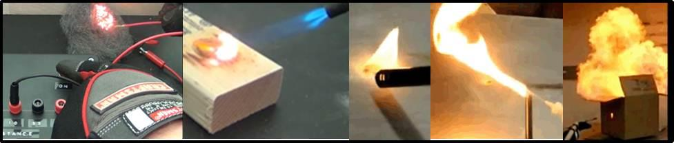

Directions:

The virtual laboratory is located on the [www.firesciencetools.com](http://www.firesciencetools.com) website. [Here is a direct link to the virtual laboratory.](https://sites.google.com/site/srcombexp/home/fse-120-virtual-lab/virtual-laboratory-six-station)

Each of the six sections should take around 20 minutes to complete.

If any of the videos do not play for some reason, make a note on the sheet and move on to the next one.

1. [**Electrical Ignition**](https://www.youtube.com/watch?v=-QWmtLq24pY)**:**

This experiment involves using an apparatus to determine the DC electrical current required to ignite steel wool. The power supply is 12V direct current. Using ohm law (V=IR) to determine the current necessary to heat the steel wool to ignition.

Does the steel wool ignite during the experiment? ______yes_______ (yes / no)

At what maximum resistance does the steel wool ignite? ______10_________ (ohms)

To determine the current needed to ignite the steel wool you will increase the resistance in the system until the wool no longer ignites. Using ohms law the current can be calculated by dividing the voltage by the resistance (I = V/R)

At what current does the steel wool ignite? _____________1.2___________ (Amps)

1. [**Fire Plunger**](https://www.youtube.com/watch?v=OxwUrV6bphs)**:**

The fire plunger uses adiabatic temperature increase to ignite cotton. For some compression systems the temperature increase can be estimated by the combined gas law (P1V1/T1 = P2V2/T2). Cotton is found to auto-ignite at 530K. The inside diameter of the tube is 0.01m, and the open volume is initially 8cm tall. The initial pressure is 298K, and 14.7 psi.

What is the initial volume inside the plunger? ______6.28_cm^3_________

Based on the video, what is the volume of the gas when the cotton ignites? _______0.78_cm^3________

(it will be something very small)

Can you estimate the pressure inside of the plunger based on the reduction in volume shown in the video and the ignition temperature of cotton?

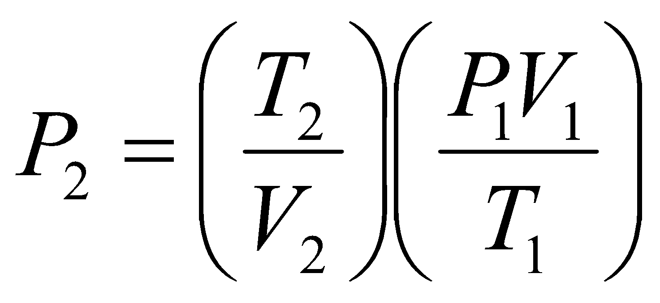

P = 31 psi

The limits of the combined gas law are hard to define. Some researchers have said that the ideal gas law, which is used to derive the combined gas law, should not be used with systems over 10 atmospheres. One atmosphere is 14.7psi, is the calculation you just did a reasonable calculation based on this limit? _________yes______________

1. [**Surface ignition**](https://www.youtube.com/watch?v=aDTiJNDklAI)**:**

This experiment uses a variable temperature soldering iron to estimate the autoignition temperature of materials. This is not a particularly good estimation due to the characteristics of the iron tip and the energy limitations of the soldering iron. The temperature is increased by 50F after each test.

What temperature does the nitrocellulose ignite? ________500________ (F)

What temperature does the match head ignite? _______650_________(F)

What does this tell you about the hazards associated with different materials and how they need to be stored?

Surface ignition should be taken in consideration as some materials can catch on fire when touching high temperature surfaces.

1. **Ignition of** [**magnesium ribbon**](https://www.youtube.com/watch?v=BnCyrq3Egrk) **vs** [**magnesium shavings**](https://www.youtube.com/watch?v=e9T9M2mWeSA)**:**

Magnesium ribbon ignited; sparks, diffusion flame, and a premixed torch are used as potential ignition sources. What method ignites the magnesium ribbon? _premixed propane flame______________

Magnesium shavings are ignited. What method is able to ignite the shavings? ___spark____________

What is the cause of the difference between the two configurations of the magnesium metal? _____The form or shape of magnesuim _______________________________________________________________________________________________________________________________________________________________________________

1. [**Ignition of dust (Lycopodium dust)**](https://www.youtube.com/watch?v=hBnWp37egYc)**:**

Does the pile of dust burn well? _____no__________________

Does the spray of dust burn well? ____yes____________________

What does this tell you about the hazards of dispersed dusts in industrial settings? __It could rapidly spreed the fire__________________________________________________________________________________________________________________________________________________________________________________

1. **dust vs gas** [**flash fire**](https://www.youtube.com/watch?v=nWReclW3qXY) **and** [**explosion**](https://www.youtube.com/watch?v=mFR00qEKt0c)**:**

Watch the gas vs dust flash fire and confined explosion videos

Does the dust flash fire look similar to the gas flash fire? ___yes________

Does the confined dust explosion produce an overpressure in the box? _yes______

It should be noted that the air fuel ratio and the total amount of fuel was not matched inside of the box so the severity of the fire ball cannot be compared directly.

1. [**Van de Graff generator ignition**](https://www.youtube.com/watch?v=yd3cWzUW3dk)**:**

The minimum ignition energy for most hydrocarbon mixtures is 0.25 mJ, the static spark produced by the human body is can be 10- 15J [ref]. If we assume energy of an electrical flow can be calculated by multiplying the power times the duration, i.e. combining Ohms law and equations for electrical power: If we assume that for the Van de Graff generator, the voltage is 200,000, the duration of the spark is 300 nanoseconds (0.3x10-6sec), and the resistance of air is 1.3x1016 ohms/m, the energy in the spark created by the Van de Graff generator can be estimated.

What is the distance between the two steel spheres? _________0.025_____________(m)

What is the total resistance of the air between the spheres? _______10______________(ohms)

What is the energy of the spark created by the Van de Graff generator? _______25_________(J)

The minimum ignition energy for most hydrocarbon mixtures is 0.25 mJ, should the spark created by the Van de graff have enough energy to ignite a propane air mixture? yes

Does the spark ignite a propane air mixture coming out of a Bunsen burner? _______yes_________ (yes/no)

