**Li Jiahao**

**160242461**

**CPE6020-Research Project**

Department of Chemical & Biological Engineering

Academic Year 2016-2017

**AReviewof**

**PumpedHydroStorageforSolarElectricity**

Content

1. Abstract 55 2

2. Introduction 941 2

2.1 Background 535 2

2.2 Project Overview 299 3

2.3 Aims and Objectives 107 4

3. Literature Review 1326 4

3.1 Solar Power 50 4

3.1.1 Solar Thermal Electricity – CSP 307 4

3.1.2 Photovoltaic Electricity – PV 147 5

3.2 Solar cell 283 6

3.2.1 Crystalline PV Panels 307 7

3.2.2 Thin Film PV Panels 176 8

3.2.3 Other PV Panels 56 8

3.3 Energy Storage Methods 8

3.3.1 Pumped Hydroelectric Storage 8

3.3.2 Batteries or Fuel Cells 8

3.3.3 Other Methods 9

3.4 Summary 9

4. Conclusion 9

4.Reference 10

# Abstract55

Renewable energy meets its opportunity to relieve the stress of global energy demand and climate change.Solar poweris defined as an inexhaustible energy source which has a large daily supplyof desired consumption.This paper reviews solar technologies for electricity generation and the viabilityof an integrated building solar power system with storage system.

# Introduction941

* 1. Background535

Modern life relies on energy which guarantees all human activities in industry, agriculture, commerce and community, and energy further stimulates the developmenthuman civilization (Banos et al., 2011). Meanwhile, energy demand which accompanied the advancement of human society increases rapidlyover time.International Energy Agency (IEA) (2015) indicates this demand will improve 70% in 2040 over 2015. Hodgson (2008, pp.17-27)reports the remarkable energy demand thus turns into an energy crisis due to depleting non-renewablesources likefossil fuels, and theheavily consumption of non-renewable sourcestriggers worldwide problems such as environmental pollution and climate change.These issues directly or indirectly cause natural disasters, for example floods and droughts, which further lead to around 160,000 death of people each year and this number willdouble itself in 2020 (Mekhilef et al., 2011).In this case, it is imperative toexploit vigorously renewable energy whichenables to mitigate the pressure of all associated problems(Banos et al., 2011; Hodgson, 2008, p.17).Renewable energy is energy obtained from natural resources which can produced perpetuallywith no fear ofsources exhaustion(Panwar, 2007).Guney (2016) further points that renewable resources are repeatedlyfilled within a cyclingperiod less than a hundred years.There are various renewable energy sources, and the sun in fact is the direct or indirect basis of almost all renewable energy on earth with few exceptions like geothermal energy (Guney, 2016). Specifically, light, heat and electromagnetic radiation created by the sun activate thephotosynthesis, air movementandwater circulation(Omer, 2008).As a result, electricity can be converted from the biomass, wind and hydro power. Comparing with these electricgeneration methods, directly harvesting solar power for electricity is far more attractive and substantial(Guney, 2016).In addition, the amount of solar radiation that reaches the earth each day enables to meet the global energy needs for at least 20 years (Chu and Mensei, 2011).Therefore, Mekhilef’s group (2011) suggests that solar power, a major alternative energy source, will account for 45% of energy demand in 2050. Thus, this review mainly focuses on renewable energy system based on solar power.

A complete solar power system involves three core processes: harvesting, converting， and storing (Guney, 2016).For the first two steps, it is generally reported that solar photovoltaic technology (PV) and concentrated solar power technology (CSP) service in commerce and industry (Turkenburg et al., 2000; Chu andMeisen, 2011;Mekhilef et al., 2011; Khan and Arsalan, 2016).PV uses solar cells to directly convert sunlight into electricity. CSP convertssolarradiation to thermal energy to heat working fluid, and then this fluid further drivesa hot engine or steam turbine to generate electricity (Herzog et al., 2001). However, a solar power system operates periodically due to its intermittent nature (Franco andSalza, 2011).Therefore, a reliable energy supply of solar power system always requires an electricity storage module (Guney, 2016).The storing apparatus adopted in this module depends on factors like capacity and corresponding costs. Battery packs can be used as the conventional mean which is named as battery energy storage system (BESS). However, pumped hydroelectric storage(PHS) which stores energy in form of potential kinetic energy in lifted water at a certain height attracts attention.

* 1. Project Overview299

In the early time of solar power development andutilization, Salomon de Causfirst used solar thermal energy for water pumpingin 1615 for water pumping (McVeigh, 2013, p.3).Spencer (1989) concludes that many heat engines were inspired and manufacturedand they are generally expensive and inefficient between 1615 and 1900.Subsequently, flat-plate solarcollector was produced in 1910 to improve the heat engine output. In 1950,the heat engine was finally practiced with 100kW power output (pp.191-195). It is notable that, in 1839,Alexandre-Edmond Becquerel found electrical potential difference can be enhanced in different parts of a semiconductor with sunlight, which is the foundation for modernPV (Lewis and Crabtree, 2005, p13). However, the development of PV starts in the 1950s basedthe appearance of a silicon semiconductor (Turkenburg et al., 2000, p.852). Energy crisis in the 1970s and threat of the environmental disruption in the 1990s promote the solar power industry in tandem (Razykov et al., 2011). In the new century, many works focus on effective energy conversion and applications. Many researches has analyzed the advantage and disadvantage of PV and CSP.Khan and Arsalan (2016) reviews literatures pertaining toutilizations of solar power technology from 1999 to 2015, which includes seawater desalination, water pumping, space cooling and power generation.Among these applications, power generation is mainly reviewed in this paper.Moreover, analyzing comprehensive energy storage technologies are conducted by many researchers: Chen’s group (2009) gives such a critical review for electricity; Hou’s team (2011) specifically introduces solar energy storage strategies; and Akinyele and Rayudu (2014) present a comparisonof storage methods for sustainable energywith their characteristics. Among all approaches, PHS is emphasized byArdizzon, CavazziniandPavesi(2014). Hereby, this review analyses a small-scale integration of PHS with solar power technology **in the residential zone**.

* 1. Aims and Objectives107

With previous background, this review aims to find a system withthe most suitable solar energy generation technology in residence. Moreover, the feasibility of using a PHS to store electricity for this system is demonstrated. Section 3 presents all associated technologies. The solar power generation technologies, PVt and CSPt, are illustrated in section 3.1 with their characters. Section 3.2 primarilyintroducesboth BESS and PHS.Additionally, a complete system, which is an integration of solar power generation and storage system, is summarized in section 3.3. Section 4 presents the conclusion at last.It is expected that this review can help in improving solar energy application in buildings.

# Literature Review1326

* 1. Solar Power50

Sun produces solar power through its radiation. This radiation is regarded as the most promising substitution of current energy sources due to its abundanceand clean. To convert this radiation to electricity, either PV or CSPwill be adopted. Nevertheless, taking consideration of costs and performance should not be ignored.

* + 1. Solar Thermal Electricity(CSP)307

A CSP systemutilizes extensive mirrors and lenses to focus the light beam on a small area where subsequently a working fluid is heated and drives a conventional turbine for electricity generation (Xu et al., 2016, p.1107). It can be simply understood as thermodynamic processes by using solar rays as the heat producer. Philibert (2010)reports that parabolic trough, linear Fresnel reflector, central receiver and parabolic dish are the four main types of strategies adopted in a CSP plant (see Fig. 1).Each name is differentiated from others through the means of light aggregation.Among all technologies, parabolic trough systems master the key CSP market due to its technical maturity, this kind of system uses sunlight reflector arraysof at least 100 meters long and around 5 meters width. (Philibert, 2010). It is possible to generate electricity for CSP systems without the sun (Khan and Arsalan, 2016). To overcomeextreme working conditions such as cloudy days and nights, a thermal energy storage (TES) system can cooperate with the CSP plant (Xu et al., 2016).Whereas only a few CSP plants integrates with TES, combination of CSP and fossil fuel based standby heat sourceis common in practice (Philibert, 2010).Cooper and Sovacool (2013) claim that a CSP system always has a large output power more than 100MW, thus a large site area is required; and it is generally connected to the power grid.Philibert(2010) adds that the optimal capacity of a CSP plant should be at least 200MW.From this point, itrestricts CSP applications in residential buildings with limited floor space. Furthermore, Krupa (2013) suggests that deserts are the most adequate place for large-scale solar power generation. Therefore, CSP is not recommended to be applied in urban zone but in desert. Due to the limitation of words, this paper will not introduce CSP much here.

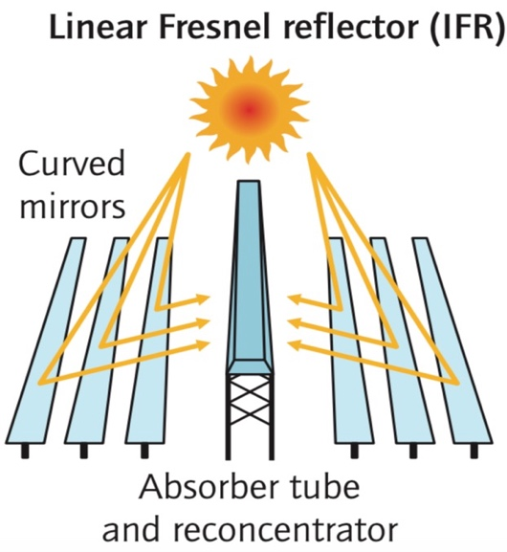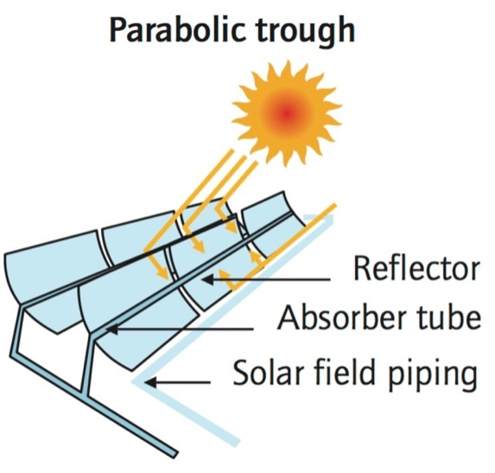

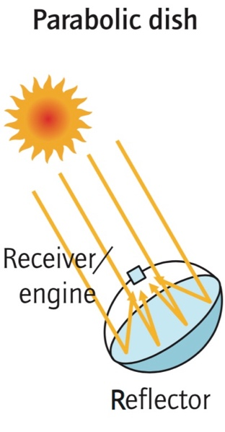

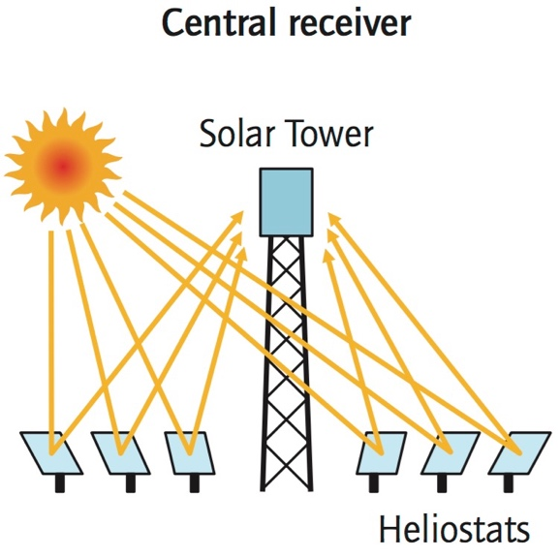

**Fig. 1. Major CSP technologies (Philibert, 2010)**

* + 1. Photovoltaic Electricity (PV)147

PV technology is built on the PV phenomenon, which photons in the sunlight are directly transformed into electricity in solar cells (Khan and Arsalan, 2016). Each solar cell is only a small component ofPV modules. PV systems are suitable for use in a wide range of applications between smalland very large scale.In terms of flexibility, this is a superiority of PV which CSP does not possess of.Not only this, PV systems can be either designed as grid-connected or isolated (Mekhilef et al., 2011). A PV system can generate more power comparing with a CSP system with same sun collector area (Desideri andCampana, 2014, p.423). According to Wu et al. (2007), thestandalone PV generation system is regarded as an economic power supply system.To sum up, PV is the most likely technology to achieve the proposedbuilding integrated solar power generation system.

* 1. Solar cell283

Solar cells also refer to PV cells, which basically consist of two layers made of semiconductors such as silicon and selenium (Razykov et al., 2011). The upper layer is exposed to the sun holding electrons, so that this layer has a slightly negative (n-type) charge while a positive (p-type) charge builds on another layer on bottom. Once the n-type layer receiving sunlight, photons consisted in the light activate atoms adhered on this surface to form free electrons.Then electrons are excited across band gapcumulating potential difference. At the present of electrodes, direct current is produced for electrical appliancesat last. However, alternating current is always required for domestic users, and it can be addressed by an inverter (NEP, 2010). Fig. 2 shows the process of thePV effect.

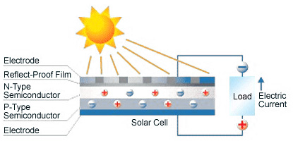

**Fig. 2. Working principle of the solar cell (RITEK, n.d.)**

In order tosuccessfully utilize PV power generation, efficiency and market feasibility of the solar cellshould be aware. Currently, there are three main classifications of solar cells, that are categorized into silicon (Si)wafer, thin film and multiple junction (Khan and Arsalan, 2016).Simply from the view of efficiency, Bergmann (1999) first summaries monocrystalline silicon (mono-Si) solar cells have the highest working efficiency up to 20%, following by polycrystalline silicon (poly-Si) type with around 15% efficiency. NEP (2010) argues mono-Si cells and poly-Si cells only have a mean efficiency of 15% and 12% separately. Both belongs to Si-wafer technology which is known as the first PV generation and they are commercially viable with around 90% of solar cell market share (Khan and Arsalan, 2016).Despite the poly-Si cells have the higher efficient, mono-Si cells dominate global PV cells share at present. Colville (2017) forecast the future PV technology development trends (see Fig. 3).

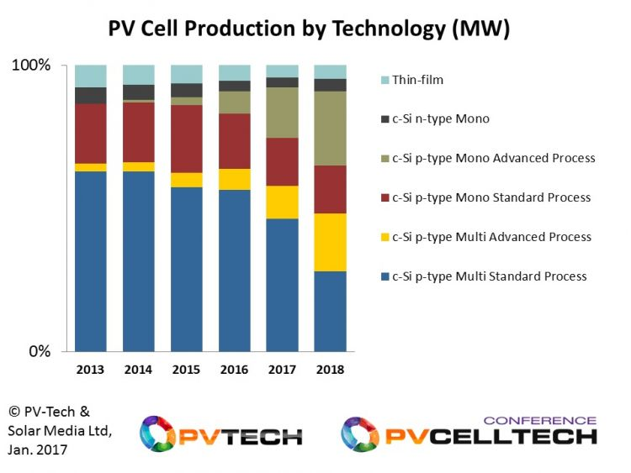

**Fig. 3. World cell production by technology developing trends (Colville, 2017)**

* + 1. CrystallinePV Panels307

Mono-Si is the known best material to produce solar cells with the nominally highest efficiency at a practical range between 15% to 17% (Tyagi et al., 2013). Si is the main raw material to manufacture all Si-wafer based cells.The processes of mono-Si cell production in sequence consist Si purification, single crystal silicon casting, wafer cutting, doping, electrode embedding, coating and encasing.Pure Si is derived from quartz or sand, which means a vast amount of Si is reserved on earth (Green, 2000).Green (2000) states extracted pure Si should be refined and casted into a singlecylindrical crystal for Si slicing, followingmono-Si cells are the assembly of the Si slides. The Si doping process is further adds by Tyagi et al. (2013) thata certain amount ofboron orphosphorous isintermingled with the pure Si to endow its enhanced electronic trait.A chosen metal then paste on both surface and bottom with a very thin thickness.Moreover, an anti-reflective coating,generally titanium dioxide,must be employed with the Si slices to avoid the light reflex by its shiny surface (Zaki, 2013). At last, wafers can be encased well to and protected from theweatherdamage (Green, 2000).Cost thus becomes high due to these complex processes.

Poly-Si cells are a variation of mono-Si cells with lower efficiency and cost (Becker et al., 2011). The difference between poly-Si and mono-Si comes from the casting process, where no dopant is introduced in poly-Si crystal growth (Poullikkas, 2010). The ease of manufacture leads to cost decreasing. Other steps of a poly-Si cell fabrication are same as the mono-Si cell. At last,each Si-wafer based solar modulegenerally brings a set of assemblies of 36 cells (Green, 2000). In this paper, Si-wafer cells are regarded as the most possible technology used in the integrated building power generation system.

* + 1. Thin Film PV Panels176

Thin film technology is the second generation in PV development, which basically includes amorphous silicon (a-Si) solar cell, copper indium gallium selenide (CIS/CIGS) and cadmium telluride cells (CdTe) (Khan and Arsalan, 2016).Semiconductor material largely reduces in use, a thin film is around 100 to 1000 times less thin than the layer of a Si wafer (Green, 2000). As a result, cost of a thin film PV panel is much cheap than the first generation.Among all thin film cells, amorphous silicon (a-Si) attracts most attentiondue to its maximum efficiency is 13% (Yang et al., 2003).However, Khan and Arsalan (2016) demonstrate a-Si technology is only practiced in a very small scale. This is caused by its easily degradable character(Parida et al., 2011).As for CIS and CdTe technologies, both lab efficiency and commercial efficiency are worse than crystalline PV panels (Khan and Arsalan, 2016).Tyagi et al. (2013) conclude that despite all a-Si, CIS/CIGS and CdTe contain good band-gap from 1.45eV to 1.7eV, researchers are trying to improve the performance of these technologies.

* + 1. Other PV Panels 56

Others mainly refer to multi-junction technology which is the third generation (Khan and Arsalan, 2016).Organic solar cells and dye-sensitized cells are the major two technologies in this class. They do not have a good efficiency yet, butadvantages of these technologies may further provide flexibility, light weight and durability which current PV materials cannot offer.

* 1. Electrical Energy Storage (EES)157

It is undeniable that solar power is one of many alternative energy sources. Linking the renewable energy system into a power grid certainly increase the power security and variety.However, the emphasis on promoting grid-connected renewable generation system is not always a good measure. This is mainly caused by the intermittentand stochasticnature of these systems (Akinyeleand Rayudu, 2014).Disordercleanenergycharging into electric grid at unwanted conditions only contributes negative efforts. Thus, an electrical energy storage (EES) system is necessary to the renewable power system. Chen et al. (2009) define EES as a reversible energy converting system which can store electricity in any form and deliver the electricity whenever requested.Moreover, EES offsets the deficiency of a renewable power system to dispatch electricity at any time with adequate power reserve. As for solar power, in this article, considering of domestic utility and installation, an off-grid type of system with EES should be proposed.

* + 1. Pumped Hydroelectric Storage (PHS)

The earliest PHS was operated in 1929

* + 1. Batteries or Fuel Cells

It is certain that battery packs enable to store solar electricity. However, cost and operationmonitor

* + 1. Other Methods
  1. Integrated Building Solar Power System
  2. Summary

Unlike CSP, PV systems can operate efficiently on a small scale for generating solar electricity. Besides, it will not

# Conclusion

# 4.Reference

Ardizzon, G., Cavazzini, G., and Pavesi, G. (2014) A new generation of small hydro and pumped-hydro power plants: Advances and future challenges. *Renewable and Sustainable Energy Reviews*, *31*, pp.746-761.

Akinyele, D. O., and Rayudu, R. K. (2014). Review of energy storage technologies for sustainable power networks. *Sustainable Energy Technologies and Assessments*, *8*, pp.74-91.

~~Ammar, M. B., Chaabene, M., and Elhajjaji, A. (2010) Daily energy planning of a household photovoltaic panel.~~*~~Applied Energy~~*~~,~~*~~87~~*~~(7), pp.2340-2351.~~

Banos, R., Manzano-Agugliaro, F., Montoya, F. G., Gil, C., Alcayde, A., and Gómez, J. (2011) Optimization methods applied to renewable and sustainable energy: A review. *Renewable and Sustainable Energy Reviews*, *15*(4), pp.1753-1766.

Becker, C., Sontheimer, T., Steffens, S., Scherf, S., andRech, B. (2011). Polycrystalline silicon thin films by high-rate electronbeam evaporation for photovoltaic applications–Influence of substrate texture and temperature. *Energy Procedia*, *10*, pp.61-65.

Bergmann, R. B. (1999) Crystalline Si thin-film solar cells: a review. *Applied Physics A: Materials Science & Processing*, *69*(2), pp.187-194.

Chen, H., Cong, T. N., Yang, W., Tan, C., Li, Y., and Ding, Y. (2009) Progress in electrical energy storage system: A critical review. *Progress in Natural Science*, *19*(3), pp.291-312.

Chu, Y., andMeisen, P. (2011) Review and comparison of different solar energy technologies. *Global Energy Network Institute (GENI), San Diego, CA*.

Colville, F. (2017) New findings on the PV technology roadmap for p-type multi modules. PV-Tech publishing. Last access 29th March available at: <https://www.pv-tech.org/editors-blog/new-findings-on-the-pv-technology-roadmap-for-p-type-multi-modules>

Cooper, C., andSovacool, B. K. (2013) Miracle or mirage? The promise and peril of desert energy part 1. *Renewable energy*, *50*, pp.628-636.

Desideri, U., andCampana, P. E. (2014). Analysis and comparison between a concentrating solar and a photovoltaic power plant. *Applied Energy*, *113*, pp.422-433.

Franco, A., andSalza, P. (2011) Strategies for optimal penetration of intermittent renewables in complex energy systems based on techno-operational objectives. *Renewable energy*, *36*(2), pp.743-753.

Green, M. A. (2000) Photovoltaics: technology overview. *Energy Policy*, *28*(14), pp.989-998.

Guney, M. S. (2016) Solar power and application methods. *Renewable and Sustainable Energy Reviews*, *57*, pp.776-785.

Herzog, A. V., Lipman, T. E., andKammen, D. M. (2001) Renewable energy sources. *Encyclopedia of Life Support Systems (EOLSS). Forerunner Volume-‘Perspectives and Overview of Life Support Systems and Sustainable Development,* pp.34-38.

Hodgson, P. E. (2008) Energy, the environment and climate change. pp.1-47.

Hou, Y., Vidu, R., and Stroeve, P. (2011) Solar energy storage methods. *Industrial & engineering chemistry research*, *50*(15), pp.8954-8964.

IEA. (2015) World energy outlook 2015 factsheet. p.5.

Jäger, K., Isabella, O., Smets, A., Van Swaaij, R. A. C. M. M., andZeman, M. (2014) Solar energy-fundamentals, technology, and systems. *Delft University of Technology*, *77*.

Khan, J., and Arsalan, M. H. (2016) Solar power technologies for sustainable electricity generation–a review. *Renewable and Sustainable Energy Reviews*, *55*, pp.414-425.

Krupa, J. (2013) Energy from the desert: very large scale photovoltaic power-state of the art and into the future. *Energy Policy*, *61*, pp.1608-1609.

Lewis, N. S., and Crabtree, G. (2005) Basic research needs for solar energy utilization: report of the basic energy sciences workshop on solar energy utilization, April 18-21, 2005.pp.11-75.

Wu, L., Zhao, Z., and Liu, J. (2007) A single-stage three-phase grid-connected photovoltaic system with modified MPPT method and reactive power compensation. *IEEE Transactions on Energy Conversion*, *22*(4), pp.881-886.

McVeigh, J. C. (2013) *Sun power: an introduction to the applications of solar energy*. Elsevier, pp.1-24.

Mekhilef, S., Saidur, R., and Safari, A. (2011) A review on solar energy use in industries. *Renewable and Sustainable Energy Reviews*, *15*(4), pp.1777-1790.

NEP. (2010) Photovoltaics-electricity from daylight. Last access 29th March available at: <http://www.nottenergy.com/images/uploads/pdfs/Electricity_From_Daylight.pdf>

Omer, A. M. (2008) Energy, environment and sustainable development. *Renewable and sustainable energy reviews*, *12*(9), pp.2265-2300.

Panwar, N. L. (2007) *Renewable energy sources for sustainable development*. New India Publishing, p.3.

Parida, B., Iniyan, S., andGoic, R. (2011). A review of solar photovoltaic technologies. *Renewable and sustainable energy reviews*, *15*(3), pp.1625-1636.

Philibert, C. (2010). CSP status today.*Technology roadmap: concentrating solar power*. OECD/IEA, pp.9-18.

Poullikkas, A. (2010). Technology and market future prospects of photovoltaic systems. *International Journal of Energy and Environment*, *1*(4), pp.617-634.

Razykov, T. M., Ferekides, C. S., Morel, D., Stefanakos, E., Ullal, H. S., and Upadhyaya, H. M. (2011). Solar photovoltaic electricity: Current status and future prospects. *Solar Energy*, *85*(8), pp.1580-1608.

RITEK. (n.d.) How solar power works. Last access 29thMarch available at: <http://www.riteksolar.com.tw/eng/p2-solar_modules.asp>

Spencer, L. C. (1989) A comprehensive review of small solar-powered heat engines: Part I. A history of solar-powered devices up to 1950. *Solar Energy*, *43*(4), pp.191-196.

Turkenburg, W. C., Beurskens, J., Faaij, A., Fraenkel, P., Fridleifsson, I., Lysen, E., Mills, D., Moreira, J. R., Nilson, L. J., Schaap, A., and Sinke, W. C. (2000) Renewable energy technologies. *World energy assessment: Energy and the challenge of sustainability*, pp.219-272.

Tyagi, V. V., Rahim, N. A., Rahim, N. A., Jeyraj, A., and Selvaraj, L. (2013) Progress in solar PV technology: research and achievement. *Renewable and sustainable energy reviews*, *20*, pp.443-461.

Xu, X., Vignarooban, K., Xu, B., Hsu, K., and Kannan, A. M. (2016). Prospects and problems of concentrating solar power technologies for power generation in the desert regions. *Renewable and Sustainable Energy Reviews*, *53*, pp.1106-1131.

Yang, J., Banerjee, A., andGuha, S. (2003). Amorphous silicon based photovoltaics—from earth to the “final frontier”. *Solar Energy Materials and Solar Cells*, *78*(1), pp.597-612.

Zaki, M. M. (2013) Photovoltaic building facades, pp.5-14.