Features in Systems Integration

Name

Course

Tutor

Date

Features in systems integration

**The process of eliciting the requirements**

Having identified how system integration can help Google Inc. to improve its service delivery, the next stage is to move forward and examine the various features of integrated systems that would help the company to achieve the desired objectives. For this to happen, it is necessary to conduct a review of the various requirements that would be needed in the exercise. In that regard, the following are the procedures that would be undertaken in identifying the relevant requirements in the systems integration project.

Consultation with the stakeholders is the initial step in the identification of the needs. The assumption is that the stakeholders own the project and it would, therefore, be necessary to consult them so that they provide their views on what the implementation team should do. It is also needed to consult the stakeholders since they hold the keys to solving the possible issues that could prevent a successful implementation of the project. One such issue is the availability if finances and that will have that factor at the back of their minds while providing their suggestions. Besides consulting the stakeholders, it would be relevant to seek information from reputable peer-reviewed journals that are of interest to the matter at hand. In modern communities, scientists have carried out research and made publications on systems integration. Such information is going to be consistent in identifying the most appropriate integrative approaches to take and the requirements that come with them.

**The stakeholders and their roles**

For this project, a stakeholder is any individual or a group of people who will be affected by the outcome of the project (Fassin, 2009). In that regard, the following groups of people are the primary stakeholders of the systems integration project at Google Inc. The first group of stakeholders is the end users of the project. They are the consumers of the primary stakeholders since all the adjustments that are being made in the project are to ensure that they continue enjoying the services of the company. Their role in this endeavor would be to provide feedback regarding the changes that have been made and suggest the necessary adjustments.

The principals are the second category of stakeholders. In this regard, the heads include the owners of the enterprise, the management and any other high ranking persons that are influential in making the decisions that the company takes. One of the roles of the principals is to provide the resources that would be needed by the corporation to accomplish its goals. Besides the provisions of resources, the administrators will provide the necessary guidance as and when may be required by the implementation team.

The other two groups of stakeholders comprise the partners and the insiders. In this case, the partners are those people who will be involved directly in the production of the system. They include installers, the operations staff, the supervisors and even the legal team. Their core duty is to come up with a quality system that meets the specifications of the original plan as well adhering to the general quality and legal standards. The insiders are those individuals who provide support to the partners. Their duty is to make sure that the partners get what they want as and when they may need them. They include security experts, database administrators and network experts among others.

**The components of the interfaces and a schematic presentation**

The system to will adopt a three-tier data model that will make sure that all the functional areas of the data creation and presentation become easy and accessible to the customers. The three data models include conceptual data modeling, logical data modeling and finally the physical data modeling. For the systems at Google Inc. to achieve significant integration, then the whole process needs to start from the conceptual data integration to the physical data integration.

In the Conceptual data integration model, there is the production of the implementation-free representation of some of the requirements that are needed for data integration in the proposed system (Hay, 2013). It is a level of implementation that primarily determines what will need to be done and how they will be done. The major function of adopting the conceptual model is that it will help the company in understanding its internal organization and processes. That knowledge will be necessary for developing an approach towards the execution of other programs. Once the team has known the relationships that exist among the various units, then they would use this knowledge for its other services.

The next component of this integration will include the logical integration. Google Company has an international presence, and that brings complexities particularly regarding semantics. In this connection, it is important to make sure that the data being utilized is normalized. Normalization is the process by which data information are being placed in their right places. It reduces the redundancy of data by putting different kinds of information in the right groupings hence making it easy to access. In that regard, a user would not be faced with the situation where search results present a broad range of conflicting information. As a consequence, normalization will make sure that entities are properly formed and attributes assigned to appropriate entities.

Physical data modeling is the final component of the integration that the process will undertake. It is a component-based approach to and clearly demonstrates how data will flow through the various attributes in the integration environment. The representation presents the last face in the adjustments in the company which will make sure that the form of presentation of data corresponds with the needs of the users and the organization.

**Schematic representation of the integration**

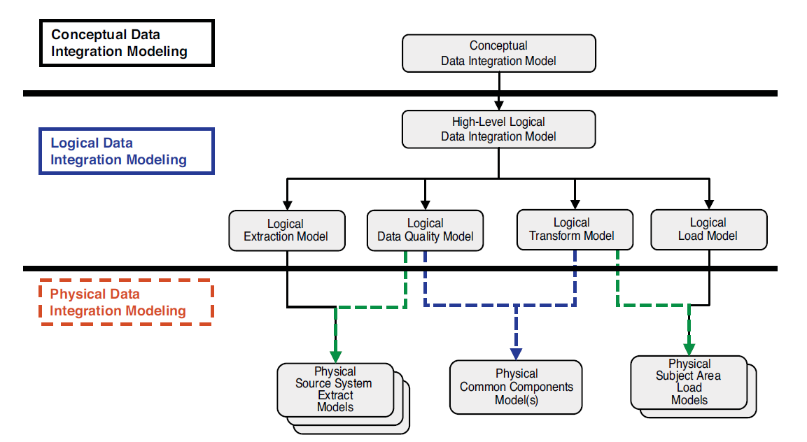

**The functional requirements**

It is always prudent to generate all the possible elements of a project for the project to succeed. There are two groups of conditions; functional and nonfunctional requirements. The technical requirements in the project are those conditions that expressly specify what a project should do (Shiloh, 2014). In this integration project, the measurable functional requirements include administrative functions, audit tracking, certification requirements, audit tracking and external interfaces.

**The Nonfunctional requirements**

The nonfunctional requirements are those whose primary roles are to specify the functions of the systems. Mostly, they indicate how the system should behave. To that extent, they act as the yardstick used in measuring the efficiency of the scheme (Chung et al, 2012). Some of the measurable nonfunctional requirements in the project are the capacity, the reliability, the usability, the security and maintainability of the scheme.

**The assumptions used in the project**

Various assumptions were made in the process of coming up with the system. The assumptions revolved around the areas of control, environment, data, usage and convention.

* Regarding control, the assumption is that the general architectural principles are based on the company's past experiences and the various best practices and methodologies that it has established.
* The web browser is the primary client that is used by both the employees and other outside users
* The user acceptance test will be available in performing usability testing.

**The pros and cons of proceeding with the project**

The major advantage of this project is that it will make the services of the company responsive to the needs of the customers. Besides, it will be substantial for the company in reducing the costs that are related to maintenance. However, the biggest advantage of the project comes from the fact that it will improve the experiences of the customers while using the services of Google Inc.

However, there are concerns with the overall project. Firstly, it is uncertain if the company will get value for the investment that they have made on the project. Additionally, since the company operates on the global stage, it is not clear whether it will manage to satisfy the demands of its clients that are of a different background. So, it is likely that the changes may attract more customers just as it may fail to impress the other individuals. That may destabilize the client base of the company.

**References**

Chung, L., Nixon, B. A., Yu, E., & Mylopoulos, J. (2012). Non-functional requirements in software engineering (Vol. 5). Springer Science & Business Media.

Fassin, Y. (2009). The stakeholder model refined. *Journal of business ethics*, *84*(1), 113-135.

Hay, D. C. (2013). Data model patterns: conventions of thought. Pearson Education.

Shiloh, S. (2014). FUNCTIONAL REQUIREMENTS DOCUMENT.