**ASSIGNMENT 8**

EN360 Technical Communication

**Directions**: Be sure to save an electronic copy of your answer before submitting it to Ashworth College for grading. Unless otherwise stated, answer in complete sentences, and be sure to use correct English, spelling and grammar. Sources must be cited in APA format. Your response should be four (4) double-spaced pages; refer to the "Assignment Format" page located on the Course Home page for specific format requirements.

**Part A: Email/Text Problems**

What are some of the problems that you have experienced when writing or receiving poorly, perhaps hastily, written emails/texts? Describe at least five (5) types of issues.

**Part B: Writing a Process Description**

Select a specialized process that you understand well and that has several distinct steps. Using the process description discussed in Chapter 19 of your textbook as a model, write a one page description of this process.

**Part C: Difficult to Follow Instructions**

Find a short set of instructions or some other technical document from work or the Internet that is hard to follow. Replicate or download those instructions at the top of a one-page analysis. Assume that you are the Associate Director of Communications for the company that produced this document and that you are doing a final review before the document is released. Using the “Checklist for Instructions and Procedures” on the following page (also found in Chapter 20 of your textbook), identify what, specifically, makes the document difficult to use, providing a specific reference for each problem area.

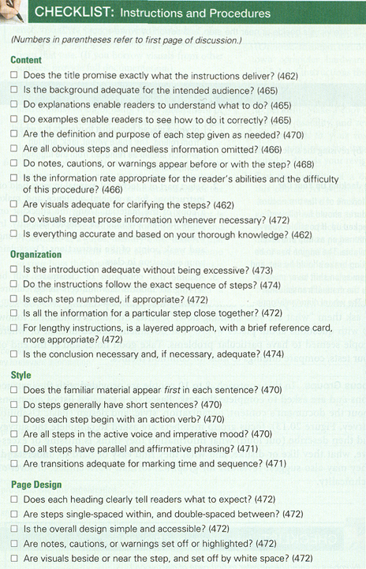

**Part D: Ted Talk Lecture Evaluation**

Watch a 10-20 minute TED Talks lecture online (www.ted.com). There are 27 evaluation criteria on the “Checklist for Oral Presentations” below (also found in Chapter 24 of your textbook). Select 10 among them that you believe are most salient for this speaker. Identify strong areas and areas that could have been better. Provide an example for each. (These are skilled speakers, so you'll probably be highlighting more strengths than weaknesses.)

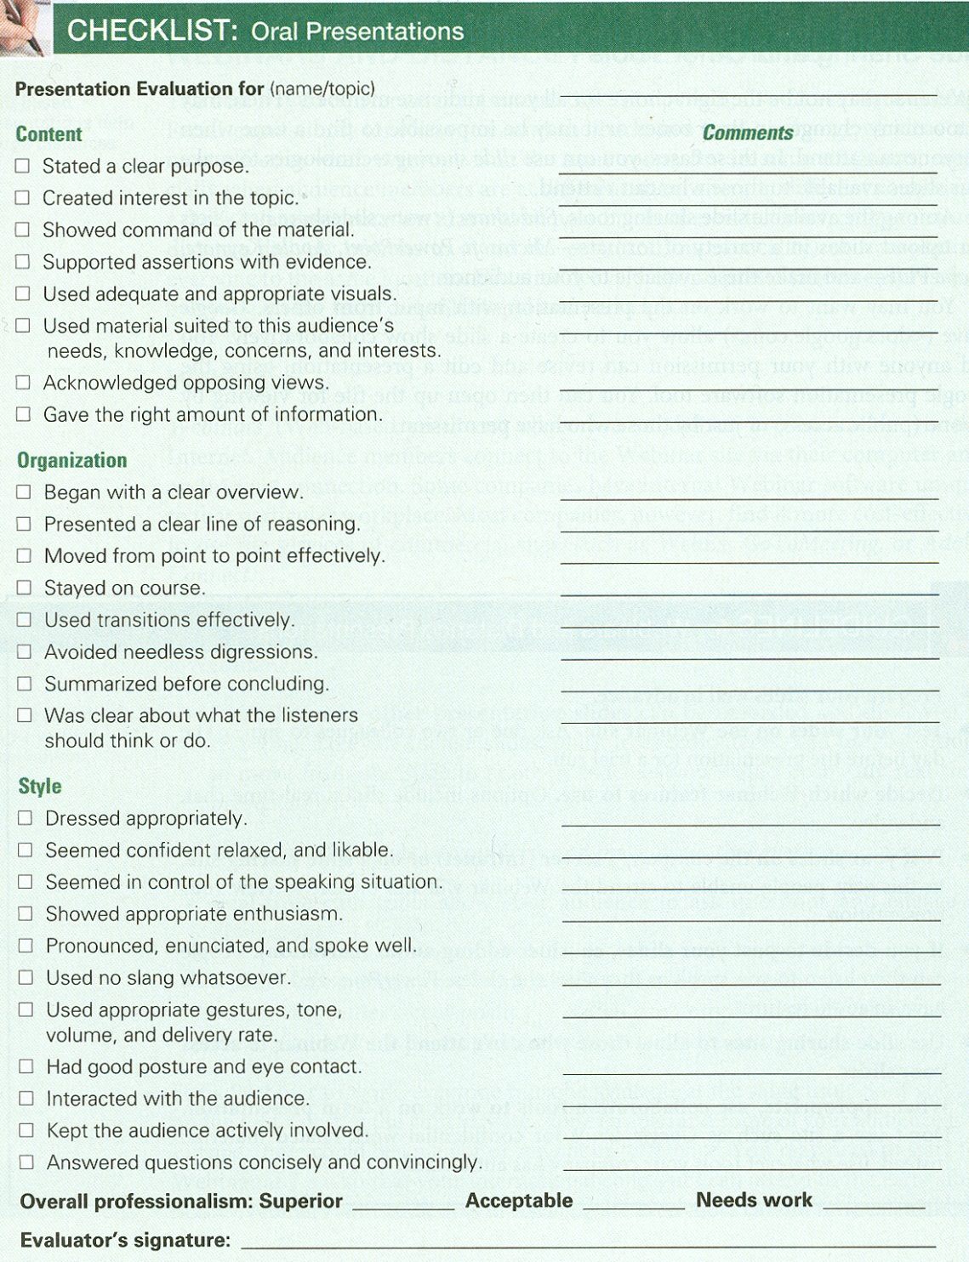

**Grading Rubric**

*Please refer to the rubric below for the grading criteria for this assignment.*



This is the end of Assignment 8.