Berta’s Pizza Business Case

1.0 Introduction/Background
Berta’s Pizza Shopconsists of five locations in the city of Lawrence. Many restaurants in the city offer efficient carryout and delivery mobile/online ordering. Berta’s does not have an online ordering system. Customers cannot order from Berta’s menu via a mobile device or from Berta’s website. Customers must call Berta’s to order delivery or carryout. The current takeout/delivery order process is inefficient and negatively impacts Berta’s current and future revenue goals.

2.0 Business Objective
Berta’s strategic goals are to increase customer loyalty, brand recognition, and revenue. The Berta’s mobile/online ordering system (BMOS) project will support these goals by facilitating food orders from mobile devices, and from the Berta’s Pizza website. A mobile/online ordering system will allow Berta’s to compete in the food carryout and delivery market.

3.0 Current Situation and Problem/Opportunity Statement
Berta’s Pizza has five Lawrence locations, downtown, in the north-east, north-west, south-east, and south-west areas of the city. Berta’s current carry-out and deliveryorderprocess is inefficient. Customers may order pizza delivery from a Berta’s location that is further away than the Berta’s Pizza closest to the customer. The phone ordering process places customers on-hold until a current order has been taken. Ordering over the phone places the burden of order mistakes on the order takers. Customer loyalty has diminished since other pizza shops began offering mobile and online takeout and delivery orders. Additionally, revenue has decreased.
The addition of a mobile/online ordering system will enable all orders to come into one system. The system can determine which Berta’s Pizza would be appropriate to fulfil the delivery orders based on the customer’s location, the status of the Berta’s locations, and the customer’s order. Customers will be able to order Berta’s menu option at will through mobile, or stationary devices. Customers will be able to register and create an account on Berta’s website and receive promotional offers.

4.0 Critical Assumptions and Constraints
Berta’s mobile and online ordering capabilities must be available before the annual convention starting next year in July. Instead of building two applications, a mobile app, and a web app, only one web-based,device-responsive system is developed. The system must host 100 concurrent customers, and have data backup and automatic system recovery capabilities. The system must have security and access levels for customers, and Berta’s internal staff. Customer personally identifiable information (PII), and credit card information must be encrypted during transmission and while stored in Berta’s databases. A team from Hi Five Software will develop Berta’s online ordering system. The system must be hosted on the existing servers that host Berta’s current website. A project manager must manage this project.

5.0 Analysis of Options and Recommendation
There are three options to consider:
- Do nothing. Berta’s takeout and delivery comprise almost 80% of sales. We must facilitate ordering for these customers, and engender customer loyalty by offering promotions to customers who register on the website.
- Purchase access to new servers to support this new capability, with Hi Five Software as developers and a project manager.
- Use existing servers to support this new capability, with Hi Five Software as developers and a project manager.
After consideration by stakeholders, option threewas chosen.

6.0 Preliminary Project Requirements
Description: Takeout and delivery customers may register to use the Berta’s Pizza website. Or, customers may order from the site without registering. Customers may choose multiple items from Berta’s menu for delivery or carryout. Customers can pay for their orders by the methods described in the requirements document (cash, credit, debit, and PayPal). Different website user roles will define a user’s level of website accessibility. Roles may be assigned to customers, Berta’s staff, website developers, and others. The order system will assign orders to Berta’s locations. An order will display on the takeout/delivery order webpage at the Berta’s location assigned to fulfill the order. Internal users, on Berta’s staff, will have an accessibility role needed to update the menu. Another role will update orders as completed or canceled.

7.0 Budget Estimate and Financial Analysis
A preliminary budget of $150,000 has is estimated for this project. This estimate is based on a project manager working 15 hours per week for six months, and software developers working 60 hours (2 developers, 30 hours each) for six months. The customer representatives from Berta’s Pizza will not be paid from the project budget. The hourly rate of the project manager is $55, and the hourly rate of the developers is $75. After project completion, a maintenance cost of 35,000 for the first year is included in the estimate.
The projected benefits are established by an increase in takeout and delivery orders. More customer loyalty and satisfaction. A projected 30% increase in takeout and delivery orders translates to a 24% increase in orders and revenue. After one year, a $57,000 revenue increase per pizza shop is projected. Totaling $288,000 per year increased revenue, after one year.Exhibit A depicts the projected costs, benefits, estimated net present value (NPV), return on investment (ROI), and the year that payback occurs. The NPV is $502,740, based on a three-year projection. The discounted ROI is 209 percent.
Exhibit A BMOS Financial Analysis
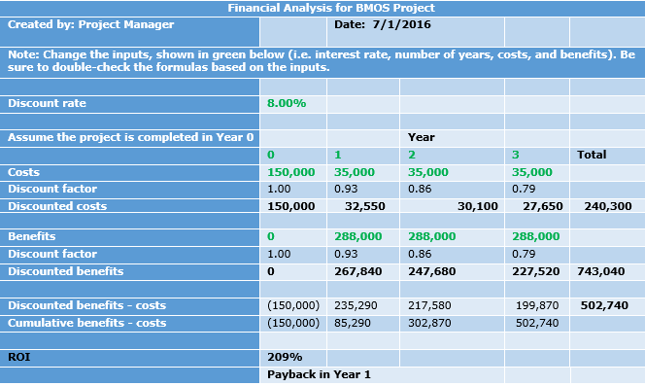

8.0 Schedule Estimate
Berta’s Pizza expects the project to be completed before the annual convention in July next year. The size and complexity of the project indicate a six-month duration.

9.0 Potential Risks
The main risk is the customers not using the mobile and online system for carryout and delivery orders. To mitigate this risk, Berta’s informs each customer who orders takeout or delivery by phone, of the mobile/online order system. Business risks are no increase in or lower customer loyalty and satisfaction, and no increase in or lower revenue. To mitigate these risks, the mobile and online ordering systemisuser-friendly, intuitive and easy to use, and defect free.

10.0 Exhibits
Exhibit A: Financial Analysis for BMOS Project
Berta’s Pizza Business Case

