Hi,, I want somebody to write me a paper for my religion class. The paper should follow the structures. You have to read the articles to write this paper. Read the paper structure. Read the promptand answer it.

I want it to be perfect in organizations and ideas, our Prof. expect a good writing. You should use the needed religious word to express the meaning. Don’t forget if you quote something (do not fill the paper with quotes, but use them at least one or two to get a better paper) do not forget the citaion. If you are going to use quotes more than two lines, separate and narrow them in small lines. just narrow them. This should be a truly outstanding paper. It is clearly written, well argued, and original. A paper that just gives a straightforward or “obvious” response to some philosophical or interpretive problem would not merit an A, even if it is clear. An A paper does something extra—but not at the cost of a clear treatment of the problem.
The paper must bea no less than a complete 5 and no more than 6.5 pages. Double spaced.

Here’s the Prompt ..please READ CAREFULLY

V
V
V
V
V
V
V
V
V
V
V
V
V
V
V
V
V
V
V
V

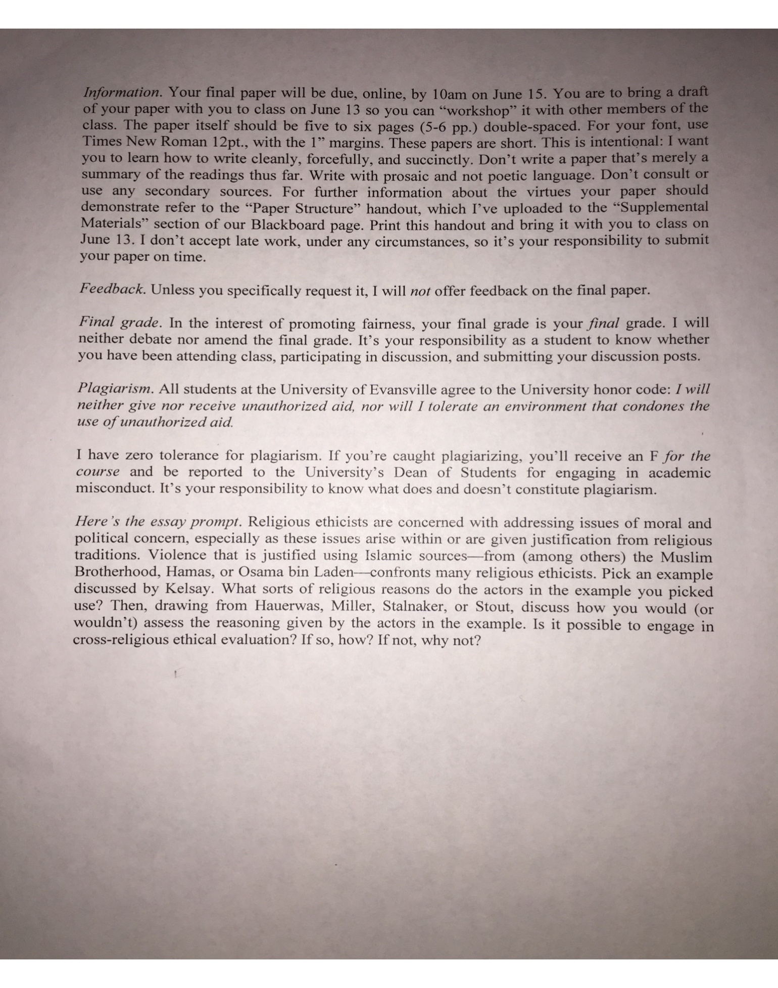

Here are some grammatical and stylistic comments:
- Use gender-neutral language. That is to say, "he" or "man" shouldn't be used as a generic term for people.
- "If" versus "whether." Use "if' only in conditional sentences. For example, "If you're going to lunch, could you let me know?" "Whether" should be used in sentences like "Do you know whether you're going to lunch?" or "Do you know whether you're getting
Chinese or Italian for lunch?"
- "Ethics." "Ethics" is singular, Thus, it is "an ethics" or "a Christian theological ethics" and not "an ethic." (The same thing can be said about apologetics, metaphysics, poetics, etc.)
- Please avoid writing that someone "has demonstrated" or "has shown." For example, avoid writing "As Kant has demonstrated..."
- "Critique." Please use "critique" as a noun and not as a verb. So, "I will offer a critique," whereas, for the verb, "I will criticize..."
- "Between" versus "among." Use "between" for relations involving two objects—for example, "Between Rawls and Nozick"—and "among" for relations involving or more—for example, "Among Rawls, Nozick, and Sandel."
- When speaking, someone might say "an historic event," etc. But in writing, please write "a historic event," etc.
- For the singular possessive, it is "Rawls's" or "Hauerwas's" not "Rawls"' or "Hauerwas."'

