System Integration

Name

Course

Tutor

Date

System Integration

**Project information**

**Description of enterprise**

Google Inc is an international technology company whose primary interest is the provision of internet related services. The company organizes information from all over the world and makes it accessible to various groups of users (Vise, 2007). In most cases, the enterprise provides a search engine from where individuals can search for whatever information that they may need. System integration is the process in which different subsystem are coordinated to work together to achieve a particular goal. Google Inc is in a position to apply the processes of system integration with a view to meet some of its commercial and administrative needs.

**The objectives of system integration**

The primary purpose of integrating the systems at Google Inc is to improve the efficiency of service delivery and in return reduce the number of complaints that customers could present the company. There have been multiple cases in which individuals have filed complaints against some activities of the enterprise. One of the ways to reduce the rates of charges is to integrate systems so that they are easy to monitor. In situations where systems function separately, it is always difficult to monitor the performance levels of the systems. In that regard, one of the components could easily malfunction without being noted (Chapman & Kinh, 2009). That would affect the quality of the services that the company offers.

The integration of systems is an efficient way of cutting g down on costs especially those related to maintenance. Companies always incur a lot of expenses regarding maintenance of the various parts. It is evident that when systems are brought together, it will be easy to monitor their situations and therefore prevent any damages by taking note of any deviations in their performance. The fundamental idea is that when systems are integrated, it is relatively easy to monitor how they work and that will make sure that the engineers take note of any anomaly in their functions. That would prevent any further damages that may increase the costs of maintenance.

Finally, integration would be useful in reducing the number of errors that may be experienced by users of the services of the company. It is notable that one source of mistakes in machines is the lack or poor communication among the subsystems that help software to work optimally. Integration is one way of tackling the matter to make sure that it eradicates or reduces the number of errors that users may experience while using the systems.

**The business and technical needs to be met by the project**

The main business needs that the project needs to achieve are the satisfaction of the needs of the customers. It is necessary to satisfy customers by offering high-quality services that meet international standards. It is a need to reduce the chances of errors and delays that clients might experience. That would make sure that the business stays competitive in the market and maintain profitability. In the modern economic times, the world has become so competitive that Google cannot afford to lose any customer as that may have far-reaching effects on its business goals.

Finally, due to the diversity of its customers, it is necessary for Google to make sure that it serves the interests of all its clients. Due to its global presence, it is necessary for the company to customize its services so as to meet the demands of its highly diversified market base. For example, the market in America may want services that are contrary to what is needed in Asia and America. That diversification of its products can be achieved through a careful integration of the company's systems.

**The boundaries of the project**

The project is to be designed to improve the efficiency of services offered by Google Inc. through its search engines. Its main aim is to improve the customer satisfaction and eliminate all the unfavorable factors that come with inefficiencies. It is also going to improve the ease with which people can use the systems.

**Project plan**

A work breakdown structure of this project is presented in another document.

**The Duration**

The project is expected to run for three months starting from the first of March until the end of June 2017.

**System Integration best practices**

In any project, there are always some practices that institutions adopt to ensure a successful implementation of the projects. For this project, the following are the elements of best practices that will be utilized to bring the changes. Firstly, time would be a key consideration in the whole process. It would be necessary to make sure that the project adheres to the strict timelines that have been created.

The second issue is the budgetary consideration. It is necessary to make sure that the project operates within the budgets that have been created. A wasteful utilization or misappropriation of resources is likely to result in the failures (Chen et al, 2008). In circumstances where funds would be used for purposes that were not assigned to them, it becomes apparent that the targets will be missed and that may hamper a successful implementation of the project.

**The process flow diagram**

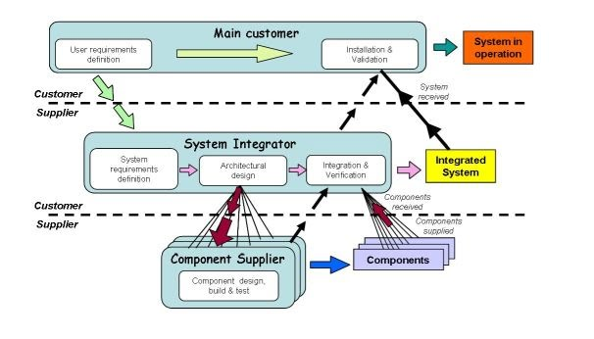

**References**

Chapman, C. S., & Kihn, L. A. (2009). Information system integration, enabling control and performance. Accounting, organizations and society, *34*(2), 151-169.

Chen, D., Doumeingts, G., & Vernadat, F. (2008). Architectures for enterprise integration and interoperability: Past, present and future. Computers in industry, *59*(7), 647-659.

Vise, D. (2007). The google story. Strategic Direction, *23*(10).