# Grading Guide

| ***Content*** | *Met* | *Partially Met* | *Not Met* | Comments: |
| --- | --- | --- | --- | --- |
| Described the project and the criteria used in the selection process | X |  |  |  |
| Provided an overview of the scope and nature of the project. | x |  |  |  |
| The team includes a summary of milestones and tasks that must be accomplished in the project, including the critical path. |  | x |  | Need to discuss the critical path; see notes in paper |
| The team provides/discusses a high-level Work Breakdown Structure that details tasks, dependencies, resources, and the critical path. | X |  |  |  |
| The team includes a Microsoft® Project Gantt chart and included appropriate tasks/subtasks, naming of tasks, dependencies, start/stop times, etc |  |  | x | Did not include the MS Project file; had a pdf file but I need to see the actual file to be able to view multiple items, etc. |
| The team provides/discusses a project budget plan | X |  |  |  |
|  |  | ***Total Available*** | ***Total Earned*** | Went over the word limit. |
|  |  | 7 | 6 |  |

| ***Writing Guidelines*** | *Met* | *Partially Met* | *Not Met* | Comments: |
| --- | --- | --- | --- | --- |
| The paper—including tables and graphs, headings, title page, and reference page—is consistent with APA formatting guidelines and meets course-level requirements. |  |  |  |  |
| Intellectual property is recognized with in-text citations and a reference page. |  |  |  |  |
| Paragraph and sentence transitions are present, logical, and maintain the flow throughout the paper. |  |  |  |  |
| Sentences are complete, clear, and concise. |  |  |  |  |
| Rules of grammar and usage are followed including spelling and punctuation. |  |  |  |  |
|  |  | ***Total Available*** | ***Total Earned*** | Some grammar errors; see paper comments |
|  |  | ***3*** | 2.7 |  |

| **Assignment Total** | **#** | **10** | **8.7** |  |
| --- | --- | --- | --- | --- |

Project Management Plan Team C

Katherine Bonilla, Keith Rumpel, Maryan Negron, Montie Preston Agee IV, Renee Battie, Frankie Hill-Jones and Robert Wallace

May 21st, 2018

CPMGT/305

Gary Denney

Project Management Plan

Throughout this paper we will take a look at a specific project and the criteria used in the selection process of a project. We will then provide an overview of what the scope of a project is as well as the nature of a project. We will at this point start to look at the project schedule using a specific project of building homes. Microsoft Project will be used to capture all of the project tasks that will be needed to be completed. A summary of milestones and tasks along with a critical path will be looked at which will lead us into the work break down schedule. Lastly, we will discuss the budget plan and capture all of the estimated cost associated with our project.

**Project Selection Criterion**

In this paper, the project will be to build homes for the local people of the region. The building of the houses will also provide employment for the people. For there to be a workable project one must have a project plan. There are factors to consider ensuring that the project achieves success (Spradley, 2013).

The first step is to ensure that one explains the project plan to the key stakeholders and discuss the key components that will help the program become a reality. Being that it is houses there needs to be communication with the local authorities of the region. Therefore, the need to set up a plan to follow which also includes directions on how to deal with the possible risks that may occur. The project will have the baseline which will consist of the scope, the schedule, and the cost. The second step will be to define the roles and the responsibilities of the parties involved. They will be the project sponsor, project manager, the experts, and the project team. Then there will be meetings to discuss the project plan and the costs, the management plans, issues regarding staff, qualities and the risks that might arise. All these factors have assisted me in coming up with the housing project as money and labour spelling are essential items for the success of the project.

**Overview of the Scope**

The scope of the project will include numerous factors, the objective will be to come up with a home design that will not only attract the local people but also people visiting from other regions. The goals of the project in this situation will be the fact that the homes will add to the beauty of the region and make the lives of the people who purchase a home easier. It is also aimed at creating jobs for people. There will be the sub-phases of the project which will include coming up with the project plan, the planning itself, the execution and completion of the project. It will also add the task which is the design of the house and how it should be divided and the perfect location for its building.

Then there is the issue of the resources. The plan will have to consider whether they will be able to find raw materials that will be needed for the building and everything necessary to make the project a success. The budget then comes into play. The amount of money to be spent should be included. This will enable the sponsors to identify the amount of money that is necessary. The budget will be inclusive of raw materials, transportation expenses, and labour spelling. The budget should be a bit higher as it will create room for unforeseeable risks that may be encountered. Finally, there is the schedule which states the time frame of when the project should have been completed (Cho, 2001). What are you sourcing? Can’t place a source at the end of a paragraph...must go directly with the item sourced/quoted

**Overview of the Nature**

The nature of the project will consider a few issues like the planning and estimation. The plan will include the identification of the project itself and the addressing of problems, such as who will oversee the staffs’ issues, the scope of the activities, issues with location and the rationale of conducting the project. Estimation will include understanding whether the project is dependent on other organizations. Measuring and controlling will include analysis of the project and the implementation of the correct procedures. Leading and directing will involve the performance of one’s regular duties: for example, the functions of the engineers and the contractor. Then there is the management of risks and potential risks and how to deal with them ensuring they don’t interfere with the project (Tunner, 2003). Same comment on sourcing

**Project Schedule**

The attached MS Project file shows the schedule for a project to build a home. It indicates the vital elements for the completion of the project including the chief deliverables and associated activities. Further, the main tasks have subtasks complete with the resources and the start and finish times. Additionally, the tasks are linked as is shown by the predecessor activities column. The resources for the home building project comprise of the building inspector, civil, mechanical and electrical engineers, the main contractor, the surveyors, the subcontractors, architect and client.

From the attached program of works, the project will take a total of 77 days. It is scheduled to begin by 6/15/18 and end at 7 /1/18. There are 11 main tasks including Acquisition of approvals and permits followed by the financial budget approval. Afterwards, the main construction is expected to begin with site preparation followed by foundation work. Consequently, other activities will be carried out on the superstructure of the building including tasks like walling, beams and columns, windows and doors, finishes, as well as electrical and plumbing work. Finally, the building will be handed over to the client after passing the building inspection requirements.

**Project Management Plan Summary**

Indents are far overIn summarizing the project for building a home, we can identify the milestones and tasks that will be worked through to enable the project managers and project teams to reach goals that will bring the project to completion. As milestones and tasks are created, the development of a critical path will provide important steps that is not what the critical path means that will be worked through to help the project reach the ideal completion date.

The project for building a home that is being evaluated is set to be completed in 77 days. The start and finished date for the project goes from June 15, 2018 to August 1, 2018. Building inspector, civil, mechanical, and electrical engineers, main contractors, surveyors, subcontractors, architects and clients will work together to meet goals and carry out tasks within a critical path. Therefore, bring the project to completion by meeting all expectation and deadlines of the project plan and client.

The milestones and tasks that are created for the home building project allows the project manager and individuals to understand the steps that are going to be taken to help the project reach completion. The tasks that will start the project, will have the project managers acquiring approvals for build permits. As the permits are filled out and submitted, the project manager waits to reach the milestone of the approvals being accepted and building can start. At this point the project manager will start on the tasks that will get the foundation for the home built and reach the milestone for getting the foundation inspected and approved. The tasks of building interior and exterior walls will then take place to help reach another milestone of having the home framed and ready for the next tasks. The following tasks of the project are the adding of doors, windows, fixtures, electrical, and plumbing to get the home ready its final inspection. The milestones in the recent listed tasks enables the project to reach some final milestones of completion and have everything inspection ready. As the project manager and the project team carries out such tasks and reach such milestones the home building project can effectively move through the plans that where establish and implemented.

The critical path that the home building project will utilize to help bring the project to completion will work along with the tasks and milestones, while breaking down the important tasks that are essential to the project plan. Therefore, showing the importance of developing and getting the approval of building permits, gathering resources to start the building process, and scheduling inspection are essential tasks to the critical path that is developed for the home building project. As the project manager and project team works through the tasks along the critical path, they will ensure the home building project is developing effectively. Need to tell me the activities that are on the critical path....the critical path is not the “important” items for a project...need to review the text to ensure you understand what the critical path is. MS Project will calculate this for you based on your activities and dependencies established.

Through the evaluation and overview of the project management plan summary, the home building project’s managers and project teams can work effectively to reach goals that will bring project to completion.

**Work Breakdown Structure**

The work breakdown structure (WBS) is used to help the project manager determine the work that needs to be completed by the project team. It provides a detailed hierarchical top down approach based on the scope of work to be performed and shows a visual of the tasks to be completed within the project. In additional to defining, organizing and visualizing the project, the WBS has many other benefits for the team as well. The WBS can show the overall budget for the project and breakdown each area based on the costs and time to complete each stage of tasks. It can also show what team member is responsible for each task to be completed. Below is a high level WBS detailing the tasks, dependencies and resources as they relate to this Building a Home Project based on an overall budget of $500,000.

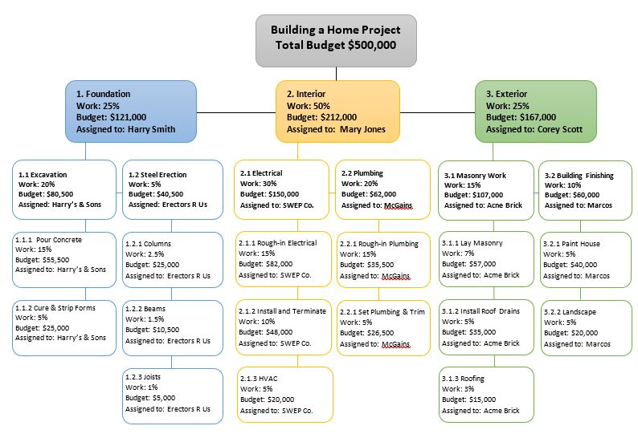

**Budget Description**

* Budget 315,000
* Project Manager: Katherine Tumelty
* Team Leader: Frankie Hills-Jones
* Team Members: Monte Preston, Keith Rumpul, Renee Betty, Maryan Negron, Robert Wallace

Project Coordinator: Katherine Tumelty - This position directs the overall operation of the project; responsible for overseeing the implementation of project activities. This position relates to all program objectives.

Included is the following: The details with in the budget to express and cover the cost of the follows tools, permits, licensing, and materials needed to complete this project of building a house for our customer.

Equipment Total $71,320

* Scaffold
* Crane Hire
* Site Shed
* Guard Rail Hire

Equipment will be used to get project started by protecting site perimeters and is equipment needing to be rented for construction of the home itself.

Materials Total $ 78,393

* Provide Hot & Cold Point inc Drain
* Provide Floor Drain
* Gas Allowance
* Stacks
* Sewer Suspended
* Storm water supply & fit
* Septic Tank Allowance
* Storm water pit Allowance
* Garden tap supply & fit
* Fit Spa bath
* Fit off D/Washer, W/c etc
* Supply & lay Carpets inc Underlay inc stairs
* Supply & lay Floating Floor
* Sand & polish Floor boards
* Sand & polish Concrete Slab

Permits & Licensing Total $ 24,475

* Building Permit
* Lot Prep Fees
* Indemnity Insurance
* Site Labourer
* Cross Over permit
* Drafting & Design
* Engineering Fees
* Contribution fee's

Misc. Total $140,212

* Stripfooting's inc labour & materials
* Bulk fill Concrete 15MPa
* Pads inc labour & materials
* Dingo for stumps holes & post holes
* Slab on ground (A-M) inc steel & labour
* Slab on ground (H) inc steel & labour
* Suspended 125 THK Slab inc Labour & mat
* Suspended 180 THK Slab inc Labour & mat
* Concrete pump - Minipump
* Concrete pump - Boom or Line pump
* Cross Over to council reg's
* 400 Series Commercial Alum
* Domestic Alum
* Timber Windows specials lead lite
* Timber Windows Specials
* Provide Hot & Cold Point inc Drain
* Provide Floor Drain
* Gas Allowance
* Stacks
* Sewer Suspended
* Storm water supply & fit
* Septic Tank Allowance
* Storm water pit Allowance
* Garden tap supply & fit
* Fit Spa bath
* Fit off D/Washer, W/c etc

All other expenses include the Contingency Sum, Supervision Fee's, Builders margins & Overheads, which are all other aspect needed to conduct and complete the build of this house. **Budgetary Plan**



**Conclusion**

The Project Management Plan involves many details and in order to have a successful project the Project Manager needs to make sure there are certain things included in their project management plan. One of the first things that will need to occur is selecting a project to work on and in this paper, we were able to discuss the criteria behind the selection. After a project is selected it is up to the project manager to make sure they have the scope and nature of the project clearly define. This paper showed the importance of having a detailed project schedule with a work breakdown structure listing milestones and task along with the critical path. One must keep in mind that the budget is as important as the schedule of tasks and both need to be met for succus. We provided a detailed budget with the estimated cost which completes our project management plan.

**References**

Cho, C. S., & Gibson Jr, G. E. (2001). Building project scope definition using project definition rating index. *Journal of architectural engineering*, *7*(4), 115-125.

Deskander, D. ( 2017). The basics of project scheduling. Retrieved from

https://www.knowledgehut.com/blog/project-management/basics-project-scheduling

Project Scheduling. Retrieved from

[https://www.projectinsight.net/project-management](https://www.projectinsight.net/project-managementbasics/project-management-schedule)

[basics/project-management-schedule](https://www.projectinsight.net/project-managementbasics/project-management-schedule)

Spradley, M. K. (2013). Project IDENTIFICATION: developing accurate identification criteria for Hispanics. *Washington, DC: US Department of Justice*.

Turner, J. R., & Müller, R. (2003). On the nature of the project as a temporary organization. *International journal of project management*, *21*(1), 1-8.