Project Implementation Plan

Keith J. Rumpel

CPMGT 305

May 21, 2018

Gary Denney

**Introduction**

This paper describes a project implementation plan for building a home with all the required strategies to realize a well-constructed home for sale at a profit. This plan consists of the development of a practical human resource plan, quality management plan and the procurement plan necessary for the realization of the project implementation goals and objects. Therefore, this document details the roles and responsibilities of the involved staff including their reporting relationships and their management. Further, this paper gives the quality management policies and requirements for the overall project. Since a home building project requires materials for its completion, this document details the procurement procedures and the goods or services necessary for procurement.

**Human Resources Plan**

The human resource plan for this home building project will involve an analysis of the personnel while detailing their roles and responsibilities as well as their competencies and authorities to accomplish the project. First, it is important to point out that this project shall involve various people with diverse competencies. At the top level, this project shall employ a project manager. The project manager shall oversee all the activities of the project to its completion. He or she is required to have at least two years of experience in the building and construction field and particularly in the same rank. Besides the project manager, there shall be the project engineer. The engineer is responsible for giving advice on the required standards including the designs and materials for the construction. The engineer’s role is important to the project to prevent failure that could accrue without proper guidance on the right materials to use for a durable, standard and profitable building. The engineer is also responsible for sourcing a skilled contractor as well coordinate with the foreman and give instructions as relayed from the project manager. The foreman and the site manager shall ensure proper coordination of the daily activities by the unground staff.

Like the project manager, the supervisor and the engineer shall be people with hands-on skills in the relevant field and experience beyond one year. However, since the project is a business, it shall be wise to cut cost in areas that are appropriate. In this regard, the supervisor shall carry out the typical roles of a site manager and that of the supervisor. This means that the foreman or the supervisor shall be responsible for the evaluation of the site and planning of the ground as well as the coordination of the different trades working the construction site and ensuring that the work being completed is within the expected standards. It is thus apparent that the project shall involve electricians and plumbers as well as the masons. Although the foreman as the site manager shall coordinate all the clearing works, he or she shall coordinate with the contractor to facilitate standard interior and exterior painting, the framing of the windows and doors as well as overall building image. Finally, the contractor through the foreman shall ensure that the home when completed is turn key and ready to occupy.

To have a successful project, the project manager will be sourced from an advert in both the electronic media and the print media. It is apparent that to get the right project manager, it is wise to source from a pool of experienced and skilled managers. In this regard, the advertisement shall run in the radios and television as well as in the newspaper. The process of the sourcing shall be a crush such that by mid-June, the manager shall be ready to get the approvals and certifications. Further, the project manager shall source the right contractor to oversee other activities. In this, regard, the project manager shall ensure that all the procedures to acquire the right contractor are set by the end of July. All the personnel shall face the project steering committee for evaluation and approval. The contractor shall maintain a high level of integrity and accuracy when carrying out his or her duties to ensure that the construction starts on the 15th of September and end on 1st of October. Below is the chart demonstrating the command flow as well as the authority and responsibilities of the staff.

**Home Building Project Organization Chart**

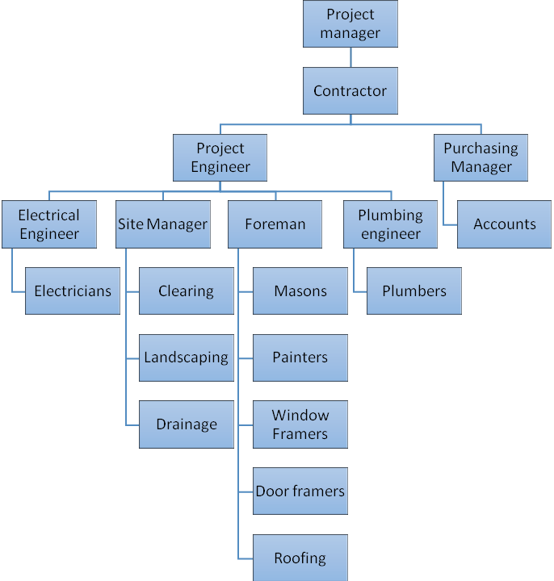

To realize the objective of the overall project, the team as outlined above shall demonstrate a high level of cooperation and synergy throughout the project implementation process. Further, the leaders shall be required to act within the prescribed rules and regulations as well as the timelines.

**Quality Management Plan**

The home building project is a business project that requires high quality to meet the standards of the project committee as well as the market standards and the prescribed government regulations. In this regard, this implementation plan sets quality policies including construction using the required standard materials in all areas. It is apparent that some contractors would want to use cheap materials that sometimes are of very poor quality. The project engineer under the supervision of the project manager shall ensure that all the materials used in the construction project meet the standards. The project engineer shall strictly oversee the work of the engineers including the electrical, plumbing, general construction and the foreman as well as the site managers. As mentioned above, the project manager through the contractor and the engineers shall ensure coordination among the workers in all areas to avoid mismanagement of the resources including money, time and human resources. To achieve this, the project manager shall develop the time frame for each activity and hand it over to the respective manager through the contractor. It is apparent that the team may fail to get the required standards for failure to have time discipline. Time is often one of the courses of project failure that can affect the project through many forms, therefore the project manager shall discuss with the project engineer on the right timings for the activities given, and a certain number of workers. The manager then shall develop a practical timeframe to ensure the project meets the standards of the steering committee as well as the market and government standards.

Often, projects fail for lack of adequate funding. In this regard, the project team shall not only provide adequate funding but timely funding (Kerzner&Kerzner, 2017). While the team may have sufficient funding for the project, the funding may have long bureaucracies that may hinder the purchase of the materials at the right time or even the payment of the staff on time. Failure to pay the workers of usually leads to lack of motivation among the workers, which leads to poor quality work. In this regard, the team shall motivate the workers through timely payments to realize good quality work. In addition to adequate and timely funding, the project team shall encourage the workers by appreciating their work. In addition, to realize quality work, the workers shall require a progressive plan of activities. It is apparent that a well-planned program motivates the workers as they manage their time with the activities. Therefore, the plans shall guide the workers through the activities and milestones (Hussain, Chakravarthy& Fatima, 2016). Finally, the quality of the project shall depend on the proper sourcing and valuation of the suppliers. While the materials are essential and critical for the overall project completion, it is significant to source for a credible supplier of high integrity.

**Procurement Plan**

The realization of a successful project depends on the purchase of high-quality materials. Further, the project requires the supply of the materials on time from the suppliers. In this regard, the procurement manager shall source the suppliers through tendering process right supplier is granted the tender (Harrison & Lock, 2017). The purchasing manager shall place the order with proper timing and allocation of time for counterchecking and verification. The supplier shall be given the quality of the materials required number or quantity as well as the duration of the supply of the goods or services. The supplier shall deliver the goods together with the delivery note and the invoices. It is apparent that some suppliers may not deliver the required goods in terms of number or quality. Therefore, a delivery note is crucial as well as the invoice. Upon the verification of the goods from the purchasing manager, the supplier shall hand over the invoice to the person receiving the supplies and her in turn will turn it over to the accountant for payment. However, in the case the poor-quality supply of goods, the supplier will be requested to supply the quality goods as ordered or forfeit the order.

As highlighted above, the purchasing manager has is responsible for processing the purchase documents. First, the purchasing manager shall identify the suppliers. Upon the identification of the suppliers for each item required for the completion of the project, the manager shall place the orders to the right suppliers. Upon the receipt of goods, the accountant shall process the payment as prescribed in the invoice. However, the accountant has the right to seek confirmation of the goods delivered before issuing the payments. For accountability, integrity as well as transparency, accountants shall not handle any cash. Therefore, the payments shall be made through checks. Further, the purchasing manager shall seek funding from the contractor who will finance the project from the project manager as prescribed by the project team. The accountant shall be the custodian of all the receipts and invoices and overall books of accounts regarding every payment of goods or services to the supplier. It is essential to state that the management team through the accountant should fund the project in all phases without failure or delays. The table below shows the phases of the project that need timely funding.

|  |  |  |
| --- | --- | --- |
| **Deliverables** | **Estimated Cost** | **Due Date** |
| 1.1 Home Building and project plan | $4000 | July 1, 2018 |
| 1.2 Home Building budget. | $4000 | July 15, 2018 |
| 1.3 home building start date. | $2000 | Sept 1, 2018 |
| 1.4 Revive funding. | $300,000 | Sept 1, 2018 |
| 1.5 Homebuilding | $3000 | Sept 15, 2018 |
| 1.6 Receive feedback for a home building project | $1000 | Sept 22, 2018 |
| 1.7 Home Building close date. | $1000 | Oct 1, 2018 |

**Conclusion**

With sufficient adherence to the specified implementation plan. The home building project shall be a success within the prescribed time frame for profits and the increase of affordable housing within the region.

**References**

Harrison, F., & Lock, D. (2017). *Advanced project management: a structured approach*. Routledge.

Hussain, S. A. M., Chakravarthy, M. M., & Fatima, A. (2016). Scheduling Of An Residential Building Using Project Management Techniques.

Kerzner, H., &Kerzner, H. R. (2017). *Project management: a systems approach to planning, scheduling, and controlling*. John Wiley & Sons.