Assignment Choice #1: Team Advertisement Project

Brandon Butler

CSU-Global Campus

Managing & Leading Team DynamicsHRM 425

Jacqueline Gilliard

October 05, 2016

Assignment Choice #1: Team Advertisement Project

**Product Name:** “The Explorer” Coordinates Bracelets

**Company Name:** Off We Go: Bracelets & Couture

**Team Members:**Brandon Butler &Lauren Derman

**Advertising Vehicle:** Billboard Style

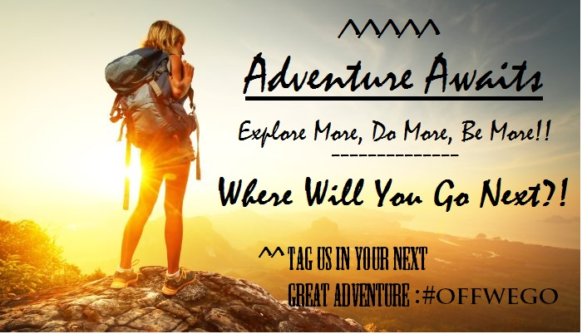

**Why Buy: “The Explorer”**

The Explorer is the perfect way to remember the exact place where you spent your last great adventure by retaining the exact coordinates with the jewelry. It is not only stylish but it also is a way to give back to conservation efforts while stimulating eco-tourism. It is the perfect gift idea for the adventurer that is living in as all.

**Team Project Summary**

There was some difficulty connecting with everyone on our team to get the project up and going. After messaging and texting Lauren and I connected and once we started to go work on the project everything else just fell into place. We talked several times to brain storm the project. After getting to know one another better we discovered that we both have a passion for traveling. Lauren also has a great business since about her and she was very easy to talk to about this. My work schedule was very busy and it was sometimes hard to get me on the phone but we made time for it.

The idea was to create something meaningful to that was unique to the places that people travel. Lauren has a love for jewelry and with that we created Off We Go: Bracelets & Couture. Once the had the business name and idea down we discussed several different types of jewelry. It took us about two hours to come with the bracelet idea from that came “The Explorer” Coordinates Bracelets. It is the perfect idea for Lauren and I it was truly a boundless collaboration for the fact that it really involved something that was evocative to us both.

We wanted to really make the bracelet something that not only was a great souvenir but something that was making a real change. So that is how we came up with the idea for a portion of the proceeds be donated to various organizations from the areas that you visited by giving back to conservation efforts and in addition stimulating eco-tourism. It is important to many people to give back to the places that they love.

After all of the obstacles were overcome this was a great experience. I am glad that I had the chance to work with Lauren on this project. This team exercise was very beneficial in many ways. One of them was learning to collaborate with someone that I didn’t know and being able to still work together to achieve our common goal.