6-6 An Integrative Case Study of LensCrafters to illustrate how goods and services are designed in an integrated fashion, we will study LensCrafters—a well-known provider of eyeglasses produced “in about an hour.” We use the framework for goods and service design shown in Exhibit 6.1.

Steps 1 and 2—Strategic Mission, Market Analysis, and Competitive Priorities

LensCrafters (w­w­w­.­l­e­n­s­c­r­a­f­t­e­r­s­.­c­o­m) is an optical chain of about 860 special service shops with on-site eyeglass production capabilities in the United States, Canada, and Puerto Rico. All resources necessary to create and deliver “one-stop-shopping” and eyeglasses “in about an hour” are available in each store. LensCrafters' mission statement is focused on being the best by creating customers for life by delivering legendary customer service, developing and energizing associates and leaders in the world's best work place, crafting perfect-quality eyewear in about an hour, and delivering superior overall value to meet each customer's individual needs.21

Step 3—Customer Benefit Package Design and Configuration

Our perception of the LensCrafters customer benefit package is the integrated set of goods and services depicted in Exhibit 6.11. The primary good (eyewear) and the primary service (accurate eye exam and one-hour service) are of equal importance. Peripheral goods and services encircle the primary ones to create “a total LensCrafters' experience.” GWImages/S­h­u­t­t­e­r­s­t­o­c­k­.­c­o­m Exhibit 6.11 One Example View of LensCrafters' Customer Benefit Package © Cengage Learning 2013

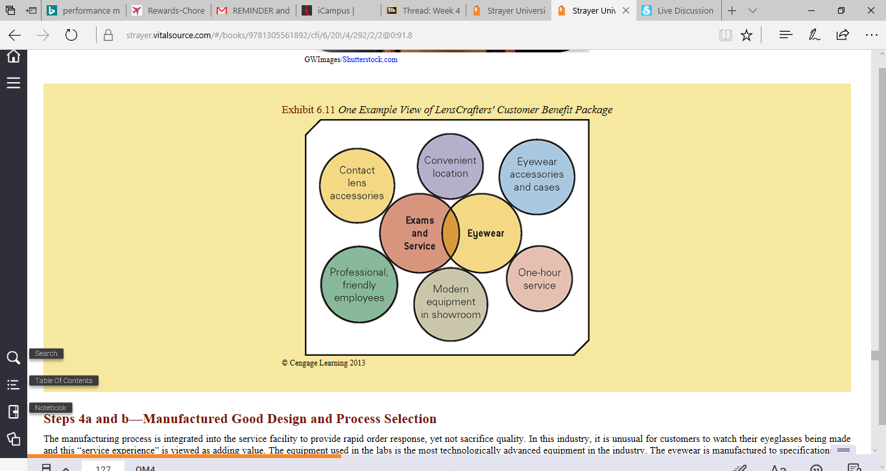

Steps 4a and b—Manufactured Good Design and Process Selection

The manufacturing process is integrated into the service facility to provide rapid order response, yet not sacrifice quality. In this industry, it is unusual for customers to watch their eyeglasses being made and this “service experience” is viewed as adding value. The equipment used in the labs is the most technologically advanced equipment in the industry. The eyewear is manufactured to specifications in a clean, modern, and professionally run facility. Other issues that LensCrafters would need to consider in designing its manufacturing processes are the following: How are eyeglass lenses and frames ordered? Are these materials ordered by individual stores or consolidated by region/district? How can the high quality of eyewear be ensured? What new materials are available? What items should be stored at the region/district warehouse and stores? What type of purchasing and inventory control systems should be used? How should supplier performance be evaluated? What eyewear-making equipment should be used? What is the latest technology? Which equipment is most flexible? Should the equipment be purchased or leased? How should it be maintained and by whom? What is the most efficient production procedure to make the goods and meet time schedules? Where should quality be checked in the manufacturing process?

Step 4c—Service-Delivery System Design

The service-delivery system, as evidenced by the location and layout, servicescape, service processes, job designs, technology, and organizational structure, is combined into an integrated service-delivery system. LensCrafters' stores are located in high-traffic areas such as shopping centers and malls within 5 to 10 miles of the target market. A typical store layout is shown in Exhibit 6.12. The servicescape is designed to convey an impression of quality and professionalism. The store is spacious, open, clean, carpeted, with professional merchandise display areas, modern furniture in the retail area, and modern equipment in the laboratory, technicians in white lab coats, shiny machines in the lab, and bright lights throughout. The store display cases, eye examination areas, and fitting stations are in the high-contact area where customers and service providers interact frequently. Optometry degrees, certifications, and licenses hanging on the wall provide physical evidence of employees' abilities. A greeter directs each customer to the appropriate service area as he or she enters the store. The low contact area of a LensCrafters store—the optical laboratory—is separated from the retail area by large glass panels. The optical laboratory becomes a “showroom” where the customer's perception of the total delivery process is established. The store is a service factory. The typical service process begins when a customer makes an appointment with an optician and continues until the eyeglasses are received and paid for. Between these two events, the customer travels to the store, parks, receives a greeting from store employees, obtains an eye examination, selects frames, is measured for proper eyeglasses and frame fit, watches the eyeglasses being made in the laboratory, and receives a final fitting to make sure all is well. Information flow in the forms of prescriptions, bills, and receipts complements the physical flows of people and eyewear. Exhibit 6.12 A Schematic View of a Typical LensCrafters' Store Layout © Cengage Learning 2013 Step

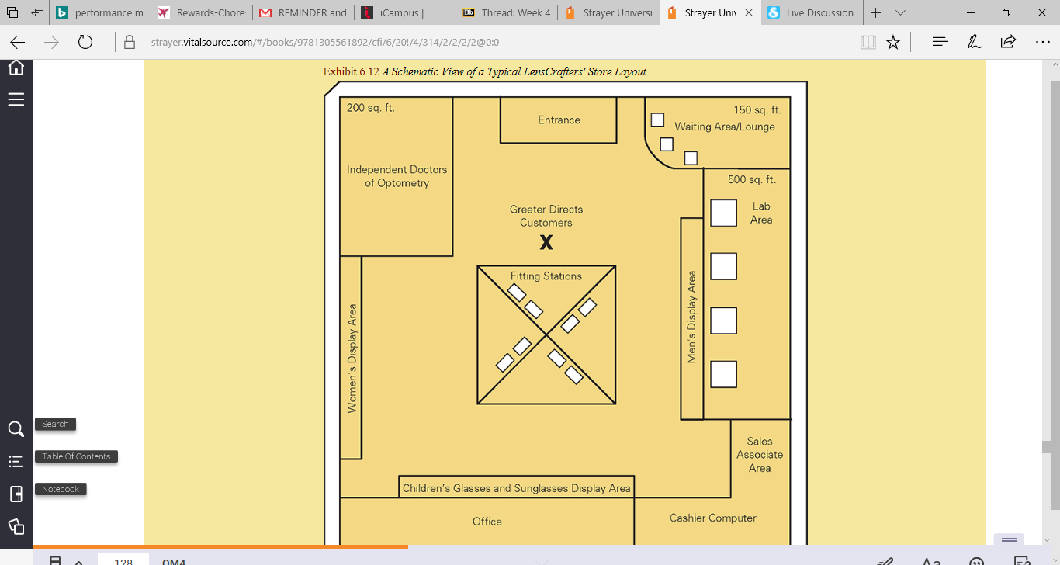

4d—Service Encounter Design

Each job at LensCrafters—sales associate, lab technician, and doctor of optometry—requires both technical skills and service management skills. Associates are well trained, friendly, and knowledgeable about their jobs. The lab technicians are certified in all work tasks and processes. Many associates are cross-trained. At the service-encounter level, key issues that managers need to consider include the following: What human resource management processes and systems will ensure hiring the right people, training them properly, and motivating them to provide excellent service? What recognitions and rewards should be provided? How are associates trained to handle service upsets and service recovery? What standards should be set for grooming and appearance? What behavioral standards, such as tone of voice, physical mannerisms, and the words that associates use in customer interactions, should be set? How should employee performance be measured and evaluated? What can be done to make the one-hour wait a positive experience for customers? LensCrafters reinforces its customer benefit package with a comprehensive 30-day unconditional service guarantee design defined as follows: You buy a pair of glasses at LensCrafters and then you think, ‘Maybe red's not my color.’ Or, you question, ‘Wow, should I have gotten the antireflective coating?’ Or after wearing them for a while you realize, ‘These really aren't going to be comfortable enough to wear every day.’ Whatever your reason, if you don't completely love your eyeglasses or prescription sunglasses, you can exchange or return them for a full refund at LensCrafters—no excuses, no explanations. That's what our 30-Day Unconditional Guarantee is all about—giving you peace of mind with every pair. So how does it work? Simple. Just return your eyeglasses—in their original condition—to LensCrafters within 30 days. We'll exchange them for a new pair or refund your money. Why do we do it? Because LensCrafters stands behind each and every pair of our glasses. And we want to make sure you simply love them. What does ‘Unconditional’ really mean? The 30 days begins on the date you actually receive your eyeglasses. You can return or exchange your new eyewear as many times as needed within the 30-day time period. However, the 30 days does not start over with each return or exchange. If you exchange your purchase for a pair at a lower price, we'll refund the price difference. If you exchange your purchase for a pair at a higher price, you'll only pay the price difference. If your eyeglasses get broken, you can use our 1-Year Replacement Discount.22

Steps 5 and 6—Market Introduction/Deployment and Evaluation

Although the company has been around for some time, it undoubtedly faces challenges in replicating its design concept in new locations. On a continuing basis, as technology and procedures change, LensCrafters will have to develop processes to introduce changes into all existing locations to maintain operational consistency and achieve its strategic objectives. For example, how might it react as competitors such as Walmart enter the optical industry? As you see, LensCrafters, manufacturing and service design depends on a variety of operations management concepts, all of which are integrated and support a rather complex customer benefit package.