Task Organization of Unit to Conduct Operation

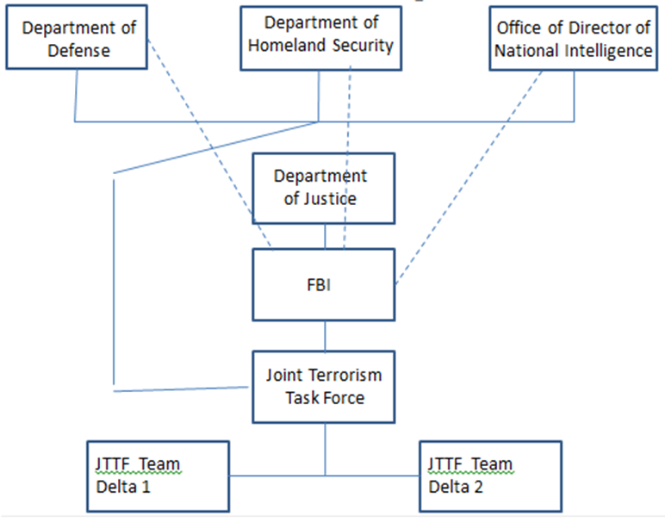

- Analysis of the current situation:
Terrorism is defined as the use of threats and violence in intimidating or coercing in the pursuit of political aims especially against civilians (Bovenkerk & Chakra, 2004). Organized crimes refer to criminal activities which are performed on a large scale and controlled and planned by powerful groups. The organized groups and terrorism of today are so similar that their commonalities are becoming clearer and their differences are beginning to blur. Organized crimes and terrorism is an ideal match which may have different goals, but they can achieve their objective through each other. The effects of technology and globalization, financial institutions, recruiting tactics, methods they share and use to achieve a task in support of each other, and the underground networks are the major similarities. In the world of today, terrorism and organized crime do not survive without each other. Their ideologies are becoming so indifferent and their methods are similar. Terrorist will sometime carry out attacks like illegal activities, contraband smuggling, bank robberies and kidnapping only for capital benefits to further their intentions (Bovenkerk & Chakra, 2004). The organized crime groups commit criminal activities to gain money for power.
  - Discussion of possible or actual terrorist threats to an area of the U.S. or U.S. interest.
Al Qaeda commonly referred to as the Islamic State of Iraq and the Levant refers to a powerful terrorist militant group with specifically violent ideologies which call themselves caliphates and claim religious authorities over all Muslims. It is a Terrorist Organization that was started and motivated by al Qaida. Al-Qaeda is a powerful Sunni jihadist group which has put under control large Middle East areas under their governance (Bovenkerk & Chakra, 2004). Infamous for its murderous as well brutal violence, this terrorist organization and caliphate have accepted the responsibility for various suicide bombers attacks and other terrorist bombings worldwide; together with the destruction of artworks from antiquity, building and ancient buildings, as well as priceless monuments.
      - Terrorist organization’s identified or implied mission and objective(s) against the U.S.
Al Qaida is also referred to as “Salafist jihadists” dedicated to what they view as initial definition of Islam sacred texts that include Quran (Bovenkerk & Chakra, 2004). They unite that with a belief that the U.S is the greatest enemy and threat of their faith and a total dedication to violent jihad. The terrorist organization is barbaric psychopaths’ collection willing to participate in the sordid and most brutal violence forms without any hesitation of normal human morality born. The greatest enemy ISIS or Al Qaeda is the U.S and its allies. The other enemies of are the Salafis, the Arab oil sheiks, all Shiites, the Iran government and its military, the government of Iraq and its military, as well as the Syria government and its military. Al Qaeda has the right of declaring any group outside their true faith and therefore allowing for the execution for those states that do not support their philosophy known as takfir (Bovenkerk & Chakra, 2004). Takfir implies those activities which pose threat to all the Muslims.
      - Cell structure composition (types of specialists involved) and disposition (geographical or specific locations).
Al Qaeda adopted the vertically integrated bureaucratic model for its leadership and management (Bovenkerk & Chakra, 2004). The bureaucratic model of al-Qa'ida resembled the ideal structure of ISIS operatives described in the memo. However, the management and organization structure is a replica of the structure at the local level to execute territorial management and controls. The terrorist organization had subdivided Iraq into particular sectors by 2008. However, the group struggled to fill the designated positions at the level of sub-national. With the security and intelligence personnel dominated by Iraqi members as well as corps of suicide-bombers from the organization rationally allocates its human capital. Nevertheless, the foreign fighters’ majority are not suicide bombers (Bovenkerk & Chakra, 2004). The requirements of information reporting and management of the powerful Sunni jihadist group appears quite systematic for Al Qaeda.
      - Reporting structure (names of leaders and team/cell members).
Islamic State of Iraq and Syria (ISIS) roots can be traced back when this powerful Sunni jihadist group was referred to as the “al Qaeda in Iraq” (Bovenkerk & Chakra, 2004). The powerful militant ground was discovered by Abu Musab al-Zarqawi who was initially part of al Qaeda Network of Osama bin Laden. The Iraq invasion by the United States started in 2003 and the al Qaeda aim in Iraq was to eliminate the occupations of the Western and substitute it with the regime of a Sunni Islamist. In 2006, Egyptian Abu Ayyub al-Masri took the power of al Qaeda when Zarqawi was murdered during the airstrike of a United States and he rebranded the group as the Islamic State of Iraq (ISI). Masri died in 2010 in operations of United States-Iraqi. Abu Bakr al-Baghdadi became the new leader after the death of Masri. The Islamic State of Iraq fought against the forces of Syria when the civil war in Syria began, gaining ground throughout Syria (Bovenkerk & Chakra, 2004). The terrorist organization was officially renamed in 2013 as the Islamic State of Iraq and Syria since Syria had joined the group.
      - Communications strategy and methodology.
Al-Qaeda runs powerful propaganda machines on the social media platforms that appeal for the young individual (Bovenkerk & Chakra, 2004). The organization uses appealing propaganda machine to persuade the youths to join the group. Using high-level techniques of production, Islamic State of Iraq and Syria (ISIS) has continuously promoted to celebrate their brutalities. The terrorist organization promises a good life to the youths and even offers them gifts when they join the militia group. It appeals to religious idealism of young people and to their desires to escape life frustrations. The organization offers the deluded young women and men with adventurous trips. The loyalists of ISIS receive gifts as allegiance reward from Allah that includes a house with free water and electricity (Bovenkerk & Chakra, 2004). The organization has an efficient and diffused network of recruitment.
      - Types of threat capabilities available to the organization.
The Middle East countries do not support the activities of the al Qaeda. The nations have been briefly united to fight against the common course of eliminating the activities of the ISIS. Almost every important entity in Iraq and Syria supported the anti-ISIS campaigns even though they did not always coordinate directly (Bovenkerk & Chakra, 2004). The factions of Kurdish which detested each other, worked against Islamic State of Iraq and Syria (ISIS). So did the Damascus, Baghdad and Iraq Kurdistan and may of ISIS opponents fought against its brutal activities in the Middle East.
      - Terrorist organization’s center of gravity (critical vulnerability that when destroyed or disabled make the organization ineffective).
In the whole universe, Al Qaeda has been known as the richest organization of terrorists. In 2014 alone, the terrorist organization was said to have acquired and made about $ 2 billion, even though these are just estimates (Bovenkerk & Chakra, 2004). Much of the funds of the Islamic State of Iraq and Syria have originated from seizing assets, control of financial institutions such as banks, and oil refineries in the territories that are under its control.
  - Discussion of Nexus between terrorist organization(s) identified as a threat and organized crime (OC)/transnational organized crime (TOC) organization(s).
Russian Organized Crime (ROC) is an umbrella slogan which confines various criminal activities and crime groups.
      - OC/TOC organization’s vision and mission for its illegal business enterprise.
The major vision and mission of Russian organized crime is to use violence and threats to intimidate their opponents. Violence and threats are utilized in gaining and maintaining criminal markets control. Retributive violence is applied between and within Russian organized group (Bovenkerk & Chakra, 2004). The common violence application is not shocking because protection rackets and extortions are such Russian criminal activity staple. Extensively, Russian Organized Crime has engaged in arson against businesses, whose owners refuse to settle the money for extortion, contract murders, and kidnapping.
      - Organization’s composition (structure) and disposition (geographical locations).
It is approximated that about fifteen of the loosely classified criminal groups are under Russian Organized Crime and are operating in the U.S. They maintain an association with Russia. The approximated membership of Russian Organized Crime is five to six thousand members (Bovenkerk & Chakra, 2004). Currently, it is estimated that two hundred Russian Organized Crime groups operating in fifty-eight nations in the whole world that include the U.S.
      - Reporting structure (Leaders and organization members).

The forms of criminal organization and the forms in some instances here differ from those of Russian Organized Crime (ROC). This may be a result of criminal opportunities and external environments (Bovenkerk & Chakra, 2004). There is not a particular organizational structure due to the proliferation of the groups which can be delineated as if it describes a single criminal.
      - Communications strategy and methodology.
The organized crime group has earned recognition for videotaping their brutal crime activities and spreading them virally through the use of social media sites such as YouTube, Twitter, and Facebook (Bovenkerk & Chakra, 2004). The group uses such scary and threatening videos to intimidate their opponents and to spread propaganda of their superiority ability.
      - Identified nexus between the OC/TOC organization and the terrorist organization
There is a big difference between Al Qaeda and Russian Organized Crime is totally two different organizations (Bovenkerk & Chakra, 2004). In the 1980s, out of anti-Soviet jihad in Afghanistan, Al Qaeda emerged. Osama bin Laden and his close associates decided to take advantage of the networks they had created in taking jihad international. The vision of Osama was to build elite fighters vanguard which could lead the international jihad projects in a strategic and clear direction. His objective was to unite under one umbrella the small teams of jihadist that are often feebly and struggling against their own regime. Osama wanted to reorient the entire movements in the mid-1990s that concentrating it on the United States that he viewed as the biggest enemy and to underwrite all the corrupt domestic regimes. The emphasis of Al Qaeda was to fight their biggest far enemy that was the U.S and near enemies that were repressive regimes in the world of Muslims (Bovenkerk & Chakra, 2004). On the hand, the biggest mission of Russian Organized Crime is to engage in arson against businesses, whose owners refuse to settle the money for extortion, contract murders, and kidnapping.
      - Impact of risk related to the nexus.
Russian organized crime group has had no or little political in the U.S in contrast to their persistent political influences in Russia and other former Soviet Union republics. The Russian criminals have not cultivated law and political enforcement contacts even though they have the financial strength of doing so. There have been no reported judicial or police corruption cases (Bovenkerk & Chakra, 2004). There is no evidence that Russian Organized Crime groups have tried to influence either the American political processes or politicians and that they have been in a position to manipulate matters of media coverage. Likewise, there is no proof o any associations between political terrorism and Russian organized crime in the U.S.
      - What is the illegal activity (…ies) of the OC/TOC and level of participation?

Around the world, Russian Organized Crime group is recognized for performing heinous violence acts that include crucifixions, beheadings, rapes, as well as public executions.
      - OC/TOC organization’s center of gravity (critical vulnerability that when destroyed or disabled make the organization ineffective).
The powerful organized group has also utilized support for foreign fighters and sympathizers, lootings, donations, stolen artifacts, extortions, taxes, and kidnapping ransoms to fill its coffers. The militia organization demonstrates sophisticated financial management as with the current day Russian State.
  - Threat assessment and identification of potential targets to include type(s) of threat medium and corresponding deliverable(s).
      - Type of threat(s).
Fire-raising against organizations that their owners refuse to settle the payment for extortion, contract murders, and kidnapping
      - Delivery means.

The group has captured and released various images and videos documentations to show brutal executions, rape, beheadings, and crucifixions. Some of these documentations have gone viral in the social media platforms to intimidate their target groups.
      - Date, time group (DTG) of potential terrorist attack.
The attacks are likely to take place from 1st June to 6th July 2018
      - Location(s) of possible attack(s).
The Chicago City and Tucson
      - Potential after effects of attack(s).
Loss of life and destruction of property
- MISSION of the Operation (Who, what, when, where, and purpose/end state).
Cause fear and terror
- Strategies for countering the identified organizations.
Destroy cells of the terrorist, apprehend those infiltrating the U.S and carry out counterterrorist operations in the in the Chicago and Tucson vicinity.
Strategic Operational Plan Proposal Reviewed by:____Nico Hawkins____________________________
(Instructor’s Name)
APPROVED/DISSAPROVED
Date/Time:_January 22, 2019_________________/______2000_____hours.

References
Bovenkerk, F., & Chakra, B. A. (2004, December). Terrorism and organized crime. In Forum on Crime and Society (Vol. 4, No. 1-2, pp. 3-15).

