Discussion 5.1: Nash Equilibrium

Nash Equilibrium (Continued)

Please read the remainder of Chapter 4, *The Art of Strategy,*starting from "Games with Infinitely Many Strategies" on page 124.

**Infinitely Many Strategies**

Suppose each player’s strategies are the interval [ 0, 10 ]; each one chooses a number between 0 and 10. Then we can’t depict the game as a matrix with its cells showing the payoffs from each pair of strategies. But if each player has a unique best response to the other’s strategy, their reaction functions can be plotted as curves.

**Reaction Curves**

Since a Nash equilibrium is a pair of strategies such that each is a best response to the other, it must be the intersection of the two reaction curves.

**Nash Equilibrium: A Formal Definition**

John Nash defined this concept of equilibrium and proved that most regular games possess such an equilibrium. So if we accept a Nash equilibrium as a metaphor for how a game will be played by rational individuals, it provides us with a theory that can be applied to many situations.

A best reply (or response) refers to a strategy that is best given the strategy of the other player. A dominant strategy refers to a strategy that is best regardless of the strategy of the other player. A play of the game where each strategy is a best reply to the other is a Nash equilibrium.

A game with two players, A and B, is defined as (XA,XB,uA,uB) where Xi is i’s strategy set and ui is i’s utility function. A typical strategy of player i is xi in Xi. A pair of strategies (xA,xB) is called a strategy profile. The utility function of each player is defined over all strategy profiles. Thus uA(xA,xB) is A’s utility when A chooses xAand B chooses xB. A strategy profile (xA∗,xB∗) is a Nash equilibrium if uA(xA∗,xB∗)≥uA(xA,xB∗) for all xA in XA (xA∗ is A’s best reply to xB∗) and uB(xA∗,xB∗)≥uB(xA∗,xB) for all xB in XB (xB∗ is B’s best reply to xA∗).

 Nash proved that in every game (satisfying some regularity properties) there exists at least one equilibrium.

Proof: The proof uses advanced mathematics ( a fixed point theorem) and we will not attempt it, but Nash provided a short proof.

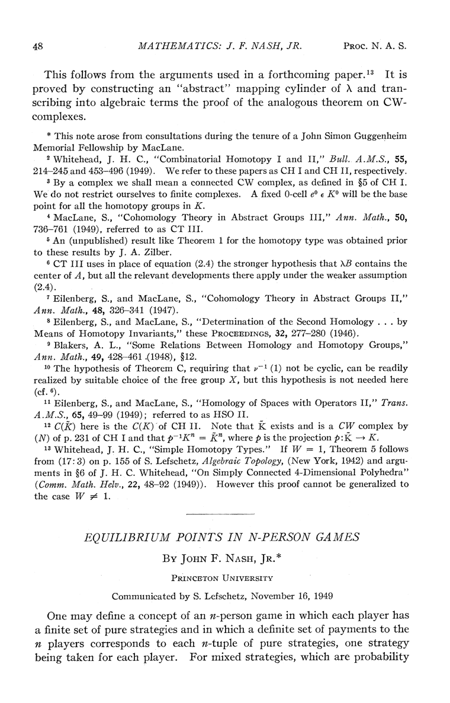

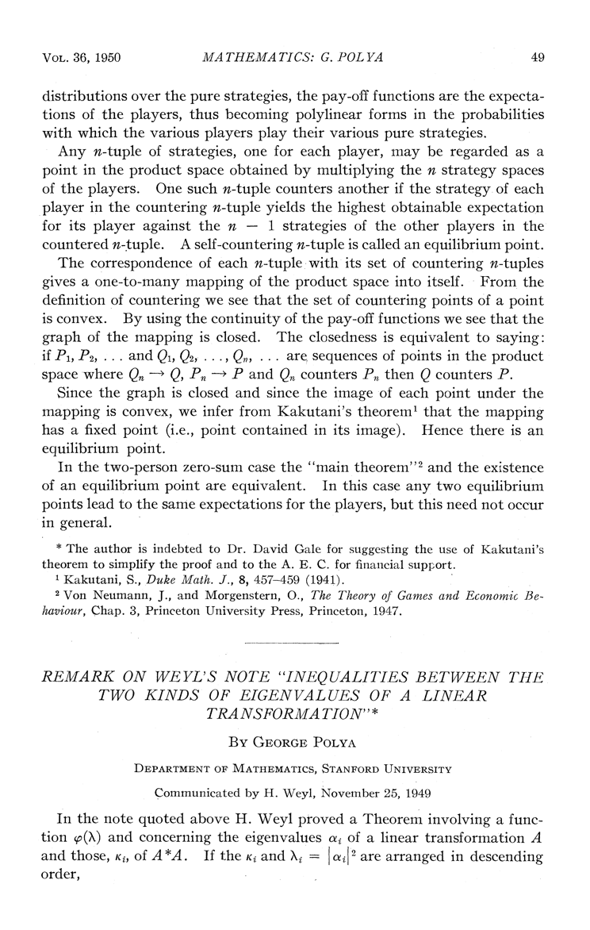

In the movie, “A Beautiful Mind”, Russell Crowe plays Nash and here is a clip that seems to portray his eureka moment, and an attempt at explaining the notion of a Nash equilibrium.

Before you view the clip, recall that in the theory of perfect competition, each firm seeking to maximize its own profit also serves the social good (social surplus is maximized) -- this is Adam Smith’s theory. But in the prisoner’s dilemma, and in many other games, individual rationality does not serve the social good.