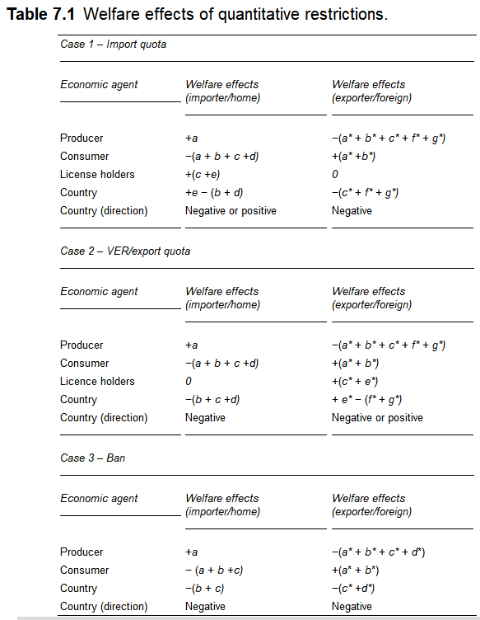

7.2.2 Case 2: What are the effects of an export quota (or voluntary export restriction) imposed by a large exporter?

In this section we consider the case where the *export quota* or *VER* is imposed by a large country. This case is nearly identical to the preceding one. The prominent difference is that the exporter, rather than the importer, imposes the restriction. The other prominent difference is that the license holders to the rents tend to be the firms or government of the exporting country, rather than the importing country. Thus, the welfare effects of the policy are altered by the nationality of the license holders.

Figure 7.1 can be used again to illustrate the markets for the good in the large country case. We can introduce an export quota or VER into this simple framework in Panel (b) of Figure 7.1. This export restriction essentially creates a “quantity limit” on the good supplied and demanded in the international market in the same way as the import quota. The size of the export quota or VER is the horizontal distance *q* in Panel (b). All of the price and quantity effects of the previous case apply as a result of this export restriction, so we do not repeat them here.

The welfare effects of the export quota or VER for the home and foreign countries can also be seen in Figure 7.1 and are summarized in Table 7.1 (Case 2). Panel (a) of Figure 1 shows the welfare effects for the importing country. As shown, the producer’s welfare increases by the surplus amount +(*a*) as a result of the export quota or VER. The consumer’s welfare decreases by the surplus amount −(*a* + *b* + *c* + *d*). The net country welfare then is the sum of the producer, consumer, and license holder welfare changes. If we assume that the license holders to the rents are foreign firms or the government of the exporter, then we cannot include the rent in our calculation of the home country’s welfare. Rather, the net welfare effect for the home country is −(*b* + *d* + *c*). Area −(*c*) is a welfare transfer from the importing country to the exporting country. Areas −(*b* + *d*) are deadweight losses incurred by producers and consumers. Area −(*b*) is a *production distortion* and area −(*d*) is a *consumption distortion*. In net, the importing country is unambiguously worse off as a result of the export quota or VER.

Panel (c) shows the welfare effects of the export quota or VER for the exporting country. As shown, the producer’s welfare decreases by the surplus amount −(*a\** + *b\** + *c\** + *f\** + *g\**) as a result of the restriction. The consumer’s welfare increases by the surplus amount +(*a\** + *b*\*). Assuming that license holders are of foreign nationality, then the rents are +(*c\** + *e\**). The net country welfare then is the sum of the producer, consumer, and license holder welfare changes. Adding these effects together, we get +(*e\**) − (*f\** + *g\**). Area +(*e\**) is a *net transfer* of license rents from the importer to the exporter. This transfer is net of the terms of trade effect. Areas −(*f*\* + *g\**) are deadweight losses incurred by consumers and producers. Area −(*f*\*) is a *consumption distortion* and area −(*g*\*) is a *production distortion*. As shown, the exporting country is worse off as a result of the restriction if the distortions exceed the net transfer from the importer to the exporter, and vice versa.

7.2.3 Case 3: What are the effects of a ban imposed between two large countries?

In this section, we consider the case where a ban or embargo is imposed between two large countries. Figure 7.2 shows the markets for the good in this large country case.

**Figure 7.2**  Ban – imposed by a large country.

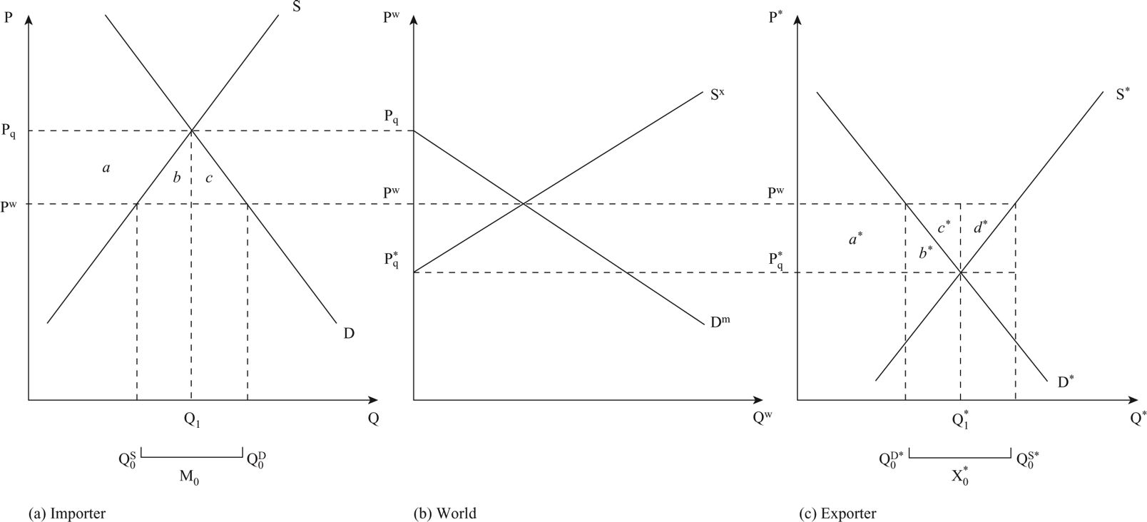

As before, the intersection of import demand and export supply in Panel (b) determines the equilibrium world price (Pw). The equilibrium world price is where the quantity of import demand by the home country equates with the quantity of export supply by the foreign country. At this equilibrium world price, the quantity of imports (M0) in Panel (a) equates with the quantity of exports (X0*) in Panel (c). The quantity of imports in Panel (a) is the excess of demand (Q0D) over supply (Q0S) at the world price. Similarly, the quantity of exports in Panel (c) is the excess of supply (Q0S*) over demand (Q0D*) at the world price.

We can now introduce a ban into this simple framework in Panel (b) of Figure 7.2. A ban essentially creates a “zero quantity limit” on the good supplied and/or demanded in the international market. That is, the ban restricts the quantity of the traded good between the two countries to zero. We can imagine placing a zero quantity limit on import demand and/or export supply in Panel (b). The effect is that prices for the good revert to the autarky prices of the two countries. When we impose a ban, the price of the good increases from the world price (Pw) to a higher price (Pq) on the restricted good in the home country. This corresponds with a movement along the import demand curve (in Panel (b)) and a decrease in the quantity of imports demanded by the importing country.

From the exporter’s point of view, the price of the good decreases from the world price (PW) to the new lower price after the ban is in place (P*q). This corresponds with a movement along the export supply curve (in Panel (b)) and a decrease in the quantity of exports supplied by the exporting country. In this case, the price effect of the ban is shared by both the importing and exporting countries. This price sharing occurs irrespective of which country imposes the ban. The sharing of the price effect occurs because the trading partners are large.

The ban also affects the quantities of the good supplied, demanded and traded in both the home and foreign countries (in Panels (a) and (c), respectively). The home country experiences an increase in the quantity supplied domestically (Q0S to Q1) and a decrease in the quantity demanded domestically (Q0D to Q1). In contrast, the foreign country experiences a decrease in the quantity supplied domestically (Q0S* to Q1*) and an increase in the quantity demanded domestically (Q0D* to Q1*). Consequently, both countries experience a decrease in trade. The home country’s imports decrease (M0 to zero) and the foreign country’s exports decrease (X0* to zero).

Intuitively, the effects of a ban on prices and quantities tell us about the impact on both producers and consumers. At home, producers are supplying more in their domestic market at a higher price. They have gained from the ban in terms of revenue from sales of the good. At home, consumers are demanding less at a higher price. They have lost from the ban in terms of the cost of the good. Alternatively, in the foreign country, producers are supplying less at a lower price. They have lost. And foreign consumers are demanding more and a lower price. They have gained. Further, the mix of consumption of domestic and traded goods changes as a result of the ban. Consumers in the home country now consume more domestically produced goods and no imports. Consumers in the foreign market continue to consume only domestically produced goods, but more of them.

The welfare effects of the ban for the home and foreign countries can also be seen in Figure 7.2 and are summarized in Table 7.1 (Case 3). Panel (a) of Figure 7.2 shows the welfare effects for the importing country. As shown, the producer’s welfare increases by the surplus amount +(*a*) as a result of the ban. The consumer’s welfare decreases by the surplus amount −(*a* + *b* + *c*). The rent associated with the ban is zero. The net country welfare then is the sum of the producer and consumer welfare changes. Adding these effects together we get −(*b* + *c*). These areas are deadweight losses incurred by producers and consumers. Area −(*b*) is a *production distortion* and area −(*c*) is a *consumption distortion*. In net, the importing country is unambiguously worse off as a result of the ban.

(Smith 153-157)

Smith, Pamela J. *Global Trade Policy: Questions and Answers*. Wiley-Blackwell (STMS), 2013-09-09. VitalBook file.