Instruction Manual
Name
Course
Tutor
Date

Instruction Manual
Introduction
Flat tires can occur anywhere during any normal drive. With this being prepared for these to happen should always be in the driver's mind. Before one starts to change a flat tire, there are some considerations that should be met. These includes in one has never changed a tire before it is advised to practice run. In this case, use a flat surface for safety reasons. Consider checking the car tires on a regular basis to ascertain that the tires are within the expected pressure range and they are not deflated. The car comes with a manual which should be used as the guide process towards successful changing of the tires in a given situation. The ordeal of changing a car tire should not bring any worries when it happens instead one should focus on the process.
Background information
They are some factors that damage tires. These factors include; physical factors such as age. Second is the road condition such as the presence of potholes. Climate is another great contributor with elements such as extreme temperatures and snow. Driving habits also influence due to elements such as over speeding and breaking (Liu et al 2014). Neglecting basic tire maintenance: such as air pressure and failure to balance the tires are major causes of damage. The process of changing a flat tire should take about 20 minutes or even less. There are no specific skills required that are required in the process of changing a tire, but the ability to use car jerks and differentiating between clockwise and anticlockwise should be vital in the process. It is important to note that one can never drive with a flat tire and hence change is mandatory (Prochowski, et al 2015). In setting the stage to try to drive the car to a flat place where changing can occur quickly.
Equipment and requirements
- A jack
- A lug wrench with a socket on one end and a pry bar on the other
- A spare tire
- A wheel lock
- Extension bars for lowering the spare tire
- Alignment studs
The last three equipment depend on the car model.
Definition
- A car jack is a tool that allows a person to lift a car off the ground in the process of making repairs or changing tires.
- A lug wrench is a type of socket wrench used to chosen and tighten a lug nut on the car wheels.
- A spare tire is a spare tire carried by car which is employed in the process of changing a damaged tire.
- A wheel lock is a particular type of lug wrench which is used to unlock a special lug nut used for security reason such as theft of car tires
Instructions
Car models differ in their wheel designs and fitting procedures. Depending on the producers of the car, the wheel features might be different. It preferably needs two people to comfortably change car tires however one can as well do it for the smaller vehicle models. Heavy vehicles are more demanding in their changing procedure due to weight and size.
- Place the vehicle is a fairly level or flat area and make sure there is no one inside before starting the process.
- Engage the handbrake and set the car on parking gear for automatic and in gear if manual. Thus makes sure in case of anything the car wheels are sure not to roll.
- Untie of unscrewing off the wheel cover in case there is one or the center cover for SUVs to make the wheel nut accessible.
- Before jacking the car, loosen the wheel nuts but do not remove them yet. If they are too tight, apply more energy and pressure using your leg.
- Place the car jack on the jack point of the car and lift the car slowly. Remember to place the jack on a firm flat ground for effectiveness and safety. Car manuals show jack points for assurance.
- After it’s safely lifted, remove the nuts then remove the car wheel carefully by pulling it off the pins.
- Get the spare tire and with the aid of the other person if present, lift the spare to position.
- Return the nuts removed earlier each to its right place and tighten lightly.
- Loosen the jack to lower the car and tighten the nuts with more pressure where applicable. Legs can be used to enhance tightening.
- Refit the wheel cover or center cover and take the punctured wheel for repair if possible (Macek et al., 2014).
Car tyre changing instruction flowchart
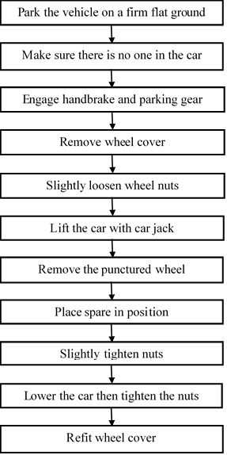

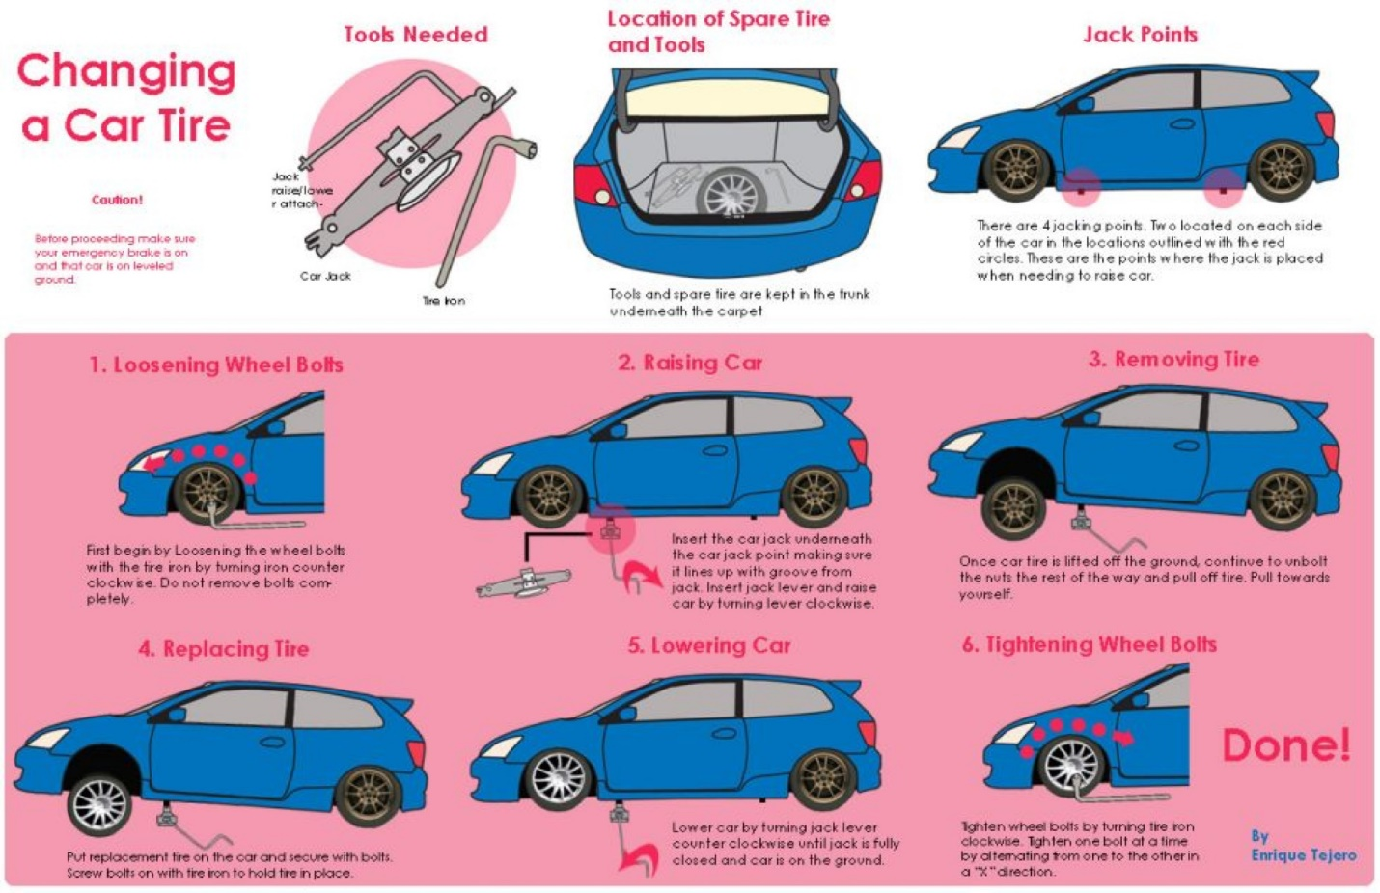
Warnings
- For safety purpose, one should at all times block the opposite side of the wheel being changed with a wheel block or boulder if necessary. It’s insurance for keeping the car in place while changing.
- Space saver wheels should not be driven for long distances or high speeds to avoid accidents.
- At all times, when changes tires, the car should be parked on a relatively firm flat ground and not overloaded.
- While the car is lifted, beware not to place your hands or legs beneath the wheels for safety.
- Changing of car tires regardless of the necessity should not be done on busy roads, and hazard lights should be on, and hazard indicators should be placed 10meters inform and behind the car (Macek et al., 2014).
References
Liu, H., Deng, W., Zong, C., & Wu, J. (2014). Development of active control strategy for flat tire vehicles (No. 2014-01-0859). SAE Technical Paper.
Macek, T., Labský, M., Vystrčil, J., Luksch, D., Kašparová, T., Kunc, L., & Kleindienst, J. (2014, September). Interactive Car Owner's Manual User Study. In Proceedings of the 6th International Conference on Automotive User Interfaces and Interactive Vehicular Applications (pp. 1-4). ACM.
Prochowski, L., Wach, W., Jackowski, J., & Pieniążek, W. (2015). Experimental and model studies on the influence of the run flat tire damage on braking dynamics of the multi-axial special purpose vehicle. Eksploatacja i Niezawodność, 17(1).

