Research Analysis for Business
Name
University Name
Course
June 23, 2017

Introduction
The organization chosen for the business analysis is Apple Inc. which has a particular niche in smartphones, IPad, iPod, and laptop. The purpose of developing any business strategy is to fulfill customer in particular niche markets. The growth of any business organization is also affected by both microeconomic and macroeconomic factors. The microeconomic factors include customer satisfaction, availability of qualified and motivated employees, thepresence of competitors, investors, etc. whereas macroeconomic factors include inflation, GDP, interest rate, federal fund rate, etc. The purpose of the paper is to apply the tools of microeconomic and macroeconomic data so that appropriate recommendations can be made regarding maximizing revenue, profit, and market share.

Market Structure Analysis
The headquarter of Apple Inc. is situated in Cupertino,California(US).Apple Inc. sells computer software, consumer electronics, and other online services. The company Apple Inc. is involved in the development and design of electronic devices like smartphones,tablets,laptops,etc. It was founded in 1976 by Steve Job, Steve Wozniak, and Ronald Wayne to develop and sell thepersonal computer. In Jan 1977 it was incorporated as Apple Inc. (Schneiders, 2011)
The market structure in which Apple operates is monopolistic in nature. The company could be considered as a large monopolistic competitive firm because there are a lot of buyer and seller. These sellers have a small market share and are independent. Also, in a monopolistic competition entry and exit of the company is easy. Apple Company has product differentiation.
In the sale of Personal Computers products, the company faces global and local competition from Dell,Acer,Hp,Sony, and Toshiba. Similarly,in the sale of smartphones company’s major competitor includes Samsung,Huawei,HTC,Lenovo, etc.The monopolistic market is qualified by thehigh cost of starting a business. Thebarriers of Appleis characterized by competition from a large number of competitive firms like Samsung, Alphabet Inc., HP, etc.

Current Macroeconomic Indicators

Current Stage of Business Cycle
It is the natural rise and fall of economic growth that occurs over time. The stages of business cycle serve as a useful tool for analyzing the economy. Further,the business cycle is characterized by four phases-expansion,peak,contraction, and trough. It is determined by National Bureau of Economic Research based on several monthly macroeconomic indicators using quarterly GDP growth rates. The US business cycle lies in the expansion stage for the last three years. (Nber.org).According to National Bureau of Economic Research, the Great Recession(2007-2009) was the last recession,and since then US economy is marked with expansion phase.

Real GDP
The real GDP is based on the US billion dollars and is seasonally adjusted. The Fig 1 below shows the trend of GDP of US for the past three years (quarterly).The figure shows GDP is increasing with respect to time.
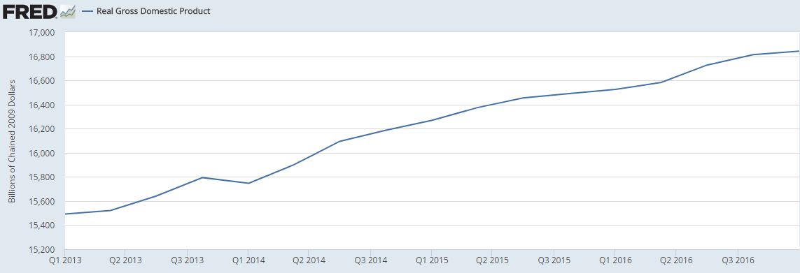
Fig 1.Real GDP trend of US from 2014 to 2016.

Inflation measured with CPIAUCSL
The inflation as measured by the CPI shows that it was minimum in 2015 which after that increases continuously.
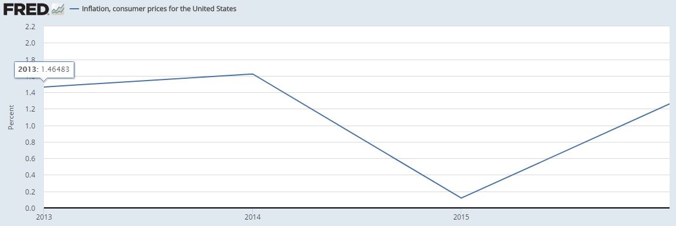
Fig 2.Inflation as measured by CPI

Unemployment rate
The unemployment rate shows a continuous decline from Jan 2013 till Jan 2017 as shown in Fig 3 below.
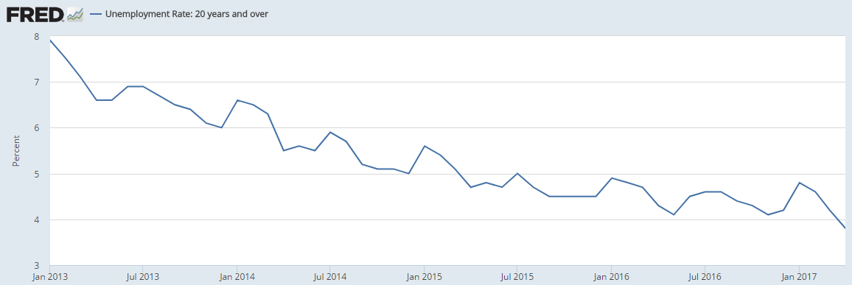
Fig 3.Unemployment rate from 2014 to Jan 2017

Federal Fund rate
The federal fund rate is the interest rate that one bank charges to another bank when the other bank needs it overnight. The money is taken from the Federal Reserve which requires banks to hold 10% of their amount. The trend of the federal fund's rate is shown in Figure 4.It shows an increasing trend till Jan 2017.
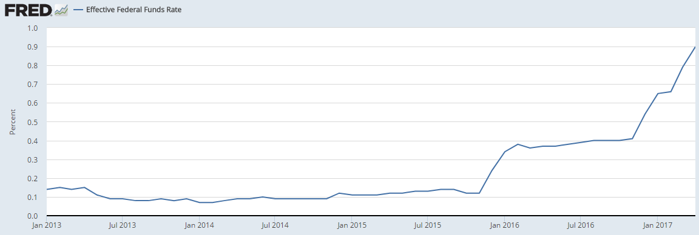
Fig 4.Effective federal fund rate from Jan 2014 till Jan 2017.

Prime Rate
The prime rate was constant till Sept 2016 and then showed an increasing trend as shown in Fig 6.
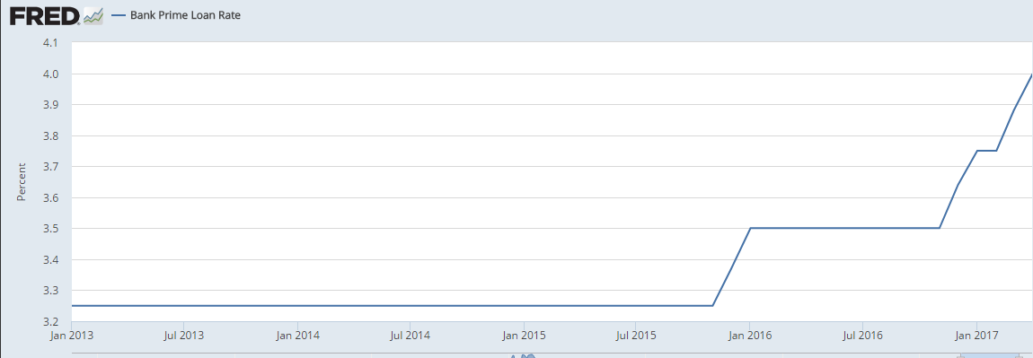
Fig 5.Prime rate trend from Jan 2014 till Jan 2017.

Trends in demand over last three years
The domestic demand is measured by the sum of investment, final consumption and stock building expenditure by the government. The trend in domestic demand for the US over the last three year is shown in Table 1.
The table 1 shows that the demand increased from 2.45% in 2014 to 3.22% in 2015.Further, domestic demand decreased from 3.22% in 2015 to 1.53% in 2016.The below table shows that due to increase in demand from 2014 to 2015 the sales of Apple products is expected to increase whereas it is expected to decrease in 2016.
Table 1
Domestic Demand of US
Year | Demand
2014 | 2.45
2015 | 3.22
2016 | 1.53
Note. Retrieved from Statistica.com
The quarterly sales data from Apple annual report shows that the first quarter sales in 2017 were $78.351 billion compared to $46.9 billion, denoting an increase of 67%. ("Apple - Annual Report,”N.p.)The annual sales for the last four year is shown in Figure 6.

Fig 6.Net Sales of Apple Inc.

The net sales for Apple Inc. for the last four-year increase in sales from 2013 till 2015 where the sales revenue of Apple Inc. declined in 2016.The trend matches with the US domestic demand as domestic demand also decreased from 3.22% in 2015 to 1.53% in 2016.

Price Elasticity of Demand
Price elasticity of demand of a particular product represents achangein the quantity demandeda particular product to the change in price. The formula gives it:
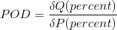
Where POD is the price elasticity of demand, Delta Q is the percent change in thequantity of theproductdemanded, and delta P is the percent change in theprice of product demanded.
In the case of Apple Inc., the price elasticity of demand can be calculated by looking at the two different price of the same product, and the quantity demanded at the given price for the same product. If the ratio of the change in quantity to the change in price is greater than 1, then the demand is elastic, and if the ratio is less than 1, then the demand is inelastic. An important factor that determines the price elasticity of demand for Apple is the availability and price of close substitutes. As the Apple products havenumeroussubstitutes, therefore the demand is sensitive to price change and hence elastic. The Apple Inc. company product is elastic. Therefore revenue can be increased by decreasing the price. As price is decreased, quantity demanded will increase at a greater rate leading to increasing revenue of the products.

Fixed and Variable Cost
The output decision of a firmis decided by the fixed and variable cost of the firm. A fixed cost is a cost that remains fixed and does not change with the level of production, whereas variable cost change with the production or output level of the firm. The fixed and variable cost affect the marginal cost of production which is the total cost by a unit-change in production level. When the company considers increasing the supply of Appleproducts, then the fixed and variable cost will increase. For example, if Apple opens more factories then they would have to pay more taxes on the land, pay wages to the worker, pay more insurance to the machinery, etc.Apple variable cost also includes spending money on research and development. Apple spends on R&D every year to make new improved products which are most application-user-friendly.
The labor, research and development and raw materials are a variablecost which greatlyaffects the output decisions. The fixed cost of the Apple Inc. include the rent paid which can also affect the output or production level

Conclusion
The above analysis suggests that there can be variousrecommendation possible for Apple Inc.A possible recommendation could be that reducing the price of the Apple products which are large compared to the price of Samsung products. Since Apple operates in a competitive environment, it is essential for them to follow competitive pricing strategy. Infact,Apple is considering this approach seriously and is trying to launch Apple products in a competitive market.
Also,there is a need to consider thetrend in economic data as the elasticityof demand for the product is sensitive and indicators like an increase in inflation rate, unemployment may cause a decline in the demand for the Apple products. The sales revenue data suggests that there is a decreasing trend in the Apple products as more and more people are now considering products having same features at a lower price.
Finally, the long-term sustainability of Apple Company can be achieved by maintaining and improving its market share, following corporate social responsibility, developing quality products and observing the set standard, policies and regulations.

References
"Apple - Annual Report." Investor.apple.com. N.p., 2017. Web. 23 June 2017.
"Consumer Price Index for All Urban Consumers: All Items." Fred.stlouisfed.org. N.p., 2017. Web. 14 May 2017.
Domestic Product - Domestic Demand Forecast - OECD Data". theOECD. N.p., 2017. Web. 15 May 2017.
"Effective Federal Funds Rate." Fred.stlouisfed.org. N.p., 2017. Web. 14 May 2017.
Nber.org. N.p., 2017. Web. 23 June 2017.
"Real Gross Domestic Product." Fred.stlouisfed.org. N.p., 2017. Web. 14 May 2017.
Schneiders, Sascha. Apple's Secret Of Success - Traditional Marketing Vs. Cult Marketing. Hamburg: Diplomica-Verl, 2011.
"Unemployment Rate: 20 Years and Over". Fred.stlouisfed.org. N.p., 2017. Web. 14 May 2017.

