In your text, you have read about the Bauhaus style. Here is the Bauhaus museum in Tel Aviv:
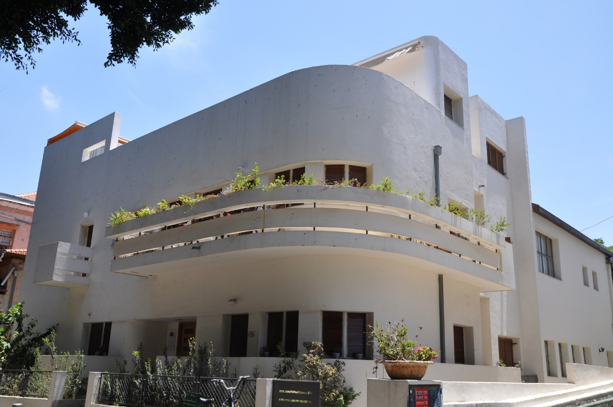

We began the course with the Egyptian pyramids which you can argue really don't connect to anything in the future - the Greek parthenon, the Roman pantheon and then an enormous leap to the medieval cathedrals . . . . the baroque palace . . . what happens in the 20th century? Do you see this style as a continuation of any one theme or principle? A complete rejection of the past?

