This assignment has three parts to it. Part 1 is its own while parts 2 and 3 relate to each other.

1. **Search** the Internet for a product or products upon which the U.S. Government has imposed an import tariff.

**Write** a paper of approximately 500 words describing how each tariff has impacted trade and other industries in the U.S.

**Format** your paper using *Writing Style Handbook* guidelines.

**Include** a minimum of two sources, which may consist of readings from the University Library, your text, and other selections.

1. **Choose** a final project topic from the suggested list (below).

**Define** the issue you plan to explore for your final paper assignment.  Explain why it is an important.  Also identify the geographic location where your analysis will apply: the U.S., a specific geographic region such as Latin America, or, identify if it is a global issue.

**Completely** define the issue in at least 50 words.

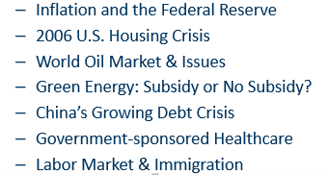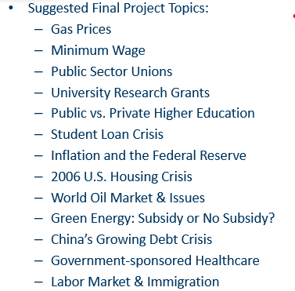

1. **Write** a paper of approximately 750 words that answers all of the following questions. Use the contemporary economic issue within your country or the world that you selected in step 2, along with your research, to inform your answers.
   * What is the economic issue?
     + Why is it important?
     + Which principles of economics apply? Choose from each of the areas: decision making, interaction, and how the economy works.
     + How do the forces of supply impact the issue?
     + How do the forces of demand impact the issue?
     + How does elasticity apply to the issue? If appropriate, include a calculation for elasticity.

* **Use** graphical representations of economic concepts such as supply and demand curves, equilibrium, elasticity, and cost curves to support your findings.
* **Determine** the theories of economics that apply (for example, theory of consumer choice, theory of the firm).
* **Compare** the issues faced in the economic issue chosen and how it relates to the economic topics discussed in the textbook and class. For example, do any of these concepts apply to the issue: efficiency of markets, costs of taxation, benefits of international trade, government interventions, and competitive markets, features of labor markets, macroeconomics data, monetary system, and economic fluctuations?
* **Recommend** strategies that could improve the situation.
* Format your paper using Writing Style Handbook guidelines
* Include a minimum of four (4) scholarly sources