**3 Day Food LogAssignment**

This assignment is designed to help you learn how to analyze your dietary intake. You can make changes using information found in our text book, government web sites and/or other credible web sites or sources. Although this is not an exact science, it is important that you track your intake as accurately as possible. You should then be able to identify foods you may want to eat more or less of based on the Dietary Guidelines, Choose My Plate and the Harvard Nutrition Source. Although you may find it challenging, do your best not to alter your eating habits while you are documenting your intake.

**Part 1**Do your best to track everything you eat and drink for 3 days. Try to include one day that has a different schedule or is less routine (eg: weekend day). Record everything that you eat and drink to include water. Get out the measuring cups and estimate portions. Write down the foods in portion sizes. The following list may help you to determine portion sizes if you are not familiar with portions sizes.

**Part 2**Analyze your three day food record using the SuperTracker online tool at<http://www.choosemyplate.gov> and respond the following.

* Enter your foods in for each day. Share how you did with each of the daily Food Group Targets. Also, how did you do with the nutrients to limit (added sugars, sodium, saturated fat)? Click on the Nutrient Intake Report. Discuss your status for macro and micronutrients. Should you make any adjustments?

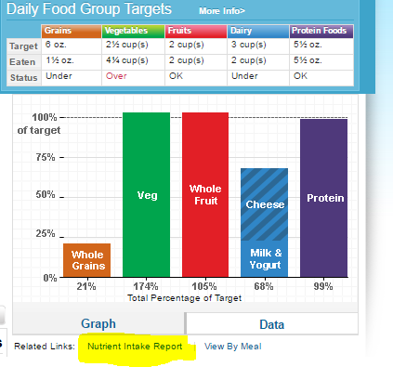

* Which foods do you get most of your protein from? What other protein foods might you try to substitute and why?
* Are any food groups lacking in your diet? How might you add more of them into your diet?
* What do you think about beverages in your diet? Do they have calories? How much water do you drink in a typical day?
* Which foods contribute healthy fats in your diet? What other foods might you try that provide heart healthy fats?
* Which foods have fiber in your diet? Do you need more fiber? If so, which foods might you add to help boost your daily fiber?
* What do you think about your diet overall? Which foods do you think you should eat more of? Any foods you think would be beneficial to cut back on?
* Healthy eating takes planning and that starts with a well thought trip to the grocery store. What’s your biggest challenge or barrier to eating healthy most of the time? If you feel you already have a mostly nutritious diet, what tips or strategies would you suggest to someone who is trying to eat healthier?