Hi Team,
Below are the links for the templates we will use for the assignment. If you do not see a picture below the link, it was because it was too much to copy so just copy and paste the link into the browser to view the template. If you see a picture below the link, you may of course use the picture to gather the needed info or again, copy and paste the link into your browser.
~Winda

Marketing Strategy Templates:
- https://www.business.com/articles/sample-marketing-plan-outline-and-template/

- https://www.pinterest.com/pin/342203271663700941/
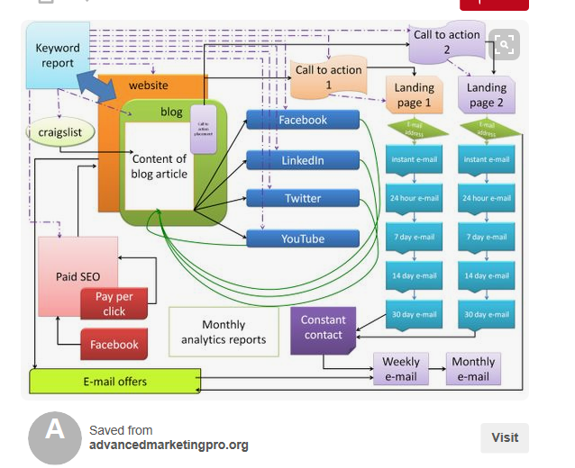

Communication Strategy Templates
- https://www.template.net/business/word-templates/communication-strategy-template/

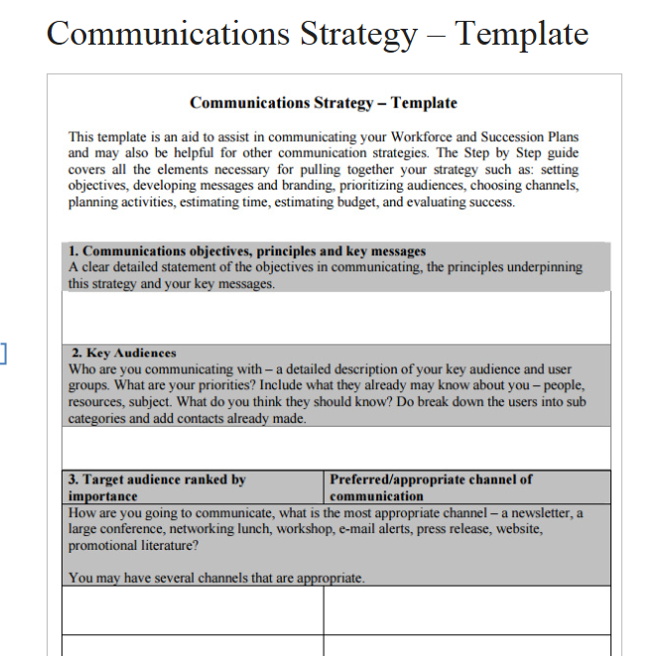

- https://upleaf.com/nonprofit-resources/strategy-design/communication-plan-template

