[Skip to content](http://www.nytimes.com/2016/11/18/us/intensified-by-climate-change-king-tides-change-ways-of-life-in-florida.html?rref=collection%2Ftimestopic%2FGlobal%20Warming&action=click&contentCollection=science&region=stream&module=stream_unit&version=latest&contentPlacement=7&pgtype=collection&_r=0" \l "story-header) [Skip to navigation](http://www.nytimes.com/2016/11/18/us/intensified-by-climate-change-king-tides-change-ways-of-life-in-florida.html?rref=collection%2Ftimestopic%2FGlobal%20Warming&action=click&contentCollection=science&region=stream&module=stream_unit&version=latest&contentPlacement=7&pgtype=collection&_r=0#site-index-navigation) [View mobile version](http://mobile.nytimes.com/2016/11/18/us/intensified-by-climate-change-king-tides-change-ways-of-life-in-florida.html)

[**The New York Times**](http://www.nytimes.com/)

[**U.S.**](http://www.nytimes.com/section/us)

* [Share](javascript:;)

Cover Photo

Credit Jonah M. Kessel/The New York Times

**Intensified by  
Climate Change,  
‘King Tides’ Change  
Ways of Life in Florida**

King tides, which frequently flood South Florida  
even when the sun shines, are the most blatant  
example of the interplay between rising seas  
and the alignment of the moon, sun and Earth.

By [LIZETTE ALVAREZ](http://www.nytimes.com/by/lizette-alvarez) and [FRANCES ROBLES](http://www.nytimes.com/by/frances-robles)NOV. 17, 2016

FORT LAUDERDALE, Fla. — In an enclave of a city known as the Venice of America, where dream-big houses look out over a maze of picturesque canals, the comparison to the Venice of Italy no longer seems so appealing.

On Monday morning, shortly after November’s so-called supermoon dropped from view on Mola Avenue, it was easy to see why. The tide swelled on command. Seawater gurgled audibly up through manhole covers and seeped from the grass. Under a sunny sky, the water drowned docks and slid over low sea walls. By 8:15 a.m., peak tide, this street in the Las Olas Isles neighborhood was inundated, just like the Venice across the pond.

Sergio Lafratta, an independent business consultant who moved in just three months ago, stood shirtless in tall waders, watching the saltwater seep into his new lawn.

“There goes my grass again,” Mr. Lafratta said. His grass squares floated away down the street. His wife, Marilia, a psychologist, stood on the doorstep in her pajamas and chimed in. “We spend too much money to live here,” she said. “We knew about this” — the flooding — “but we didn’t think it would be this bad.”

In South Florida, which takes rising sea levels seriously enough to form a [regional compact](http://www.southeastfloridaclimatecompact.org) to deal with [global warming](http://topics.nytimes.com/top/news/science/topics/globalwarming/index.html?inline=nyt-classifier), climate change is no abstract issue. By 2100, sea levels could swell high enough to submerge [12.5 percent of Florida’s homes](http://www.zillow.com/research/climate-change-underwater-homes-12890/). These so-called [king tides](https://www.epa.gov/cre/king-tides-and-climate-change#what), which happen frequently, are the most blatant example of the interplay between rising seas and the alignment of the moon, sun and Earth. Even without a drop of rain, some places flood routinely.

Monday’s planetary dance was particularly notable: The [moon](http://www.nasa.gov/feature/goddard/2016/novembers-spectacular-supermoon) was both full and at its closest distance to the Earth since 1948. The closer the moon, the stronger the gravitational tug on the oceans, the higher the tide. Rising sea levels exacerbate the flooding, scientists said.

In much of South Florida, including Broward County and Fort Lauderdale, finding short- and long-term fixes to the challenges of flooding caused by rising seas is a priority. A new position now exists to deal with it: resiliency chief or sustainability director.

U.S. By ELSA BUTLER and JONAH M. KESSEL 00:54 King Tides Flood South Florida

Video

**King Tides Flood South Florida**

Monday’s supermoon, with its strong gravitational pull, created high tides that flooded some South Florida coastal towns.

By ELSA BUTLER and JONAH M. KESSEL on Publish Date November 17, 2016. Photo by Scott McIntyre for The New York Times. [Watch in Times Video »](http://www.nytimes.com/video/us/100000004771145/king-tides-flood-south-florida.html?action=click&contentCollection=us&module=embedded&region=caption&pgtype=article)

* [embed](javascript:;)
* [Share](javascript:;)
* [Tweet](javascript:;)

Pumps and backflow valves have been put in place. Roads will be or have been elevated (most famously in Miami Beach, which invested $400 million to deal with flooding). Sea walls are being raised. Counties are also beginning to rethink building codes. Taken together, the costs will be enormous.

In the next five decades, the seas could rise two to three feet, said Jennifer Jurado, Broward County’s chief resiliency officer.

Already, life on Mola Avenue has changed considerably, depending on the moon cycle, the month, the wind and the rain. Residents are already gearing up for the next [king tide](https://www.epa.gov/cre/king-tides-and-climate-change#what). It arrives next month.

Adapting to the “new normal,” as some call it, is a requirement now. Sherry Harris kicks off her heels and splashes to her car to go to work. The Lafrattas, both originally from Brazil, pore over tidal charts for the first time in their lives. “No wake” signs warn cars to slow to a crawl so the brackish water does not inundate lawns. Residents know to park on high ground. Garbage cans are kept safely away from the curb, or they wind up bobbing up and down the road like wayward buoys.

“I forgot them one time,” Mr. Lafratta said, “and there was garbage everywhere.”

People who live here have complained to city officials for years but said they might wind up having to pay for some of the fixes themselves (one proposal asks for $20,000 from each resident). Already, many have to elevate their sea walls because they sit on private property. Raising the roads may also cost them. All of these options inevitably give rise to should-we-or-shouldn’t-we squabbles. And even as new multimillion-dollar mansions rise from the saturated ground, those who live on Mola fret about property values.

“Flood?” said Michael Asser, poking fun at the situation after he opened his front door to a waterlogged reporter. “What flood? The city says there is no flood.”

“It’s been going on 25 years, but each year it’s worse,” he added. “When I first came here, during spring tides, you had a splash here, a splash there.”

Does he ever think about selling? “I’ll probably have to stay here forever,” he said.

**Miami**

Standing in front of the whimsical garden outside his Coconut Grove house, Dr. Karl H. Muench, a physician and professor of medicine at the University of Miami, said he and his neighbors got lucky this week. The forecast called for widespread king tide flooding, but West Fairview Street dodged the worst of it on Tuesday.

[Continue reading the main story](http://www.nytimes.com/2016/11/18/us/intensified-by-climate-change-king-tides-change-ways-of-life-in-florida.html?rref=collection%2Ftimestopic%2FGlobal%20Warming&action=click&contentCollection=science&region=stream&module=stream_unit&version=latest&contentPlacement=7&pgtype=collection&_r=0#story-continues-5)

**From Our Advertisers**

**Recent Comments**

**MGN**

2 days ago

Luckily, our President Elect doesn't believe in global warming, so doubtlessly, this will stop happening. Otherwise, we're going to have to...

**Dennis Walsh**

2 days ago

Well my goodness Florida. Didn't you just vote for a climate change denier as POTUS. Seems to me you might have taken stances on that...

**yang**

2 days ago

At this stage of the conversation maybe it does not help to use the word 'believe' when it comes to a person's position on climate. Either...

* See All Comments

Photo

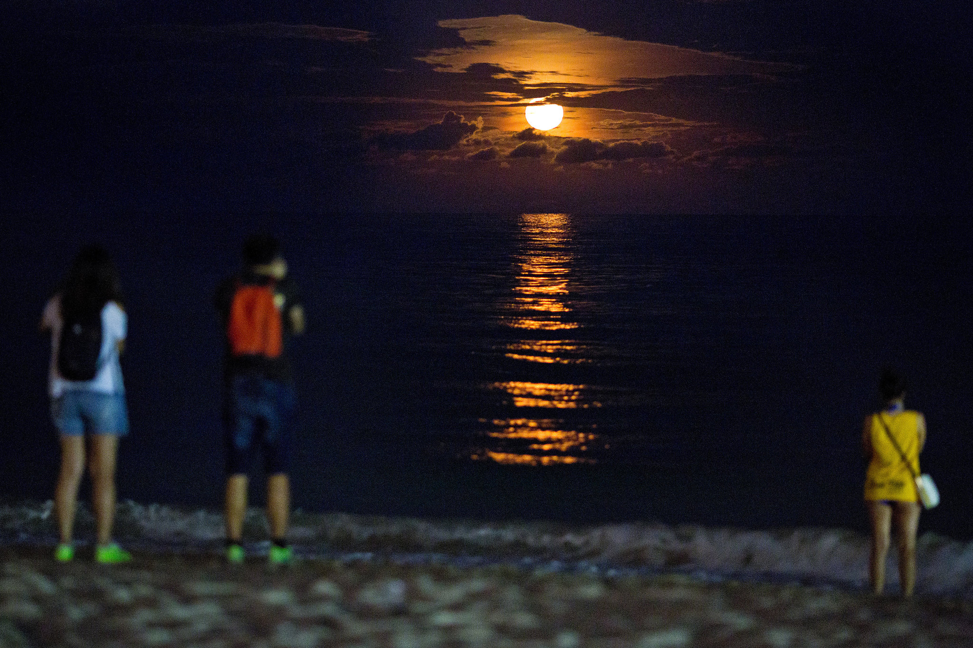

A so-called supermoon rose over Miami Beach on Monday, contributing to tidal flooding in many areas. Credit Scott McIntyre for The New York Times

“It can come up to here,” he said, pointing to the edge of his property. “I’ve had to wade home knee-deep from a block away; I didn’t want to bring my car into the saltwater.”

A stone’s throw away, a canal threatened to spill over a sea wall as a manatee frolicked by a small bridge. But the water held back, reaching the brim. Instead, it seeped up through the storm drains and pooled onto Fairview. Miami-Dade County was largely spared the tide cycle this week: Miami Beach’s [pumps and elevated roadways](http://www.mbplannedprogress.com/home/showdocument?id=1890) easily dealt with the incoming water (save for an inundated parking garage [where an octopus swam](https://twitter.com/amanda____panda/status/798301826667991044)). Other problem pockets near the Miami River and in Shorecrest got minimal flooding.

It was an example of the unpredictability of nature, which can make planning and preparing for floods tricky business. Last month, when the wind was churned up by a passing hurricane, the king tide was much worse. And last year, residents said, it was spectacularly bad.

Erratic as the weather can be at times, Dr. Muench, 82, who has lived in this graceful neighborhood of banyan trees and salt-sprinkled air for 40 years, said he was certain about one thing: Global warming is the culprit for the shin-high water that regularly covers the road in front of his house.

Top of Form

**Sign-up for free NYT Newsletters**



Morning Briefing

News to start your day, weekdays



Opinion Today

Thought-provoking commentary, weekdays



Cooking

Delicious recipes and more, 5 times a week

https://a1.nyt.com/assets/article/latest/images/shared/newsletterpromo/racerelated-30x30.png

Race/Related

A provocative exploration of race, biweekly

Bottom of Form

Top of Form



Receive occasional updates and special offers for The New York Times's products and services.

Bottom of Form

* [Privacy Policy](http://www.nytimes.com/privacy)

“There has been a definite, gradual increase since the onset of information about global warming,” he said. “In my mind, there is no question about the relationship. The canal is rising because the ocean is rising.”

Dr. Muench said he fretted about President-elect Donald J. Trump’s position on global warming. In a much-circulated 2012 post on Twitter, Mr. Trump said the concept was “created by and for the Chinese in order to make U.S. manufacturing noncompetitive.”

Now that Mr. Trump [has chosen Myron Ebell](http://www.nytimes.com/2016/11/12/science/myron-ebell-trump-epa.html) to lead his Environmental Protection Agency transition team, Dr. Muench’s concerns have deepened. Mr. Ebell has helped lead the charge against the scientific consensus that global warming exists and is caused by people.

James Murley, Miami-Dade County’s chief resilience officer, said the rising sea level did not cause king tides, “but it amplifies these events.”

Claudia Falero was drying her French bulldog inside her gleaming house as it drizzled outside. When she and her husband bought the house seven years ago, the flooding took them by surprise. “It wasn’t something advertised,” she said, laughing.

The couple’s letters to city officials have gone unanswered, she said. Residents say they hear that the road may get elevated, the sea wall fixed. So far, though, it is just talk.

“It gets you mad,” Ms. Falero said, “because you pay taxes, and nothing is getting done.”

**Key Largo**

Shirley Borg gripped the steering wheel of her Honda Accord, traveling at a turtle’s pace through saltwater a few inches deep that was rising all over her street. The homeowners here on Adams Drive know the drill: Drive slowly to keep the splash down, or drive quickly and risk ruining your car.

“I just replaced the wheel bearings because the seals were broken from saltwater,” she said. “I asked, ‘How does that happen?’ And they said, ‘Do you go through a lot of brackish water?’ Oh, yeah.”

[Continue reading the main story](http://www.nytimes.com/2016/11/18/us/intensified-by-climate-change-king-tides-change-ways-of-life-in-florida.html?rref=collection%2Ftimestopic%2FGlobal%20Warming&action=click&contentCollection=science&region=stream&module=stream_unit&version=latest&contentPlacement=7&pgtype=collection&_r=0#story-continues-8)

Photo

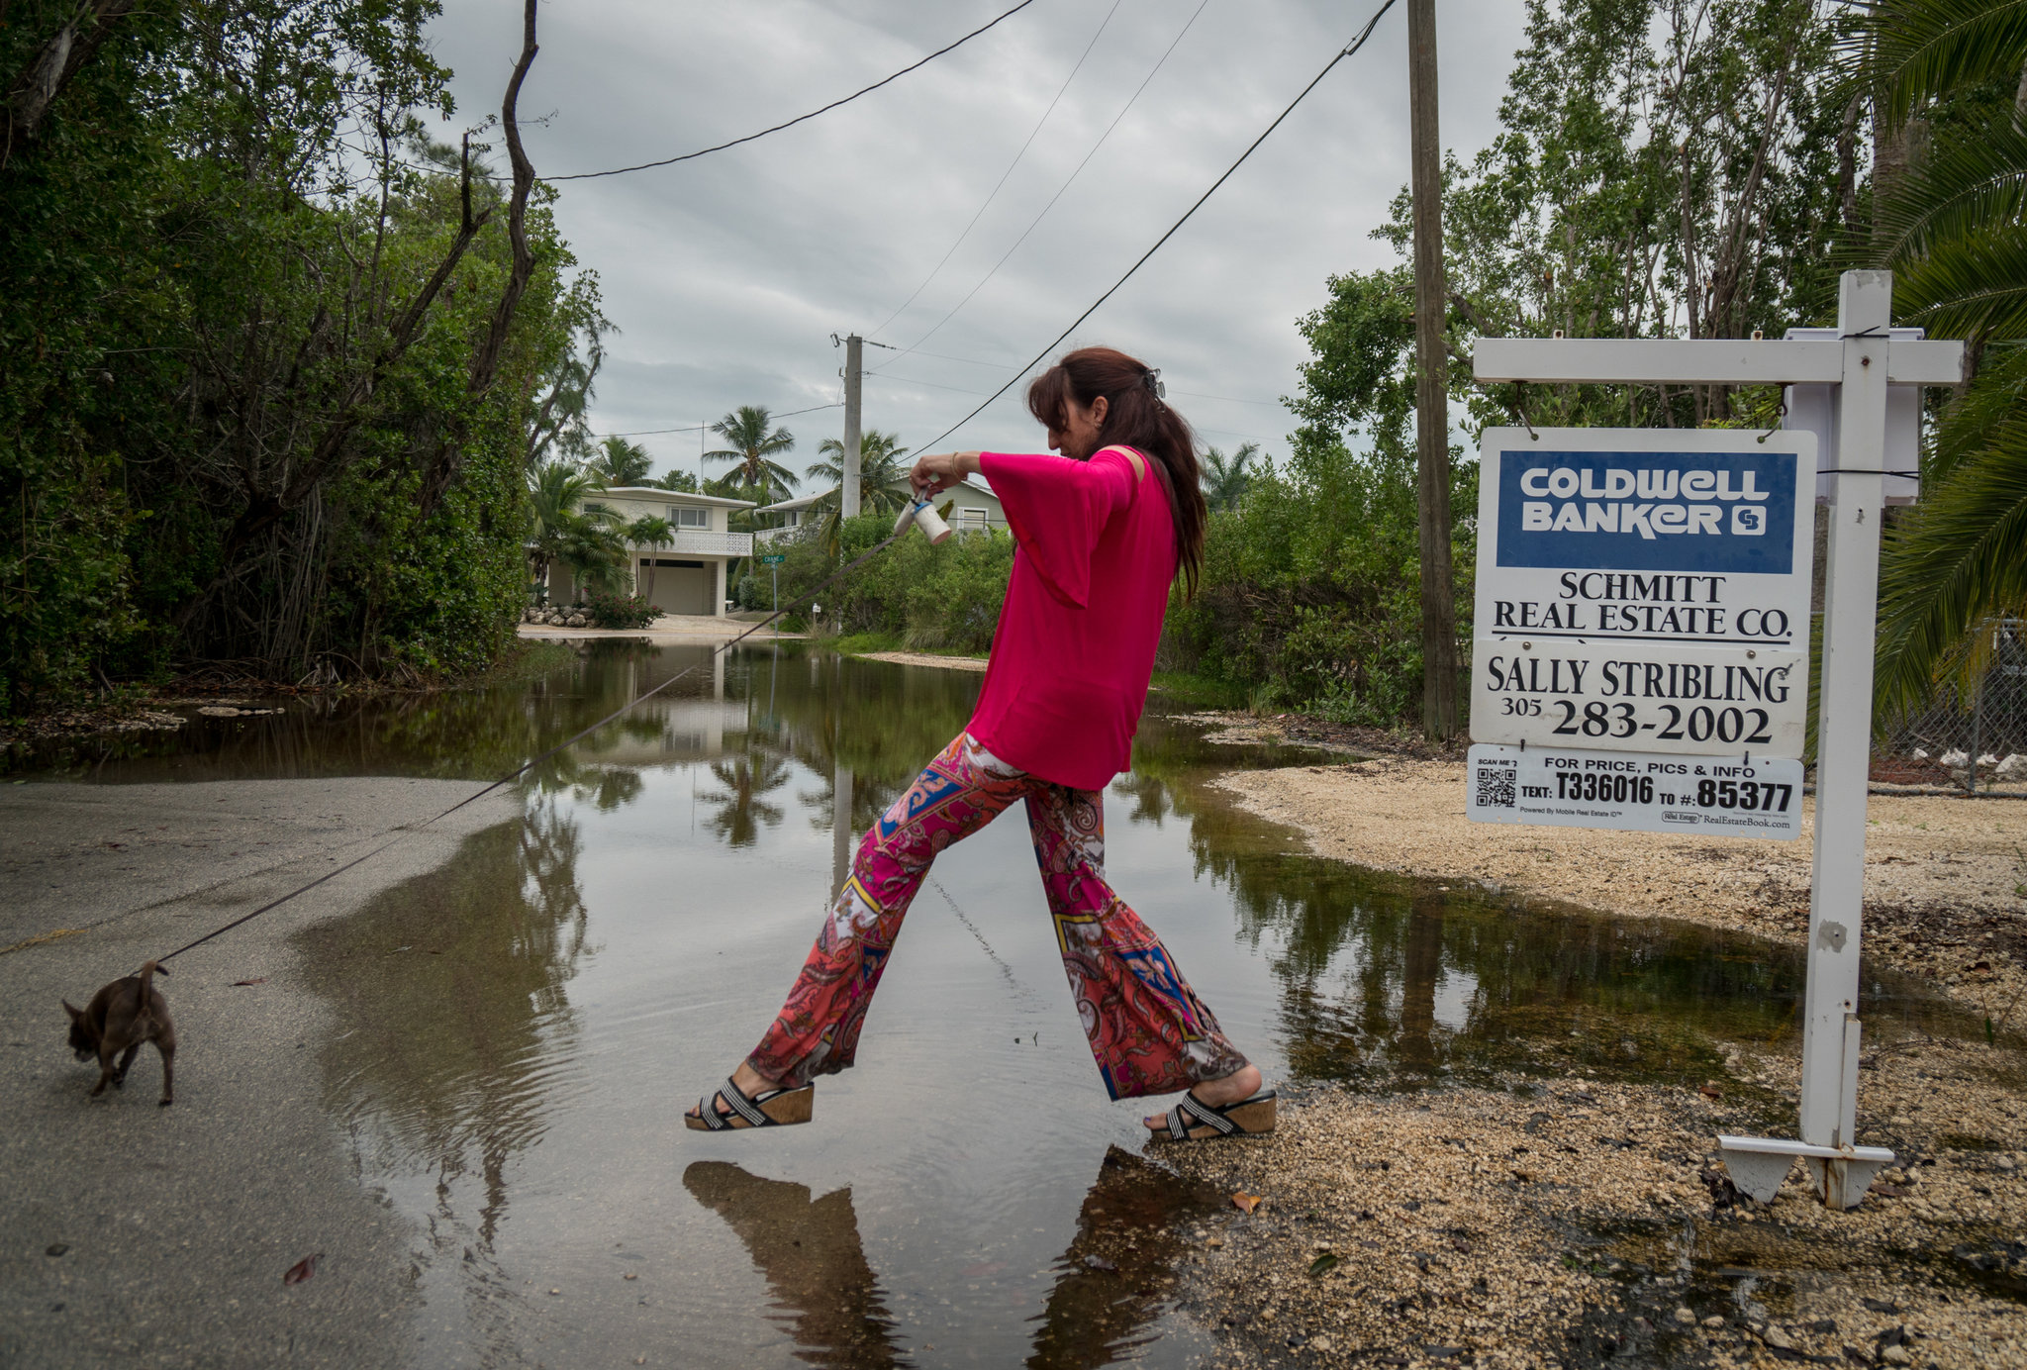

Narelle Prew, who lives in the Twin Lakes neighborhood of Key Largo, skipped over a puddle as she walked her chihuahua, Lexy, on Tuesday. Credit Angel Valentin for The New York Times

The Florida Keys have a unique problem: Unlike areas farther north, which have barrier islands and then the mainland, the Keys are made up solely of a chain of low-lying islands built on porous limestone. Stopping the water from rolling into neighborhoods here is not an easy task. Sea walls, for example, do not work.

Patience is a requirement nowadays on some Keys roads.

Ms. Borg has lived in Twin Lakes, a waterfront community, for 11 years, and floodwaters are now a regular feature of the neighborhood. They vary, like everywhere else in South Florida, depending on moon cycles, and they are compounded by poor infrastructure and rising sea levels.

“The first seven years, we only flooded twice,” Ms. Borg said on Tuesday.

Last year, 10 inches of water outside often trapped residents in their homes. Ms. Borg’s car sits five inches off the ground, so do the math. In 2015, she went carless for two weeks — not even flatbed truck drivers wanted to chance it. Some people in her neighborhood left their cars somewhere else and commuted, Florida Keys style, by boat. Others lost their cars altogether; saltwater is particularly corrosive to engines and metal.

Climate change is on many of their minds. And, like Dr. Muench, they worry — not just about the incoming president, but also about Florida’s governor, Rick Scott. Some former state environmental employees accused Mr. Scott, a Republican, last year of banning the phrase “climate change” in conversation and on documents, a charge he has said is untrue.

“A climate change denier?” quipped Benjamin Klitzkie, standing in his driveway on Tuesday morning as the water encroached. “I got a house for you in Key Largo.”

Mr. Klitzkie bought his home on Shaw Drive in 2011, but worries about his investment. Houses on the street are still selling — one is listed for $729,000 — but what if the water keeps coming? Recently, he said, it approached a neighbor’s front gate.

County officials are meeting regularly with homeowners to discuss raising the road and other improvements. They have stopped issuing building permits on the street, Mr. Klitzkie said.

“It’s sinking,” he said. “And the seas are rising.”

Rhonda Haag, Monroe County’s sustainability director, said officials had done an analysis of some county roads. The conclusion was that elevating them, including on Shaw Drive, would be the best option. But it is expensive — raising one road six inches costs $1 million for a third of a mile — and complicated.

“And we do recognize the fact that we will lose certain places sooner rather than later — some of the natural areas first,” Ms. Haag said.

For Frank Garces, an insurance adjuster who moved here less than two years ago, it cannot happen fast enough. He said he never used to give global warming a second thought. “Now,” he said, “I’m researching moon phases and tides.”

Lizette Alvarez reported from Fort Lauderdale, and Frances Robles from Key Largo.

A version of this article appears in print on November 18, 2016, on page A1 of the New York edition with the headline: Worsened by Climate Change, ‘King Tides’ Transform Florida Life.