|  |  |  |  |  |  |  |  |
| --- | --- | --- | --- | --- | --- | --- | --- |
| |  |  |  |  |  |  |  | | --- | --- | --- | --- | --- | --- | --- | | **Task 1: Application Development**  **Introduction:**  This course has introduced you to information systems (IS). In this task, you will identify the needs for a specific information system, select tools to identify and refine those needs, and go through the development stages and different management systems. You will also identify key contributors and their roles, the importance of security, and specific threats to a system.  **Scenario:**  Soliel Panel Distribution, a solar panel company, has been in business for 25 years. For the first two decades, they focused primarily on distributing small panels used in personal electronic devices, such as calculators and watches. As solar-powered technology has developed more, the company is seeing unprecedented growth. They have gone from 15 employees to well over 150 in three years. They are expanding in multiple ways and are seeing growth in residential rooftop solar panel sales, large-scale commercial applications, and product distribution.  While this rapid growth has increased both sales and profits, it has also presented various challenges for a company so accustomed to small-scale operations. One of the most pressing challenges is the orientation of new employees. In the first 12 years, the organization hired one or two employees every few years. An administrator easily handled this process, and each department handled tasks pertaining to the new hire’s various roles. More recently, the company has experienced monthly increases in personnel of as many as 20 employees, making their current orientation process obsolete. The administrator who previously handled new employee orientation had been trying to improve the process, but it has become clear that the company no longer has the time or processes in place to overcome this challenge.  In addition, analysis of the solar industry competition implies that a quick growth of the employee workforce could position Soliel Panel Distribution to improve its market share.  Over the years, Soliel Panel Distribution has grown and developed a seasoned software team as part of the IT department. The department is confident a new software application called SolDistHR can meet their needs while addressing concerns. While anticipating rapid growth and additional software vulnerabilities, the company is also concerned with security and customer support.  **Requirements:**  *Your submission must be your original work. No more than a combined total of 30% of the submission and no more than a 10% match to any one individual source can be directly quoted or closely paraphrased from sources, even if cited correctly. Use the Turnitin Originality Report available in Taskstream as a guide for this measure of originality.  You must use the rubric to direct the creation of your submission because it provides detailed criteria that will be used to evaluate your work. Each requirement below may be evaluated by more than one rubric aspect. The rubric aspect titles may contain hyperlinks to relevant portions of the course.*  A.  Explain how leveraging an IS solution can help Soliel Panel Distribution achieve operational efficiency.  1.  Explain how business process management (BPM) can help the IT department in the development of SolDistHR.  2.  Explain how *each* of the **five** steps of change management could be applied to this project.  3.  Explain the individual responsibilities of **four** key contributors (individuals or groups) that would be directly involved in the project.  B.  Select **one** system development method to be used in the implementation of SolDistHR and do the following:  1.  Justify your selection of the system development method, providing the strengths and weaknesses of the method.  2.  Explain how *each* milestone within your selected system development method would be executed during the implementation of SolDistHR.  C.  Describe the potential internal and external security threats that could exist after the implementation of SolDistHR.  D.  Explain how to protect against digital and physical threats to SolDistHR that could exist after implementation.  E.  Describe the approach you would take to troubleshoot and restore SolDistHR after system failures.  F.  Explain the importance and function of problem management in supporting SolDistHR once it is implemented.  G.  Describe how you would apply the steps of incident management to address issues and mitigate future issues related to SolDistHR.  H.  Acknowledge sources, using APA-formatted in-text citations and references, for content that is quoted, paraphrased, or summarized.  I.  Demonstrate professional communication in the content and presentation of your submission.    |  |  |  | | --- | --- | --- | | **WEB LINKS:** | | | | **1.** | [**DIP Task 1 Rubriclink opens in new window**](https://rubric.taskstream.com/rubric/?m=WGU&r=atcczafezlf3clha) |  | | |

**Textbook and Other Resources**  
Content is drawn from the following sources.

|  |
| --- |
| Haag, S., & Cummings, M. (2013). *Management information systems for the information age* (9th ed.). New York, NY: McGraw-Hill Irwin. ISBN: 9780071314640  McGannon, B., Lynda.com (2016). *Change Management Foundations*.  Skillsoft (2017). *Support Center Tools, Technologies and Metrics*. |

1.7

Industry Impact of IT: Porter's Five Forces Model

Simply put, *business strategy drives technology decisions, not the reverse.* In your personal life, you may choose to buy the latest piece of technology because it's cool. Not so in the business world. Businesses carefully scrutinize their technology purchases, seeking to find and justify a competitive advantage. A ***competitive advantage*** is providing a product or service in a way that customers value more than what your competition is able to do.  
  
To assess technology and the competitive advantage it can yield, many people choose to use Michael Porter's Five Forces Model.**8** The ***Five Forces Model*** helps business people understand the relative attractiveness of an industry and the industry's competitive pressures in terms of the following five forces (see Figure 1.10):

1. Buyer power
2. Supplier power
3. Threat of substitute products or services
4. Threat of new entrants
5. Rivalry among existing competitors

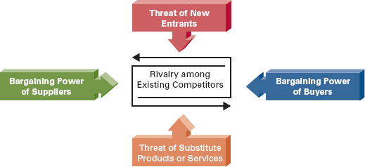

**Figure 1.10: Michael Porter's Five Forces Model**

**Buyer Power**

***Buyer power*** in the Five Forces Model is high when buyers have many choices from whom to buy, and low when their choices are few. Providers of products and services in a particular industry wish to reduce buyer power. They create a competitive advantage by making it more attractive for customers to buy from them than from their competition. Below are a few of the many companies using IT-enabled processes to reduce buyer power.

* NetFlix—Set up your movie list. After you watch a movie and return it, NetFlix will send you the next movie on your list. You can also rent videos through the mail, stream them to your computer, or stream them to your TV.
* United Airlines (or almost any airline for that matter)—Enroll in the *Mileage Plus*program. As you travel using United (or perhaps make purchases using your United credit card), you accumulate miles for free air travel, upgrades, and hotel stays. Programs like this one, which reward customers based on the amount of business they do with a particular organization, are called ***loyalty programs***.
* Apple iTunes—Create an iTunes account and buy and download whatever music you want. Then, you can organize and manage your music, move it to your iPod, and burn CDs. You can also store all your music (and photos and much more) in Apple's iCloud.
* Dell Computer—Completely customize your computer purchase. It will be delivered to your doorstep within a few business days.

What's interesting about each of these examples (as well as all the others you can think of) is that the competitors in those industries have responded by creating similar programs. This simply means that no competitive advantage is ever permanent. NetFlix was the first to offer movie rentals (with a profitable business model) using the Internet as the primary platform. Therefore, it had ***first-mover advantage***, a significant impact on gaining market share by being the first to market with a competitive advantage. Every major airline has a loyalty program similar to that of United Airlines. There are many places on the Internet where you can buy and download music. Almost every major computer vendor allows you to customize your computer purchase. The lesson learned here—and for all strategies that result in a competitive advantage—is that a competitive advantage is only temporary and your organization must constantly innovate to find new competitive advantages.

**Supplier Power**

***Supplier power*** in the Five Forces Model is high when buyers have few choices from whom to buy, and low when their choices are many. Supplier power is the opposite of buyer power: As a supplier organization in an industry, you want buyer power to be low and your supplier power to be high.  
  
In a typical supply chain (see Figure 1.11), your organization will probably be both a supplier (to customer organizations) and a buyer, or customer (of other supplier organizations). As a customer of other supplier organizations, you want to increase your buyer power. As a supplier to other organizations, you want to increase your supplier power, thus reducing your customer's buyer power.  
  
In the quest for increasing supplier power, organizations use many tools at their disposal, not just IT. Companies obtain patents and trademarks to minimize the extent to which products and services can be duplicated and offered by other organizations. The De Beers Group for many years has fought fiercely to tightly control the supply and distribution of diamonds. OPEC (the Organization of the Petroleum Exporting Countries) has organized 11 oil-producing nations to better control the distribution of the world's most popular energy resource (supposedly to ensure the stabilization of oil prices).

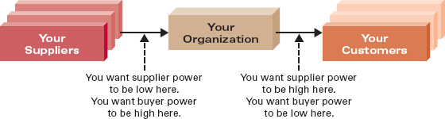

**Figure 1.11: Evaluating Buyer and Supplier Power for Your Organization**

**Threat of Substitute Products or Services**

The ***threat of substitute products or services*** in the Five Forces Model is high when there are many alternatives to a product or service, and low when there are few alternatives from which to choose. Ideally, your organization would like to be a supplier organization in a market in which there are few substitutes for the products and services you offer. Of course, that's seldom possible in any market today, but you can still create a competitive advantage by increasing *switching costs.* ***Switching costs*** are costs that make customers reluctant to switch to another product or service supplier. What you need to realize is that a switching cost does not necessarily have to be an actual monetary cost.  
  
As you buy products at [Amazon.com](http://amazon.com/) over time, for example, Amazon develops a unique profile of your shopping and purchasing habits through such techniques as collaborative filtering. When you visit Amazon, products are offered to you that have been tailored to your profile. This is only possible through the use of sophisticated technologies. If you choose to do your shopping elsewhere, there is a switching cost of sorts because the new site you visit will not have a profile of you or a record of your past purchases. (This is an effective variant of a loyalty program.) So, Amazon has reduced the threat of substitute products and services, in a market in which there are many substitutes, by tailoring offerings to you, by creating a "cost" to you to switch to another online retailer.  
  
Switching costs can of course be real monetary costs too. You've probably been introduced to a switching cost when you signed up for the services of a cell phone provider. All the options and plans sound really great. But there is a serious switching cost in that most cell phone providers require you to sign a long-term contract (as long as two years) in order to receive a free phone or unlimited night and weekend calling minutes. The very successful substitute to this is disposable cell phones that you buy and which contain a certain number of minutes for your use.

**Threat of New Entrants**

The ***threat of new entrants*** in the Five Forces Model is high when it is easy for new competitors to enter a market, and low when there are significant entry barriers to entering a market. An ***entry barrier*** is a product or service feature that customers have come to expect from organizations in a particular industry and that must be offered by an entering organization to compete and survive. Such barriers are erected, and overcome, and then new ones are created again. This is that vicious business cycle of build a competitive advantage, enjoy first-mover advantage, and then watch your competition develop similar initiatives thereby nullifying your competitive advantage.  
  
For example, if you're thinking of starting a bank, you must offer your customers an array of IT-enabled services, including ATM use, online bill paying and account monitoring, and the like. These are significant IT-based entry barriers to entering the banking market because you must offer them for free (or a very small fee). If you consider our previous example of cell phone providers, a significant entry barrier in the past had to do with your phone number. Previously, if you wanted to change cell phone providers, you couldn't take your telephone number with you (i.e., you had to get a new cell phone number). This created a significant entry barrier because new cell phone providers entering the industry were mainly limited to obtaining new customers who did not currently have a cell phone. But that has all changed with *LNP, Local Number Portability,* your ability to take your cell phone number with you to a new provider.

Industry Perspective

**Valentine's Day Goes Virtual**  
The average person was expected to spend $116 for merchandise for Valentine's Day in 2011. Total spending was expected to exceed $15 billion.  
  
To capture a portion of that money, and perhaps even more than previously, many companies went virtual in 2011 with Valentine's Day stories, messages, flowers, and even food (although the food is real).  
  
Mattel, the toy giant, created a campaign to ask people if Barbie should reunite with Ken. (Ken and Barbie split on Valentine's Day 2004.) Mattel used Facebook and Twitter to have Ken post his love and affection for Barbie. The purpose was to create "social" noise so that Ken and Barbie lovers would log on to **BarbieandKen.com** and vote one way or the other. Of course, the site included a link to Barbie's Facebook page, where people could buy Barbie and Ken merchandise.  
  
Victoria's Secret created sexy e-valentine cards that people could send through a social network. Victoria's Secret posted photos and messages which people could choose to include in a card. Women even had the option of including a photo of a gift they wanted from Victoria's Secret.  
  
Rovio Mobile, the creator of the ultra-popular Angry Birds game, created a Valentine's Day version of the game. Of course, you had to pay 99 cents to download it, but 99 cents is nothing to the millions of fanatic fans of Angry Birds.  
  
Mulberry, a British apparel maker, created virtual flower seeds you could send via e-mail. When the recipient clicked on the seeds, Valentine's Day flowers bloomed right before their eyes.  
  
Even Lenny's Sub Shop got into the social media game for Valentine's Day. It gave away subs (you had to send them to someone as a Valentine's Day gift) on its Facebook page. According to George Alvord, Lenny's CEO, "The quickest way to win someone's heart is through their stomach."  
  
The lesson learned: Each of these gave some company a competitive advantage, if only for a day.**9**

**Rivalry among Existing Competitors**

The ***rivalry among existing competitors*** in the Five Forces Model is high when competition is fierce in a market, and low when competition is more complacent. Simply put, competition is more intense in some industries than in others, although the overall trend is toward increased competition in just about every industry. Rarely can you identify an industry that exhibits complacent competition. (One example might be mortician and burial services. Solely because of the nature of the services offered, you don't see mortician and burial service organizations actively advertising on TV, offering reduced rates, and so on.)  
  
The retail grocery industry is intensely competitive. While Target and Walmart in the United States compete in many different ways, essentially they try to beat or match the competition on price. Since margins are quite low in the grocery retail market, grocers build efficiencies into their supply chains, connecting with their suppliers in IT-enabled information partnerships. Communicating with suppliers over telecommunications networks rather than using paper-based systems makes the procurement process much faster, cheaper, and more accurate. That equates to lower prices for customers—and increased rivalry among existing competitors.  
  
As you can see, Porter's Five Forces Model is extremely useful in helping you better understand the positioning of your organization within its industry and in helping you better understand the competitive forces affecting your organization. With this knowledge in mind, your organization now needs to develop specific business strategies to remain competitive and profitable.

2.7

Summary: Student Learning Outcomes Revisited

1. **Define supply chain management (SCM) systems and describe their strategic and competitive opportunities.** A ***supply chain management (SCM) system*** is an IT system that supports supply chain management by automating the tracking of inventory and information among business processes and across companies. Strategic and competitive opportunities for SCM systems include:  
   * Overall cost leadership (Porter), running the organization (RGT framework)
   * Fulfillment—right quantity of parts or products at the right time
   * Logistics—low cost of transporting materials
   * Production—ensuring production lines run smoothly
   * Revenue and profit—no sales are lost
   * Cost and price—keeping part costs down and product prices at acceptable levels
2. **Define customer relationship management (CRM) systems and describe their strategic and competitive opportunities. A *customer relationship management (CRM) system*** uses information about customers to gain insights into their needs, wants, and behaviors in order to serve them better. Strategic and competitive opportunities for CRM systems include:  
   * Differentiation and focus (Porter) and growing the organization (RGT framework)
   * Devising more effective marketing campaigns
   * Assuring the sales process is efficiently managed
   * Providing superior after-sale service and support
3. **Explain the significance of enterprise resource planning (ERP) software as the integration of functional software systems.** An ***enterprise resource planning (ERP) system*** is a collection of integrated software for business management, accounting, finance, project management, SCM, e-collaboration, and a host of other business functions. The basic goal of an ERP system is to provide (1) integrated information (data, information, and business intelligence), (2) one suite of applications, and (3) a unified interface across the enterprise. An ERP system replaces legacy systems and seamlessly integrates all functional software systems within an organization.
4. **Define social media and describe a few of its many dimensions that make it important in the business world. *Social media*** is a collection of Web-based and mobile technologies that create true interactivity among users, most usually allowing users to be both creators and consumers of content. A few of its dimensions include:  
   * Social networking—gathering with friends and family on ***social networking sites*** like Facebook and sharing everything about your life.
   * Social shopping—technology-enabled shopping through sites like Groupon and buying other people gifts through the likes of Bartab and Pepsi social vending machines.
   * Social playing—participating in large, multi-user games or ***MMORPGs***, which provide a large robust economy complete with a variety of commerce activities.
   * Social "saving the world"—competing in contests to address important issues regarding the environment and the betterment of people and their behavior.
   * ***Social locationing***, or ***location-based services***—using a mobile device and its location (as determined by GPS) to check into locations such as businesses and entertainment venues, find friends and their locations, and receive rewards and take advantage of "specials" based on location.

3.7

Summary: Student Learning Outcomes Revisited

1. **List and describe the key characteristics of a relational database.** The ***relational database*** model uses a series of logically related two-dimensional tables or files to store information in the form of a database. Key characteristics include  
   * A collection of information—Composed of many files or tables of information that are related to each other
   * Contain logical structures—You care only about the logical information and not about how it's physically stored or where it's physically located
   * Have logical ties among the information—All the files in a database are related in that some ***primary keys*** of certain files appear as ***foreign keys*** in others
   * Possess built-in ***integrity constraints***—When creating the data dictionary for a database, you can specify rules by which the information must be entered (e.g., not blank, etc.)
2. **Define the five software components of a database management system.** The five software components of a database management system include  
   * ***DBMS engine***—Accepts logical requests from the various other DBMS subsystems, converts them into their physical equivalent, and actually accesses the database and data dictionary as they exist on a storage device
   * ***Data definition subsystem***—Helps you create and maintain the data dictionary and define the structure of the files in a database
   * ***Data manipulation subsystem***—Helps you add, change, and delete information in a database and query it for valuable information
   * ***Application generation subsystem***—Contains facilities to help you develop transaction-intensive applications
   * ***Data administration subsystem***—Helps you manage the overall database environment by providing facilities for backup and recovery, security management, query optimization, concurrency control, and change management
3. **List and describe the key characteristics of a data warehouse.** The key characteristics of a data warehouse include  
   * Multidimensional—While databases store information in two-dimensional tables, data warehouses include layers to represent information according to different dimensions
   * Support decision making—Data warehouses, because they contain summarized information, support business activities and decision-making tasks, not transaction processing
4. **Define the five major types of data-mining tools in a data warehouse environment.** The four major types of data-mining tools in a data warehouse environment include  
   * ***Query-and-reporting tools***—Similar to QBE tools, SQL, and report generators in the typical database environment
   * **Artificial intelligence**—Tools such as neural networks and fuzzy logic to form the basis of "information discovery" and building business intelligence in OLAP
   * ***Multidimensional analysis (MDA) tools***—Slice-and-dice techniques that allow you to view multidimensional information from different perspectives
   * ***Digital dashboard***—Displays key information gathered from several sources on a computer screen
   * **Statistical tools**—Help you apply various mathematical models to the information stored in a data warehouse to discover new information
5. **List key considerations in information ownership in an organization.** Key considerations in information ownership in an organization include:  
   * Strategic management support
   * The sharing of information with responsibility
   * Information cleanliness

4.3

Decisions and Decision Support

To develop a true appreciation for and understanding of the role of analytics, it's helpful to first understand how we go about making decisions.

**Decisions**

In business, decision making has four distinct phases, as proposed by Herbert Simon (see Figure 4.2).**3** These four phases are:

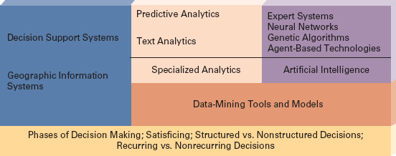

**Figure 4.1: Our Focus in This Lesson**

1. ***Intelligence*** (find what to fix): Find or recognize a problem, need, or opportunity (also called the *diagnostic phase* of decision making). The intelligence phase involves detecting and interpreting signs that indicate a situation which needs your attention. These "signs" come in many forms: consistent customer requests for new product features, the threat of new competition, declining sales, rising costs, an offer from a company to handle your distribution needs, and so on. "Detecting and interpreting signs" is achieved primarily by using various analytics tools to gather information and then convert it into business intelligence, perhaps by combining multiple sets of information or slicing and dicing your way through a data warehouse.
2. ***Design*** (find fixes): Consider possible ways of solving the problem, filling the need, or taking advantage of the opportunity. In this phase, you develop all the possible solutions you can. Here again, you can use analytics tools to build models of numerous proposed solutions. These models—like break-even analysis which we covered in Lesson 1—allow you to create many solutions "on paper." In this way, you can review the outcomes of proposed solutions without having to implement them.
3. ***Choice*** (pick a fix): Examine and weigh the merits of each solution, estimate the consequences of each, and choose the best one (which may be to do nothing at all). The "best" solution may depend on such factors as cost, ease of implementation, staffing requirements, and timing. This is the *prescriptive phase* of decision making—it's the stage at which a course of action is prescribed. Analytics still plays a role here, by allowing you to perhaps build a spreadsheet that shows the outcomes of each solution and rank orders them according to whatever criteria you choose.
4. ***Implementation*** (apply the fix): Carry out the chosen solution, monitor the results, and make adjustments as necessary. Simply implementing a solution is seldom enough. Your chosen solution will always need fine-tuning, especially for complex problems or changing environments. Here, analytics takes on the role of quality control, allowing you to gather information regarding your solution to ensure that it's staying on target.

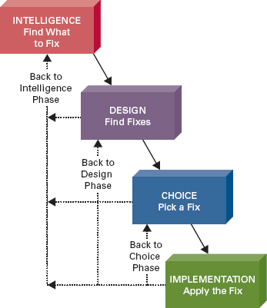

**Figure 4.2: Four Phases of Decision Making**

This four-phase process is not necessarily linear: You'll often find it useful or necessary to cycle back to an earlier phase. When choosing an alternative in the choice phase, for example, you might become aware of another possible solution. Then you would go back to the design phase, include the newly found solution, return to the choice phase, and compare the new solution to the others you generated.  
  
A second model of decision making, also proposed by Simon, is *satisficing,* which differs from the four-phase process. ***Satisficing*** is making a choice that meets your needs and is satisfactory without necessarily being the best possible choice available. Organizations in the private and public sectors are "satisficing" all the time in setting goals such as "fair price" or "reasonable profit." There's a fundamental difference between setting a goal of "high growth" and one of "maximum growth." "Maximum growth" is an optimizing strategy while "high growth" is a satisficing strategy. Usually a term like "high growth" is precisely defined. It may be 3 percent or 30 percent, but the idea is that when you reach that level, you can declare success.  
  
In both business and your personal life, you'll face decisions that are some combination of four main types of decisions (see Figure 4.3). The first type is a ***structured decision***, which involves processing a certain kind of information in a specified way so that you will always get the right answer. No "feel" or intuition is necessary. These are the kinds of decisions you can program. If you use a certain set of inputs and process them in a precise way, you'll arrive at the correct result. Calculating gross pay for hourly workers is an example. You can easily automate these types of structured decisions with IT.

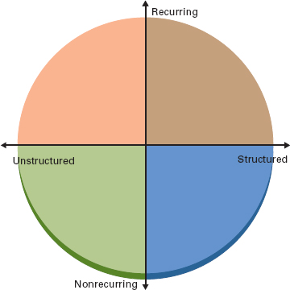

**Figure 4.3: Categorizing Decisions by Type**

On the other hand, a ***nonstructured decision*** is one for which there may be several "right" answers, and there is no precise way to get a right answer. No rules or criteria exist that guarantee you a good solution. Deciding whether to introduce a new product line, employ a new marketing campaign, or change the corporate image are all examples of decisions with nonstructured elements. In reality, most decisions fall somewhere between structured and unstructured, for example, choosing a job. Structured elements of choosing a job include consideration of such things as salary and signing bonus. Nonstructured elements of such a decision include things like the potential for advancement. Regardless of the decision at hand, analytics is most useful for decisions that have nonstructured elements. Good analytics tools allow you to model several different scenarios by adjusting the nonstructured elements. This gives you greater insight to make the right decision.  
  
Another type of decision regards frequency with which the decision is made. A ***recurring decision*** is one that happens repeatedly, and often periodically, whether weekly, monthly, quarterly, or yearly. Deciding how much inventory to carry and deciding at what price to sell the inventory are recurring decisions. A ***nonrecurring***, or ***ad hoc***, ***decision*** is one that you make infrequently (perhaps only once), and you may even have different criteria for determining the best solution each time. Deciding where to build a distribution center or company mergers are examples of nonrecurring or ad hoc decisions (although, the general trend in business today is for companies to consider mergers on a more consistent basis).

**Decision Support Systems**

In reality, any technology-based system that helps you make decisions could be classified as a decision support system; even something as simple as an inventory report that highlights inventory with low stock would qualify. But in the IT field there is a long-standing definition of what constitutes a decision support system. A ***decision support system (DSS)*** is a highly flexible and interactive IT system that is designed to support decision making when the situation includes nonstructured elements. Thus, a DSS is definitely a part of the analytics professional's tool set. The primary objectives of a DSS include providing you with:

* A simple and easy-to-use graphical user interface (GUI)
* Access to large amounts of information
* Models and tools (statistical and analytical) that you can use to massage the information

So, a DSS typically has three components, with each focusing on one of the three objectives above (see Figure 4.4). As we discuss them, think in terms of Excel, perhaps the quintessential decision support system. Excel is perhaps the most powerful and easy-to-use analytics tool you will have in your arsenal.  
  
**User Interface Management Component**  
The ***user interface management component*** allows you to communicate with the DSS. The user interface is the part of the system you see; through it you enter information, commands, and models. For Excel, the user interface management component includes things like buttons, menu options, formulas and functions, your ability to enter information into cells, and even your ability to manipulate a graph or table, for example, by switching the row and column orientations. In a digital dashboard, a type of decision support system, you can easily click on a graph of sales by year and see further detail that might include a graphical depiction of sales by month. Whatever the case, the user interface component of a DSS should be intuitive and easy-to-use.  
  
**Data Management Component**  
The ***data management component*** of a DSS performs the functions of storing and maintaining information and also that of giving you access to information you want your DSS to use. Again, think about Excel. You can build, store, and retrieve workbooks, and each workbook can contain numerous worksheets. As well, you can import data from a variety of other sources like a database or perhaps external information in an XML format, common to what you might find on the Web. Information is key in the world of analytics, as it is the basis from which you will generate business intelligence. The information you use in your DSS comes from one or more of three sources:

1. *Organizational information:* You can design your DSS to access information directly from your company's databases, data warehouses, and a host of specialized systems such as CRM and SCM.
2. *External information:* Some decisions require input from external sources of information. Various branches of the federal government, Dow Jones, and the Internet, to mention just a few, can provide additional information for use with a DSS.
3. *Personal information:* You can incorporate your own insights and experience—your personal information—into your DSS.

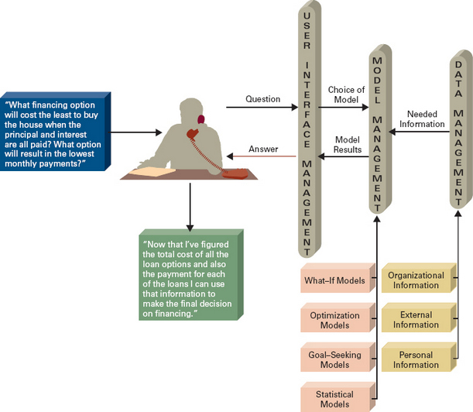

**Figure 4.4: Components of a Decision Support System**

**Model Management Component**  
The ***model management component*** consists of a wide variety of statistical and analytical tools, techniques, and models. The tools, techniques, and models you choose to use will vary greatly depending on the decision-making task at hand. Again, think about Excel. It contains basic descriptive statistics tools, goal-seek, solver, financial functions, math and trigonometry functions, engineering functions, and a host of others too numerous to mention. You can even create your own models by writing macros in Visual Basic. In an upcoming section on data-mining tools and models, we'll delve more deeply into many tools and models including some highly specialized and powerful analytics tools.

1. 5.2
2. Introduction
4. The past 15 years of the new economy introduced by the World Wide Web have certainly been interesting. There has been an entrepreneurial frenzy unlike anything the world has ever seen. Fortunes have been made and lost. Dot-com millionaires and billionaires were literally created overnight—many became dot-bomb paupers in about the same amount of time.  
     
   What fueled this frenzy and is still doing so today? It's electronic commerce enabled by information technology. ***Electronic commerce (e-commerce)*** is commerce, but it is commerce accelerated and enhanced by IT, in particular the Internet. E-commerce enables customers, consumers, and companies to form powerful new relationships that would not be possible without the enabling technologies. E-commerce breaks down business barriers such as time, geography, language, currency, and culture. In a few short hours, you can set up shop on the Internet and be instantly accessible to millions of consumers worldwide.  
     
   Is there a catch? The answer is both no and yes. It's "no" because it doesn't take much effort to create your own e-commerce Web site. It's "yes" because you still have to follow sound business fundamentals and principles to be successful. Let's not forget that fundamentally it's still all about commerce, businesses and people buying and selling products and services. E-commerce is no "silver bullet," as some entrepreneurs have found out to their chagrin.  
     
   In short, you must have a clear path-to-profitability. A ***path-to-profitability (P2P)*** is a formal business plan that outlines key business issues such as customer targets (by demographic, industry, etc.), marketing strategies, operations strategies (e.g., production, transportation, and logistics), and projected targets for income statement and balance sheet items. That is to say, running an e-commerce operation is no different from running a traditional brick-and-mortar business. You must identify your customers, determine how to reach them with a compelling story, and so on. The major error that most dot-com businesses made in the late 1990s—and they are no longer in existence today—is that they never developed a clear *path-to-profitability.*

6.3

Insourcing and the Systems Development Life Cycle

The ***systems development life cycle (SDLC)*** is a structured step-by-step approach for developing information systems. It includes seven key phases and numerous activities within each (see Figure 6.2). This version of the SDLC is also referred to as a ***waterfall methodology***—a sequential, activity-based process in which one phase of the SDLC is followed by another, from planning through implementation (see Figure 6.2).

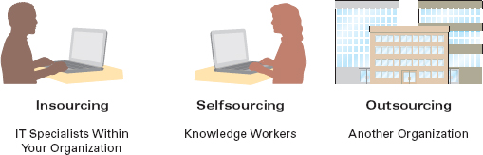

**Figure 6.1: Insourcing, Selfsourcing, and Outsourcing**

There are literally hundreds of different activities associated with each phase of the SDLC. Typical activities include determining budgets, gathering business requirements, designing models, writing detailed user documentation, and project management. The activities you, as an end user, perform during each systems development project will vary depending on the type of system you're building and the tools you use to build it. Since we can't possibly cover them all in this brief introduction, we have chosen a few of the more important SDLC activities that you might perform on a systems development project as an end user.

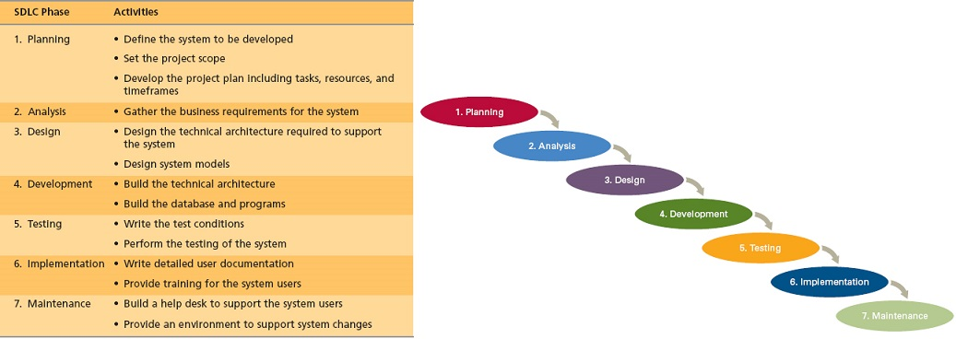

**Figure 6.2: The Systems Development Life Cycle (SDLC), Phases and Activities, and the Waterfall Methodology**

**Phase 1: Planning**

During the ***planning phase*** of the SDLC you create a solid plan for developing your information system. The following are the three primary activities performed during the planning phase.

1. *Define the system to be developed:* You must identify and select the system for development or determine which system is required to support the strategic goals of your organization. Organizations typically track all the proposed systems and prioritize them based on business impact or critical success factors. A ***critical success factor (CSF)*** is simply a factor critical to your organization's success. This process allows your organization to strategically decide which systems to build.
2. *Set the project scope:* You must define the project's scope and create a project scope document for your systems development effort. The project scope clearly defines the high-level requirements. Scope is often referred to as the 10,000-foot view of the system or the most basic definition of the system. A ***project scope document*** is a written document of the project scope and is usually no longer than a paragraph. Project scoping is important for many reasons; most important it helps you avoid *scope creep* and *feature creep.* ***Scope creep*** occurs when the scope of the project increases beyond its original intentions. ***Feature creep*** occurs when developers (and end users) add extra features that were not part of the initial requirements.
3. *Develop the project plan:* You must develop a detailed project plan for your entire systems development effort. The ***project plan*** defines the *what, when,* and *who*questions of systems development including all activities to be performed, the individuals, or resources, who will perform the activities, and the time required to complete each activity. The project plan is the guiding force behind ensuring the on-time delivery of a complete and successful information system. Figure 6.3 provides a sample project plan. A ***project manager*** is an individual who is an expert in project planning and management, defines and develops the project plan, and tracks the plan to ensure that all key project milestones are completed on time. ***Project milestones*** represent key dates by which you need a certain group of activities performed. Either of the two *creeps* alluded to above can throw off a project plan.

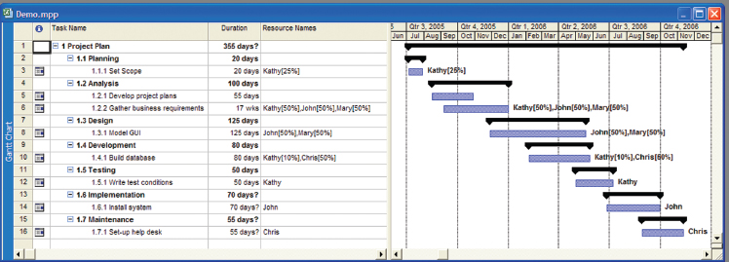

**Figure 6.3: A Sample Project Plan**

**Phase 2: Analysis**

Once your organization has decided which system to develop, you can move into the analysis phase. The ***analysis phase*** of the SDLC involves end users and IT specialists working together to gather, understand, and document the business requirements for the proposed system. The following are the two primary activities you'll perform during the analysis phase.

1. *Gathering the business requirements:* ***Business requirements*** are the detailed set of end-user requests that the system must meet to be successful. The business requirements drive the entire system. A sample business requirement might state, "The CRM system must track all customer inquiries by product, region, and sales representative." The business requirement states what the system must do from the business perspective. Gathering business requirements is similar to performing an investigation. You must talk to everyone who has a claim in using the new system to find out what is required. An extremely useful way to gather business requirements is to perform a joint application development session. During a ***joint application development (JAD)*** session users and IT specialists meet, sometimes for several days, to define and review the business requirements for the system.
2. *Prioritize the requirements:* Once you define all the business requirements, you prioritize them in order of business importance and place them in a formal comprehensive document, the ***requirements definition document***. The users receive the requirements definition document for their sign-off. ***Sign-off*** is the users' actual signatures indicating they approve all the business requirements. Typically, one of the first major milestones in the project plan is the users' sign-off on business requirements.

One of the key things to think about when you are reviewing business requirements is the cost to the company of fixing errors if the business requirements are unclear or inaccurate. An error found during the analysis phase is relatively inexpensive to fix; all you typically have to do is change a Word document. An error found during later phases, however, is incredibly expensive to fix because you have to change the actual system. Figure 6.4 displays how the cost to fix an error grows exponentially the later the error is found in the SDLC.

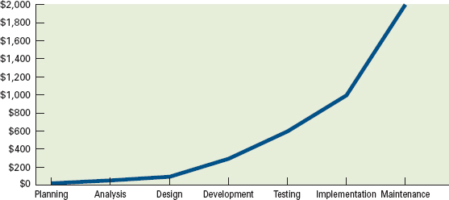

**Figure 6.4: The Cost of Finding Errors**

**Phase 3: Design**

The primary goal of the ***design phase*** of the SDLC is to build a technical blueprint of how the proposed system will work. During the analysis phase, end users and IT specialists work together to develop the business requirements for the proposed system from a logical point of view. That is, during analysis you document business requirements without respect to technology or the technical infrastructure that will support the system. As you move into design, the project team turns its attention to the system from a physical or technical point of view. You take the business requirements generated during the analysis phase and define the supporting technical architecture in the design phase. The following are the primary activities you'll perform during the design phase.

1. *Design the technical architecture:* The ***technical architecture*** defines the hardware, software, and telecommunications equipment required to run the system. Most systems run on a computer network with each employee having a workstation and the application software running on a server. The telecommunications requirements encompass access to the Internet and the ability for end users to connect remotely to the server. You typically explore several different technical architectures before choosing the final technical architecture.
2. *Design the system model:* Modeling is the activity of drawing a graphical representation of a design. You model everything you build including screens, reports, software, and databases (with E-R diagrams as we described in *Extended Learning Module C*). There are many different types of modeling activities performed during the design phase including a graphical user interface screen design.

It is at the point of the design phase in the SDLC that you, as an end user, begin to take a less active role in performing the various activities and divert your attention to "quality control." That is, IT specialists perform most of the functions in the design through maintenance phases. It is your responsibility to review their work, for example, verifying that the models of the screens, reports, software, and databases encapsulate all of the business requirements.

**Phase 4: Development**

During the ***development phase*** of the SDLC, you take all your detailed design documents from the design phase and transform them into an actual system. This phase marks the point at which you go from physical design to physical implementation. Again, IT specialists are responsible for completing most of the activities in the development phase. The following are the two main activities performed during the development phase.

1. *Build the technical architecture:* For you to build your system, you must first build the platform on which the system is going to operate. In the development phase, you purchase and implement equipment necessary to support the technical architecture you designed during the design phase.
2. *Build the database and programs:* Once the technical architecture is built, you initiate and complete the creation of supporting databases and writing the software required for the system. These tasks are usually undertaken by IT specialists, and it may take months or even years to design and create the databases and write all the software.

**Phase 5: Testing**

The ***testing phase*** of the SDLC verifies that the system works and meets all the business requirements defined in the analysis phase. Testing is critical. The following are the primary activities you'll perform during the testing phase.

1. *Write the test conditions:* You must have detailed test conditions to perform an exhaustive test. ***Test conditions*** are the detailed steps the system must perform along with the expected results of each step. The tester will execute each test condition and compare the expected results with the actual results to verify that the system functions correctly. Each time the actual result is different from the expected result, a "bug" is generated, and the system goes back to development for a "bug fix." A typical systems development effort has hundreds or thousands of test conditions. You must execute and verify all of these test conditions to ensure the entire system functions correctly.
2. *Perform the testing of the system:* You must perform many different types of tests when you begin testing your new system. A few of the more common tests include:  
   * ***Unit testing***—tests individual units or pieces of code for a system.
   * ***System testing***—verifies that the units or pieces of code written for a system function correctly when integrated into the total system.
   * ***Integration testing***—verifies that separate systems can work together.
   * ***User acceptance testing (UAT)***—determines if the system satisfies the business requirements and enables users to perform their jobs correctly.

**Phase 6: Implementation**

During the ***implementation phase*** of the SDLC you distribute the system to all the users and they begin using the system to perform their everyday jobs. The following are the two primary activities you'll perform during the implementation phase.

1. *Write detailed user documentation:* When you install the system, you must also provide employees with ***user documentation*** that highlights how to use the system. Users find it extremely frustrating to have a new system without documentation.
2. *Provide training for the system users:* You must also provide training for the users who are going to use the new system. You can provide several different types of training, and two of the most popular are online training and workshop training. ***Online training*** runs over the Internet or off a CD or DVD. Employees perform the training at any time, on their own computers, at their own pace. This type of training is convenient because they can set their own schedule to undergo the training. ***Workshop training*** is held in a classroom environment and is led by an instructor. Workshop training is most suitable for difficult systems for which employees need one-on-one time with an individual instructor.

You also need to choose the implementation method that best suits your organization, project, and employees to ensure a successful implementation. When you implement the new system, you have four implementation methods you can choose from:

1. ***Parallel implementation*** uses both the old and new systems until you're sure that the new system performs correctly.
2. ***Plunge implementation*** discards the old system completely and immediately uses the new system.
3. ***Pilot implementation*** has only a small group of people using the new system until you know it works correctly and then the remaining people are added to the system.
4. ***Phased implementation*** installs the new system in phases (e.g., accounts receivable, then accounts payable) until you're sure it works correctly and then the remaining phases of the new system are implemented.

Industry Perspective

**Green Systems Development**  
Much of our discussion in the past few sections has focused on the development of software. Rightfully so, software development efforts easily account for 80 percent or more of all effort within the SDLC. But there are other "development" issues you need to consider; one of them is building a green IT center.  
  
In March 2008, Honda opened its green IT center, a 61,000-square-foot facility, in Longmont, Colorado. It is one of only a handful of U.S. data centers certified by the Leadership in Energy and Environmental Design rating system for green building construction. What does it really mean to "go green"? Here are a few interesting things about Honda's environmentally friendly building.

* Floors made of recycled concrete
* Office furniture made of recycled steel and newsprint
* Low-flow automatic faucets
* Motion-sensor lights
* 73 percent of construction waste recycled
* Surrounding grounds left undeveloped
* Surrounding grounds that were disturbed by construction replanted with indigenous trees and shrubs
* Use of videoconferencing to avoid air travel
* Recycling almost everything from old computers to batteries to slide projectors (employees brought in 9 tons of old equipment from their home offices)
* Eliminating screen savers in favor of monitors that turn off

The list goes on and on. Even printing the right way saves Honda money. By defaulting to black-and-white and double-sided printing, Honda expects to save tens of thousands of dollars per year.**4**

**Phase 7: Maintenance**

Maintaining the system is the final phase of any systems development effort. During the ***maintenance phase*** of the SDLC, you monitor and support the new system to ensure it continues to meet the business goals. Once a system is in place, it must change as your business changes. Constantly monitoring and supporting the new system involves making minor changes (for example, new reports or information retrieval) and reviewing the system to be sure that it continues to move your organization toward its strategic goals. The following are the two primary activities you'll perform during the maintenance phase.

1. *Build a help desk to support the system users:* One of the best ways to support users is to create a help desk. A ***help desk*** is a group of people who respond to users' questions. Typically, users have a phone number for the help desk they call whenever they have issues or questions about the system. Providing a help desk that answers user questions is a terrific way to provide comprehensive support for users using new systems.
2. *Provide an environment to support system changes:* As changes arise in the business environment, you must react to those changes by assessing their impact on the system. It might well be that the system needs to be adapted or updated to meet the ever-changing needs of the business environment. If so, you must modify the system to support the new business environment.

6.8

### Summary: Student Learning Outcomes Revisited

1. **Define the traditional systems development life cycle (SDLC) and describe the seven major phases within it.** The ***systems development life cycle (SDLC)*** is a structured step-by-step approach for developing information systems. The seven major phases within it include:  
   * ***Planning***—creating a solid plan for developing your information system
   * ***Analysis***—gathering, understanding, and documenting the business requirements
   * ***Design***—building a technical blueprint of how the proposed system will work
   * ***Development***—taking all the design documents and transforming them into an actual system
   * ***Testing***—verifying that the system works and meets all the business requirements
   * ***Implementation***—distributing and using the new system
   * ***Maintenance***—monitoring and supporting the new system
2. **Compare and contrast the various component-based development methodologies.** Component-based methodologies (CBD) include:  
   * ***Rapid application development (RAD or rapid prototyping)***—extensive user involvement in the rapid and evolutionary construction of working prototypes of a system to accelerate the systems development process
   * ***Extreme programming (XP)***—breaks a project into tiny phases, with each phase focusing on a small aspect of the system that eventually becomes a component or small software module
   * ***Agile***—aims for customer satisfaction through early and continuous delivery of useful software components
3. **Describe the selfsourcing process as an alternative to the traditional systems development life cycle. *Selfsourcing (end-user development)*** is the development and support of IT systems by end users with little or no help from IT specialists. While the traditional SDLC uses in-house IT specialists to develop a system, selfsourcing has the user developing his or her own system. The user typically prototypes the system using the targeted application software environment and can thus continually refine and enhance the prototype until it becomes the final working system.
4. **Discuss the importance of prototypes and prototyping within any systems development methodology.** ***Prototyping*** is the process of building a model (i.e., ***prototype*)** that demonstrates the features of a proposed product, service, or system. Prototyping can be used effectively to gather requirements, help determine requirements when they are unknown, prove that a system is technically feasible **(*proof-of-concept prototype*)**, and sell the idea of a proposed system **(*selling prototype*).**
5. **Describe the outsourcing environment and how outsourcing works.*Outsourcing*** is the delegation of specific work to a third party for a specified length of time, at a specified cost, and at a specified level of service. Outsourcing is growing today because of globalization, the Internet, a growing economy and low unemployment rate, technology, and deregulation. Everything from food service to payroll services to call centers is being outsourced. In the outsourcing process, you target a system for outsourcing and build a ***request for proposal (RFP)*** that invites vendors to bid for its development. You choose a vendor and enter into an agreement called a ***service level agreement (SLA)*** that states exactly what the vendor is going to do. In the end, you test and accept the solution from the vendor and begin using the system.