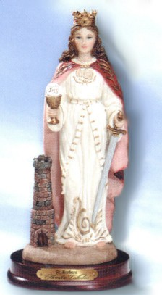
St. Barbara in Lindenwood, statue, 21st century northern Italy, www.inhisname.com/StatuePages/WomenStsStat.htm

