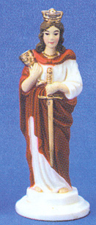
St. Barbara car statue, contemporary, Discount Catholic Store, Inc., Fort Montgomery, N.Y., www.discountcatholicstore.com/car_statues.htm

