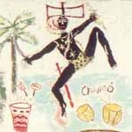
Chango, Cuba Junky, http://www.cuba-junky.com/cuba/religion.htm

