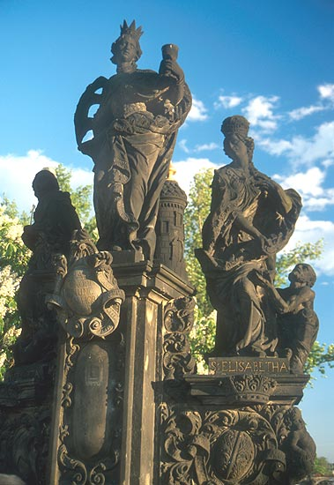
St. Barbara in middle of Charles Bridge Statue, 1707, Prauge, Czech Republic, www.photomann.com/prague

