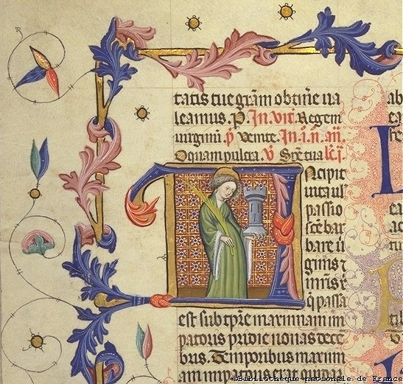
Breviary of Martin of Aragon, late 1300s-early 1400s, illuminated manuscript, Spain, Bibliotheque nationale de France, www.bnf.fr/enluminures/images/jpeg/i8_0080.jpg

