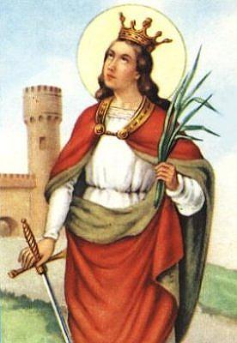
Santa Barbara, holy card drawing, 2003, Paz & Oracoes, Rio de Janerio, Brazil, www.pazeoracoes.hpg.ig.com.br/Santa_Barbara.html

