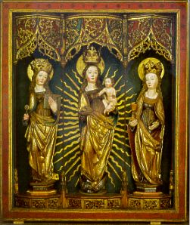
Madonna between the Saints Catherine and Barbara, altar, possibly 1243, Thuringer Museum, Eisenach, Germany, www.predigerkirche.eisenachonline.de/sammlung.htm

