I attached the template below:
Resource: RubiStar under Tools and Materials in the Assessment Toolkit.
Identify one of the objectives you have prepared for your lesson plan that reaches a high level of Bloom's Taxonomy.
Develop an appropriate assessment for the objective you have identified.
Create a rubric using RubiStar.
Click the Assignment Files tab to submit your assignment. You will submit 3 components with this assignment. 1- The lesson plan (including section of assessement filled out). 2- Assessment. 3- Rubric for your lesson plan.

Materials
- College of Education Resources
- Assessment Toolkit
- Signature Assignment: Lesson Plan*
- Signature Assignment Guide

- Signature Assignments are aligned to program student learning outcomes and provide critical information to help the university ensure students have mastered learning outcomes necessary to be effective practitioners and to assist in the university’s programmatic assessment process. Students will use the knowledge and skills learned throughout the program to complete this assignment. Signature Assignments are required and cannot be changed or deleted, as denoted by the asterisk in the title.

- This course contains a Signature Assignment: Lesson Plan. It is due in Week 6. The Signature Assignment in this course is aligned to Program Student Learning Outcome: Students can design and implement effective instruction in the elementary classroom to produce a positive impact on student learning.

- Students and faculty can access the Signature Assignment in the week in which it is due by clicking on the assignment’s link. The link will be labeled as a Signature Assignment followed by the assignment’s name and an asterisk (*).

- Sample:
- 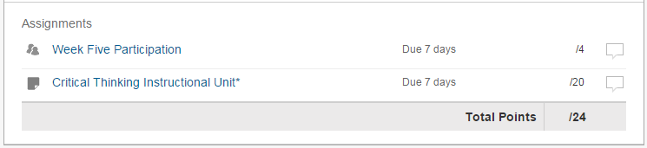

- The Signature Assignment will be evaluated by faculty using a standardized rubric. Students can access the Signature Assignment in the week in which it is due by clicking on the assignment’s link and then going to the Grading tab. Hover over each section of the rubric to review the expectations (Meets, Exceeds, etc.).

- Note: The Signature Assignment can be submitted and evaluated only one time in the course. There is no opportunity for re-submitting the assignment based on faculty feedback. It is important to review the assignment and rubric throughout the course to ensure that the final product meets the assignment requirements and the rubric expectations.

Lesson Plan Template
Subject:
Lesson Title/Lesson #:
Grade Level:

Central Focus

What is the focus for the content in this learning segment?
Content Standard(s)

Identify state standards and/or Common Core standards.
Learning Objectives

Identify specific, measureable objectives (aligned with the standards) for the lesson.

Materials

What materials are needed for the teacher and students?

What instructional resources are needed for the teacher and students?

Classroom Arrangement/Grouping  How will the classroom be set-up for this lesson in order to influence a positive learning environment?  How will you engage students based on individual and group needs?  How does the physical layout and classroom arrangement support the instructional approach? | Whole class:  Groups of students with similar needs:  Individual students:  Students with IEPs or 504 Plans:
Instruction

List detailed step-by-step procedures.

What will you and the students be doing (lesson delivery, guided practice, closure, independent practice)?

Assessment

Identify formative assessment(s).

Identify summative assessment(s).

