Sites Unseen: Shimon Attie's Acts of Rememberance. 1991-1996

Assignment: This assignment is to help you develop practices of active reading and writing. At various points throughout the essay, you will be asked to stop and comment in preparation for answering the four questions below. As you progress through the essay your responses should be more and more in depth. At the end of the essay you are required to use your comments to answer each of the four questions.

Evaluation: You will be evaluated on both your final answers and your comments
throughout.

Sites Unseen Shimon Attie’s Acts of Rememberance, 1991-1996
“Lieux de mémoire are created by the interaction between memory and history. . . Without an intent to remember, lieux de mémoire would be lieux d’histoire.”
--Pierre Nora, Realms of Memory

Some people claim intuitively to sense the invisible aura of past events in historical sites, as if the molecules of such sites still vibrated with the memory of their past. Shimon Attie is not so naive. He knows that this presence of the past is apparent only to those already familiar with a site's history or to those who actually carry a visual memory of this site from another, earlier time. For Attie, memory of a site’s past does not emanate from within a place but is more likely the projection of the mind's eye onto a given site. Without the historical consciousness of visitors, these sites remain essentially indifferent to their pasts, altogether amnesiac. They only “know” what we know, “remember” only what we remember.
For by themselves, these sites lack what French intellectual historian Pierre Nora has called "the will to remember.'' That is, without a deliberate act of remembrance, buildings, streets, or ruins remain little more than inert pieces of the cityscape. Without the will to remember, Nora suggests, the place of memory "created in the play of memory and history.. . becomes indistinguishable from the place of history."¹ If it is true that such places of memory exist "only because of their capacity for metamorphosis," as Nora believes, then here we shall examine the work of an artist as agent of metamorphosis, one whose acts of remembrance transform the sites of history into the sites of memory.
In Sites Unseen, Shimon Attie's series of European installations between 1991 and 1996, the artist has done more than simply project his necessarily mediated memory of a now-lost Jewish past onto otherwise forgetful sites.
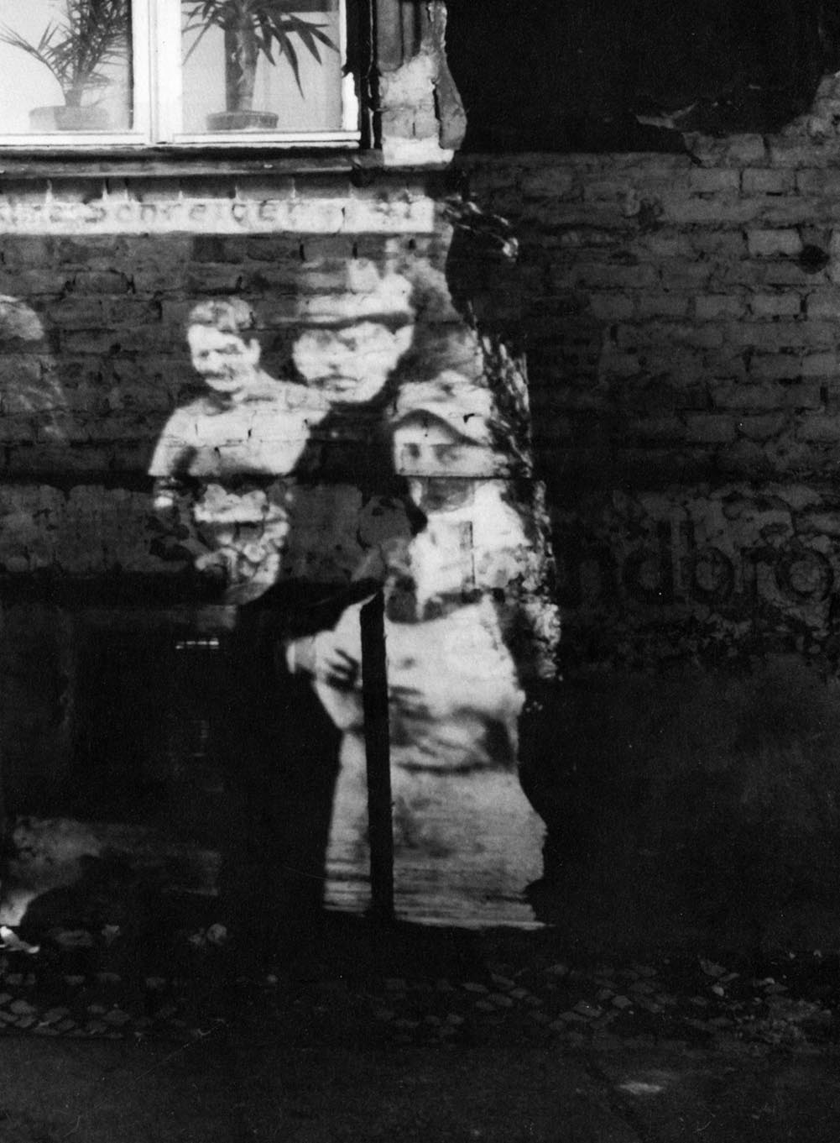

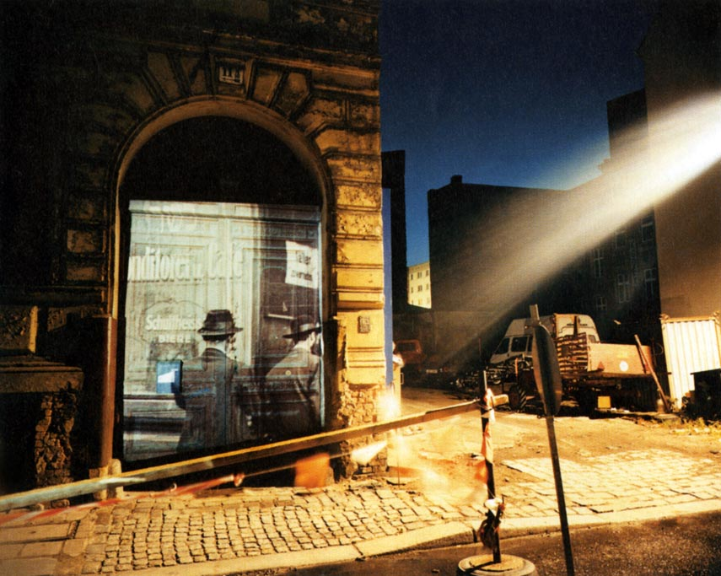

Shimon Attie, Joachimstrasse 11a, 1933, 1992. (Writing on the Wall)

He has also attempted a simultaneous critique of his own hypermediated relationship to the past. By literally bathing the sites of a now invisible Jewish past in the photographic images of their historical pasts, he simultaneously looks outward and inward for memory: for he hopes that once seen, the images of these projections will always haunt these sites by haunting those who have seen his projections. The sites of a lost Jewish past in Europe would thus retain traces of this past, if now only in the eyes of those who have seen Attie's installations.
When Shimon Attie moved to Berlin in 1991, he found a city haunted by the absence of its murdered and deported Jews. Like many Jewish Americans preoccupied by the Holocaust and steeped in its seemingly ubiquitous images, he saw Jewish ghosts in Europe's every nook and cranny: from the Scheunenviertel in Berlin to the central train station in Dresden; from the canals of Copenhagen to those of Amsterdam; from Cologne's annual art fair to Krakow's Kazimierz neighborhood. For Attie, however, private acts of remembrance in which he alone saw the faces and forms of now absent Jews in their former neighborhoods were not enough. He to chose, therefore, to actualize these inner visions, to externalize them, and in so doing to make them part of a larger public's memory. Once thus actualized, he hoped, these images would enter the inner worlds of all who saw them and would continue to haunt the sites even when no longer visible. He hoped that once others had become witnesses to his memorial projections, the installations themselves would no longer he necessary.
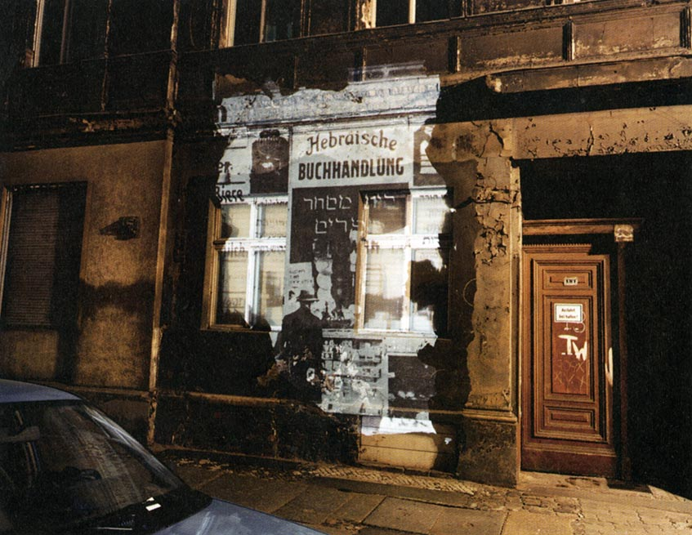

Shimon Attie, Almadstrasse 43 (formerly Grenadierstrasse 7), Former Hebrew Bookstore, 1930, 1992. (Writing on the Wall, Berlin)

At the same time, Sites Unseen was not intended as a series of simple recollective acts, attempts to repair a broken past-continuous. Each installation also recast memory in some way, re-marking its relation to the site even as it explored the site's relation to its past. As a result, each project sustained a certain yet. subtle ambivalence toward itself, even as each mixed the kinds of memory it generated. At each stage, the distance from personal to public memory was measured, as well as the reciprocal exchange between a specific site and its national context, the ways every site resonates with a nation’s self-idealizations.
Part photography, part installation, and part performance, the totality of these projects might best he described as an "act of remembrance"—retaining the resonance of actions, staged acts, actors, and acting out. For in equal measure, the projects included the literal actions that brought them into being, made actors of local residents, staged interventions between local residents and their homes, and provided a medium for the artist's own acting out of his obsession with the void left by Europe's absent Jews. Nor should the book you are now holding he mistaken for the "acts of remembrance” it explores, which like the historical events being commemorated are now over. Rather, this book is an after-image in its own right, a reflection on these acts.
In the pages that follow, therefore, I ask what happens between the mind of someone like Attie, immersed in the public iconography of the Holocaust, and the actual sites of history now seemingly oblivious to their pasts. On one hand, Attie the artist is painfully aware that all he knows and remembers of the Holocaust has been passed down to him by others—shaped and filtered by a nation’s self-aggrandizing myths, by a popular culture more intent on entertaining than on teaching him. He knows, moreover, that his artwork will inevitably interpose yet another mediating layer between history and memory, another veil of images that might be confused for the history they would recall.
But then, Attie has no alternative. Instead of memory-acts that collapse the distinction between themselves and the past, therefore, he proposes acts of remembrance that expose just this gulf between what happened in the past and how it now gets remembered. Whether it is national myth and self-idealization or the silver screen and its compelling artifice that blurs the distinction between actual past and present memory of it, or whether it is only the muteness of a cityscape that hides its history, Attie makes as his object of memory the distance between then and now, the ways that even his own acts of remembrance cannot but gesture indirectly to what was lost and how we now recall it.

Q1. Stop! Reflect on the author’s introduction. Use this information to record observations and/or notes in the comment box that will help you answer question “B".

"After finishing art school in San Francisco, I came to Berlin in the summer of 1991,” Shimon Attie writes in his introduction to a hook for The Writing on the Wall." Walking the streets of the city that summer, I felt myself asking over and over again, Where are all the missing people? What has become of the Jewish culture and community which had once been at home here? I felt the presence of this lost community very strongly, even though so few visible traces of it remained." ² Strangely enough, it was not the absence of Berlin’s lost Jews that Attie felt so strongly but their presence . For in fact, though they may have been invisible to others walking those same streets, Attie's memory and imagination had already begun to repopulate the Scheunenviertel district in Berlin with the Jews of his mind.
After several weeks of photographic research in Berlin’s archives, Attie had found dozens of images from the Scheunenviertel of the 1920s and 1930s and was able to pinpoint nearly one-quarter of their precise locations in the current neighborhood just east of Berlin's Alexanderplatz, formerly in the eastern sector of the city. That September, only three months after moving to Berlin, Attie began projecting slides of these photographs onto the same or nearby addresses where they had been taken earlier in the century. " 'The Writing on the Wall' grew out of my response to the discrepancy between what I felt and what I did not see,” Attie explains. "I wanted to give this invisible past a voice, to bring it to light, if only for some brief moments." ³ And so for the next year, weather permitting, Attie projected these images of Jewish life from the Scheunenviertel before the Holocaust back into present-day Berlin. Each installation ran for one or two evenings, visible to local residents, street traffic and passerby. During these projections, the artist also photographed the installations themselves in time exposures lasting from three to four minutes. The resulting photographs of the installation have been exhibited widely in galleries and museums, works of fine art in their own right, the only remaining traces of the original installations.
But in fact, the artist is all too aware of the difference between the public installations in situ and their reduced and codified standing in a gallery or catalogue. "The point was to intervene in a public space and project right onto those spaces,” he has said. "One can always overlay images in a dark-room or with a
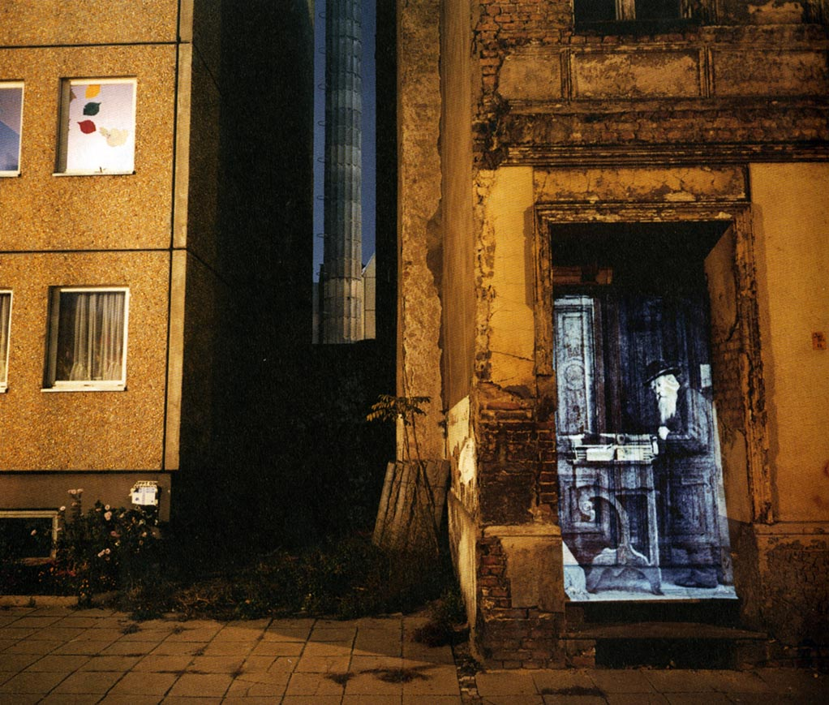

Shimon Attie, Almadstrasse (formerly Grenadierstrasse and corner of Schendelgasse), Religious Book Salesman, 1930, 1992. (Writing on the Wall)

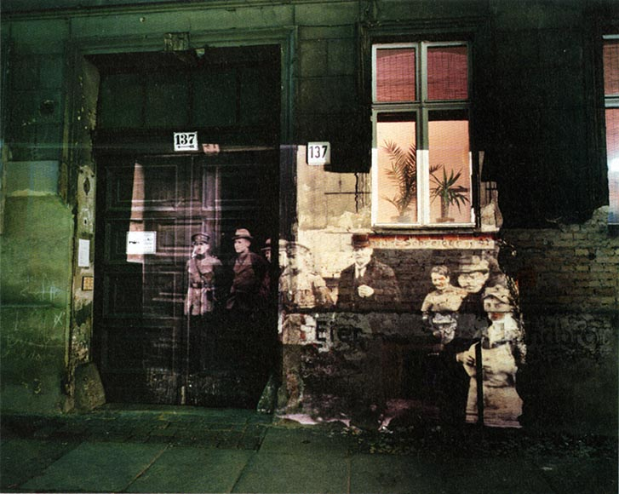

Shimon Attie, Linienstrasse 137, Police Raid on Former Jewish Residents, 1920, 1992. (Writing on the Wall, Berlin)

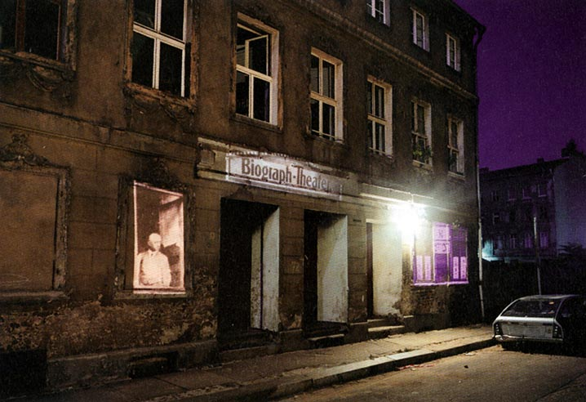

Shimon Attie, Joachimstrasse 20, Former Jewish Resident,Theatre, and Torah Reading Room, 1929-1931, 1992. (Writing on the Wall, Berlin)

computer. But I wanted to touch those spaces" ⁴ Or one might add, he wanted to "retouch" those spaces the way one retouches photographs. For the photographic process-in literal and metaphorical ways-lies at the heart of this project: as the original archival photographs captured traces of reflected light and dark from the prewar Scheunenviertel, the artist’s photographs of the installations would now capture the light of the photographic images themselves as projected onto building walls. The analogue between the mechanical process of photography and the memory of images recorded by the mind's eye is made real here: in both cases, reflected light imprints itself on light-sensitive surfaces, whether film or retina, that bear its traces afterward.
For Attie recognizes at the outset that public spaces, even the dreariest in our day-to-day lives, also reflect meaning and significance back to us. They also become "art” in the eyes of beholders, at once framed and composed by our reflective gaze. Obversely, the projections themselves become inside-out "frames" for all that surrounds them, turning the rock-hard reality of the present into an extension of the past images now draped over it.

Q2. Stop! How does this information relate to question “A”?

Once projected onto the peeling and mottled building facades of this quarter, these archival images seem less the reflections of light than illuminations of figures emerging from the shadows. Attie says he wanted "to peel back the wallpaper of today and reveal the history buried underneath." ⁵ From the doorways, in particular, former Jewish residents seem to be stepping out of a third dimension. Some, like the resident standing in the doorway at Joachimstrasse 2, are caught unaware by both the original photographer and now, it seems, by us. Others, like the religious book salesman at the corner of what was formerly the corner of Grenadierstrasse and Schendelgasse, seem to have been interrupted by the photographer; the book salesman has turned his head sideways to gaze impassively back at us. Because the streets of the dilapidated Scheunenviertel (called the Finstere Medine, or "dark quarter," by its Yiddish- speaking denizens) are still largely run down, as were many parts of the formerly East Berlin when the wall came down, the projected images added a life to these streets that they appeared otherwise not to have.
If the projected images of Jews going in and out of buildings or sitting in windows or huddled on a corner suggest themselves as a material part of the space they now reinhabited, once photographed, these subjects take on formal qualities that were less apparent in the installations themselves. As works now independent of the installations they represent, the photographs also recompose them, highlighting not only the apparition of a spatial, human dimension created in the installation but also now the iconographic play of signs and symbols. The Hebrew lettering of Yiddish signs mixes with German Gothic lettering in the images, both strewn together anarchically with painted post-Berlin Walgraffiti—all of it a kind of literary detritus on scarred walls. The projected lettering of Meier Silberberg's kosher butcher shop at Mulackstrasse 32 runs into the taggings of graffiti artists and postunification slogans like "The struggle continues." Even more dramatic in its silence is the photograph of a slide installation from the corner of Joachimstrasse and Auguststrasse: the barely visible head of a Jew in prayer philacteries beneath a white Star of David beams over the doorway of a dark building, itself backlighted by the rosy pink of a sunset. The star stands in stark, formally eloquent contrast to three rows of crucifix-like white windowpanes on the dark bugding across the street, arrayed like a battle formation of Crusader shields.
Even the human figures of Jews, animated by the play of light and air on textured surfaces, are reformalized in the photographs of the installations, hardened once again into the icons of the so-called Ost-Juden. It was the traditionally garbed Jews of eastern Europe, after all, who had moved into this quarter in the 1910s and 1920s, already a netherworld of criminals, prostitutes, and the dispossessed. But it is not this unlikely mixture of the sacred and profane that Attie hopes to capture here. Rather it is a type,” the Jew” of the Germans' minds so long associated with long black caftans, beards, and earlocks that Attie brings back to haunt current residents. Because German Jewry itself was often so well assimilated as to appear effectively invisible, Attie has had to rely on the image of Ost-Juden to make visible the otherwise , invisible Jews of Germany-even though they themselves were not representative faces of German Jewry itself.

Q3. Stop! Go back and examine all the images associated with the Writing on the Wall.

When these Ost-Juden tried to return to Poland after the first Nazi-inspired pogroms and anti-Jewish boycotts, they found that their Polish papers had been in-validated. As stateless refugees, these Ost-Juden also became Berlin's first true Luftmenschen, a type reified in Attie's projection of their images hack through the air onto buildings. And it is as both Luftmenschen and as Jewish projections of the Nazi mind that Attie would have these images haunt contemporary Germans. It would be easy to work up sympathy in Germans for all the Jews who were murdered "even though they looked just like us." But it is the idea and treatment of "the other" that concerns Attie in this project. During his stay in Berlin, Attie was fully aware that the more people appeared as "other" in today's Germany, the more likely they were to be persecuted. The tragedy of the Holocaust was not the "mistake” in killing those who looked like every-one else but the hideous rationale that justified killing those who didn't look like us.
Ironically, of course, the "voice" Attie gave these absent Jews was at times also the voice of residents objecting to the project itself. While Attie was installing the Buchhändler (bookseller) slide projection, for example, a fifty-year-old man suddenly came running out of the building shouting his father had brought the building “fair and square” from Mister Jacobs in 1938. “And what happened to this Mr. Jacobs?” Attie asked the man. “Why, of course, he was a multi-millionaire and moved to New York." ⁶ Of course. All of which was captured by German television crews, who broadcast the incident that night on national news. Attie couldn't have scripted this projection more powerfully. Another resident called the police to complain angrily that Attie's projections of Jews onto his building would make his neighbors think that he was Jewish. Make him stop, he pleaded. The residents' response is as much a part of these works as the installations themselves, says Attie. Without these responses, the installations, like the buildings themselves, would have remained inert, inanimate, dead.

Q4. Stop! What do these reactions tell us about our connection to history? Record your observations related to question “C”.

Indeed, even though these images may have disappeared from sight as soon as Attie turned off the high-intensity projector, their after-image lived on in the minds of those who had seep them once. From this point on, the images of these Jews “live” only as their subjects lived before them: in the photographs of these installations. These are quite literally photographs of photographs we are seeing here, just as the local burghers now walk their neighborhoods haunted by their memory of Attie's memory-installation. They are now haunted not by the Jews who had once lived here, or even by their absence, but by the images of Jews haunting the artist's mind.
As Michael André Bernstein has made painfully clear, photography is always about loss, about the absence of what was once real in front of the lens: hence the essential melancholia at the heart of the photograph. “To look at a photograph,” Bernstein writes, "is to experience a certain sorrow at the sheer fact of loss and separation, curiously mingled with the pleasure of recognizing that what no longer exists, has been, if not restored to us, then at least memorialized for us, fixed in the stasis of an image now forever available to our gaze."⁷ Insofar as this bittersweet mixture of sorrow and pleasure necessarily haunts our experience of all photographs, its extremes seem wildly exaggerated in these wall projections. For it's true, they are beautiful and chilling, slightly exhilarating and depressing: they inspire longing and fear, hope and despair. By keeping the mixture between sorrow and pleasure in balance, they can also keep their potential for redemption in check, never allowing the pain of such loss to be redeemed by the beauty of the image itself.

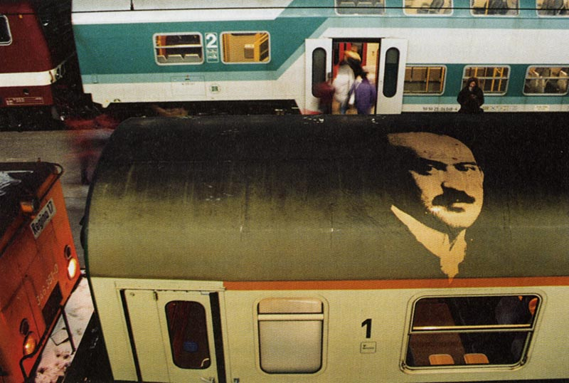

Shimon Attie, Former Dresden Jewish Citizen. (Trains, Dresden, 1993)

In this way, these installations have served as a somewhat literal metaphor for the artist’s projection of his inner desires onto the walls around him. All of us wish we could bring the victims back to life, to repair the terrible wound. But The Writing on the Wall is no such reparation or bringing back to life; it is, rather the reminder of what was lost, not what was. At the same time, it is clear in Attie’s mind, as he means for it to be in ours, that these projections are simulations, not historical reconstructions. Their immense value lies in showing us not literally what was lost but that loss itself is part of this neighborhood’s history, an invisible yet essential feature of its landscape.

Q5. Stop! Reflect on Attie’s installation and the conclusion to this section. Record observations that will help you expand your answer to question “C”.

Trains: Dresden, 1993

Of all the banal sites of daily life in Germany forever corrupted by their history during World War II, the railways may be the most ineradicably stigmatized in the eyes of Jewish tourists. Not only is this because the image of cattle cars loaded with Jews on their way to (and from) death camps remains so pervasive in the iconography of the Holocaust. But when riding these trains in Germany after the war, many young Jewish travelers can’t escape the sense of “having been there before.” The sense of traveling the same routes as the victims, watching the same landscape flit by, and hearing the same clackety-clack on the same tracks induces an illusory identification with the victims unlike almost any other experience in Germany.
Like the Scheunenviertel in Berlin, haunted by its now absent Jews, the Dresden train station seemed haunted to Attie by its absence of any sign of the central role train stations played throughout Germany during the Holocaust. These were the sites of collections for deportations, the last places many German Jews ever saw of their homeland, the tracks constituting a literal, material line connecting Germany to the death camps. In keeping with his medium of photographic projections, Attie and his collaborator, Mathias Maile, found photographs of Dresden's former Jewish citizens who either had been deported or had emigrated and then projected them back into the city's central railway station.
This project was in many ways more confrontational than The Writing on the Wall, which had more passively chastened local citizens for letting their former neighbors disappear into the ether of time. For in projecting specific faces from Dresden's Jewish community directly onto the trains, tracks and walls of the central station, Attie and Maile linked the photographic memory of the victims directly to their fate: to the literal sites of deportation, of emigration, of German-Jewish leave-taking. After culling some dozen images from family albums of Dresden's tiny Jewish com-munity, Attie converted them into high-contrast black-and-white slides. For two weeks beginning on the ninth of November 1993 (the anniversary of Kristallnacht), images of handsome, smartly dressed young and middle-aged men and women shone brightly from the rafters of the station; other images of sad-eyed Jews peered up at travelers from the tracks or stared down rebukingly from the walls or con-fronted travelers face to face from the sides of trains. The familiar daily routine of travel was estranged and disrupted by these immense black-and-white projections; weekend holidays commenced on a decidedly melancholy, less, festive note. For a few moments every day, postwar Germans were haunted by the vicarious memory of an American Jew. Now they, too, were forced to see and remember what the Jewish traveler cannot put out of his or her mind: that on this platform, on these tracks, the Jews whose faces I see began to die.

Q6. Stop! Think about the context of this installation, Trains: Dresden. How does the site of the installation differ from that of Writing on the Wall?

In a similar installation in Hamburg, Attie projected images without the benefit of explaining captions. But when a curious passerby asked him whether these were the pictures of the German Railway founders, he decided to mount large posters that made the source of these images explicitly clear. With this lesson in mind, he repeated the process in Dresden. He had wanted the rebuke of memory to come from within contemporary travelers as the significance of these images dawned on them-now trapped in this conflation of time and space. The more he had to explain, he felt, the less successful and more coercively didactic the project became. But as word of the memorial projections spread, his accompanying captions became less necessary; and in the end, as tens of thousands of travelers saw and thereby internalized these images, the projections themselves became unnecessary altogether.

Q7. Stop! Examine the images associated with Trains: Dresden. Record your responses and use them to answer question “A”.

Portraits of Exile: Copenhagen, June-July1995

An epitaph written in water is no epitaph at all, as John Keats realized when he penned his own to read: "Here lies one whose name is writ in water." Unlike the nameless tombstone bearing these words and marking Keats's grave in Rome's Protestant cemetery, however, all traces of Denmark's extraordinary rescue of its Jews were erased by the very water that bore them to safe haven in Sweden. The water that made their rescue possible, and covered their track so well, also made a landscape of commemorative traces of this rescue impossible. As a memorial medium, in fact, water is more like fleeting time in its ephemerality than like a fixed landscape in its stasis, and so more emblematic of memory itself-always taking the shape of the vessel into which it is poured.
In the memorial and historical culture of Denmark, water is also much more. It was not only the road to rescue for Denmark's Jews during the Nazi occupation in October 1943, but it has always constituted Copenhagen's historical and economic raison d’être as ancient seaport, quite literally the capital's historical life- source. With these thoughts in mind Shimon Attie chose the Borsgraven Canal in Copenhagen as his installation site for Portraits of Exile—a commemoration of the fiftieth anniversary of Denmark's liberation from the Nazis. This was not. to be merely a self-congratulatory celebration of the war's end in the monolithic image of Denmark's heroic rescue of the Jews, however. For unlike the images of Jews projected back onto the buildings of the Scheunenviertel in Berlin, which seemed to animate otherwise inert surfaces, it was the somewhat stock and myth-hardened imagery of heroism itself that Attie animated—and thus dissolved—in the watery medium of Copenhagen’s canals.

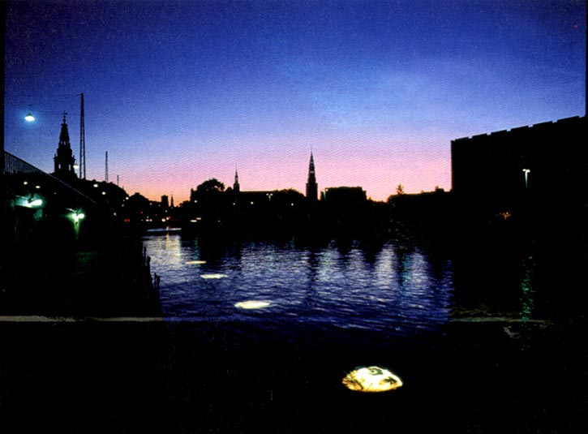

Shimon Attie, Installation Shot. On lightbox in the foreground: present-day refugee from the former Yugoslavia with Danish entry stamp on passport. (Portraits of Exile, Copenhagen)

Here he installed a row of nine light boxes, each approximately six feet by five feet, about thirty-three feet apart, and submerged nearly three feet below the water’s surface some fifteen feet from the bank of the canal. Eight of these light boxes were mounted with the transparency of a photograph depicting either the face of a Danish Jew rescued to Sweden or the face of a present-day refugee living in Denmark. One light box in the middle of the series was mounted with the transparent image of a sea map charting the straits between Denmark and Sweden. Visible by night and day, these backlighted faces stared up eerily, stirring with life as the water rippled over them. From a distance, the images seemed to float on the surface as orbs of light, a trail of stepping stones leading out to sea.

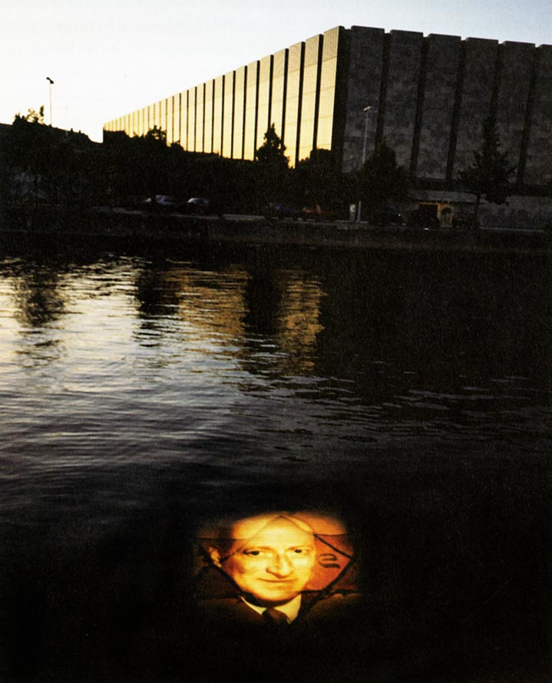

Shimon Attie, in the foreground: Danish Jew rescued to Sweden in October, 1943 with yellow star. (Portraits of Exile, Copenhagen)

But the spectacle itself might have blinded viewers to details apparent only on closer inspection. When the wind and tides were perfectly still, and the water's surface took on a mirrorlike sheen, other layers of these images came into view just be-yond the surface reflection of one's face. Each image was of a different refugee, each overlaid with a different sign of exile: a portrait of a Danish Jewish man overlaid onto an image of a yellow Jewish star; another of a Danish Jewish woman overlaid onto a sea map; other faces of rescued Danish Jews overlaid onto images of a fishing boat and a commercial freighter used in the rescue. The middle image of the sea map was itself overlaid by two boats, one with Jews on their way to Sweden, the other with present-day refugees coming to Denmark.

Q8. Stop! Study the images associated with Attie’s Copenhagen installation. Reflect further about question “B”.

At this point, the narrative created in this sequence of images began to generate a decidedly double-edged memorial message, fraught with pride and shame. For the next portrait of a Bosnian Moslem refugee in turban was followed by a Bosnian woman overlaid by an image of the Flotel Europa moored one canal away—a notoriously overcrowded floating hotel ship crammed with refuges awaiting political asylum in Denmark, some of them for years. The last two images consisted of the face of a Yugoslav man seemingly textured by an overlaid sea map and a Yugoslav woman whose face was blotched by the image of a passport entry stamp. Placed in the center of a topographical triad composed of the Danish foreign ministry, the parliament, and the National Bank of Denmark, these portraits of exile seemed simultaneously to shine as commemorative and warning lights to the government.
This mixed memorial message was intended not to refute Denmark's reigning self-idealization as a perennial haven of refuge but only to pierce the self-congratulatory side of this myth that blinds it to other, conflicting historical realities. Nor were such images juxtaposed to imply equivalence between refugees but to heighten a troubling contrast: where almost all Danish Jews were saved, not all Bosnians have found refuge, many more murdered at home than given safe haven in Denmark or other European countries. At the same time, the artist showed how every national commemoration necessarily occludes as much history as it recalls. For even this greatest of mass rescues during the Holocaust, once mythologized as part of the national character, has overshadowed another, less well known fact of this era: that Denmark had refused to grant asylum to thousands of Jews attempting to flee Nazi Germany before the war.
Such a fact does not diminish the brilliance of Denmark's national heroism but only complicates it, thereby making it less mythlike, more real. Public memory here is as fraught and contradictory, as complex and multisided, as the history being commemorated. In its mixed message, such an installation may even suggest that it is the memory of a mixed past that actually impels a nation toward new acts of rescue. For the national memory of heroism, like the heroic act itself, stems from a mixture of motives—high, low, and ambivalent.

Q9. Stop! How does Attie’s installation in Copenhagen complicate our notion of memory? Record your reflections to use in your answer to question “D”.

Brick by Brick: Cologne, November 1995

The physical sites of history are not the only potential sites of memory. In Attie's eyes, even the designs of household objects can recall the times of their origin and, by extension, the households from which they have been torn. Pieces of Bauhaus or Art Deco furniture come to stand as icons of an era that point beyond themselves to the dark age they passed through and to the owners—both killers and victims—they may have survived. Having reanimated public sites in Berlin and Dresden with images of their forgotten pasts, the artist now turned his gaze into the more private, even intimate sanctum of the household, its objects transformed into accusing sites of memory.
In Brick by Brick, an installation just outside the doors of the Cologne Art Fair in November 1995, Attie projected images of simple household objects dating from turn-of-the-century Germany onto the massive brick columns of the Rheinhalle. Projected so that they seemed almost to he materializing from within the brick columns, images of a Singer sewing machine, a late nineteenth-century commode, a Bauhaus menorah, a Bauhaus dining room table, an overstuffed armchair, and four other similarly aged objects confronted patrons of ART COLOGNE as they left the exhibit hall. Though this particular crowd of collectors and connoisseurs would have recognized the general period of these objects' origins, neither they nor the artist could know the provenance of any given piece—gleaned by the artist from antique stores as well as from Bauhaus and other catalogues. But this ambiguity was partly the point, for it was into this area of uncertainty that the artist projected his preoccupations, assigning not a precise provenance but a generic, possible provenance to these and all pieces like them.
At the same time, this was a site-specific installation. For as Attie and his collaborator, Mathias Maile, made clear in a handbill passed out to visitors at the fair, the Kolner Messegebaude (Cologne Fair Building) had its own dark, if multilayered and unacknowledged past. Built in 1923, the Cologne Fair Building had hosted its share of fairs, it was true, but after the Nazis came to power in 1933, it also served as an examination center for German army draftees as well as a great hall for the ideological reeducation of German schoolteachers. After launching the war in 1939, the Nazi government took control of the fair building and turned it first into a prisoner- of-war camp and then, in 1940, into a gathering and deportation site for Sinti and Roma. Still later it served as a transfer station for Jews about to be deported to the east through the neighboring Deutz-Tief train station.
In fact, because the Nazis had taken over all such exhibition halls in Germany by this time, the fate of the Cologne Fair Building was no more ignoble than that of any other public hall in Germany. Rather, what had made this fair building special in Attie's eyes were the ways another part of its history seemed to find some continuity in the art fair itself. For some reason, the Cologne Art Fair, arguably the most prestigious of its kind in Germany today, opens every year on November ninth or tenth, the anniversary of Kristallnacht in 1938. Even more significant for Attie, however, was the building's use during the war as a storehouse for confiscated furniture and other household belongings of Jews who had been either forced to emigrate or deported to concentration camps. As the hall's stores filled up, Nazi Party officials would hold auctions open to party members whose households had been damaged by Allied bombings. As a chilling illustration, Attie photocopied an announcement for one such auction, Gothic script and all, as part of his handbill:

Auction
Attention, Bombing Victims!
On Monday, the 21st of December 1942 and following days, I will hold an auction at the Cologne-Deutz Fair (South Hall) from 9:00 A.M. to 3:00 P.M. Bedroom, men's Bedroom, all kinds of wardrobes, tables, down beds, couches, sofas, teawagon, upright dock, table dock.

The list of objects included all the furnishings typical of any middle- or upper middle-class German Jewish home. The rest of the handbill described how beginning in 1942, a slave labor camp was installed on the Cologne fairgrounds in the form of a so-called worker education camp. And finally, at the end of 1942, a satellite camp of Buchenwald composed of "SS Construction Crew III" was established on the fairgrounds, supplying some one thousand slave-laborers to the nearby Rhenish factories.
Thus greeted by this "counter-fair" on their way out of ART COLOGNE, patrons were forced to reconsider this site as something more than an exhibition hall for contemporary art. On display at the fair, but not for sale, Attie’s installation

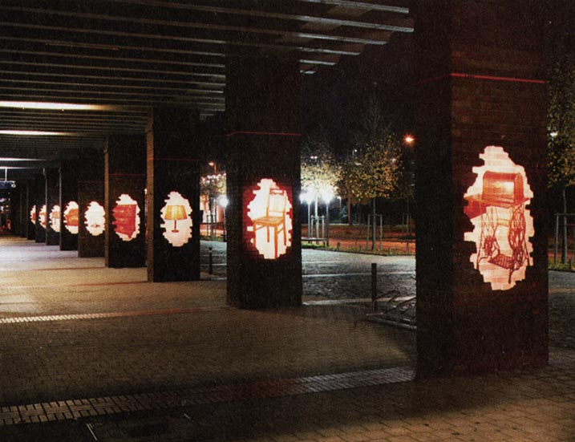

Shimon Attie, on column in foreground: sewing machine. (Brick by Brick, Cologne, 1995)

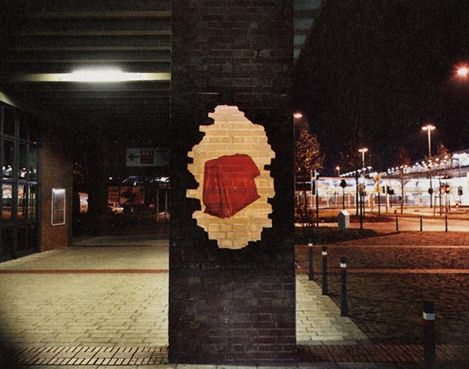

Shimon Attie, on column: briefcase. (Brick by Brick, Cologne, 1995)

redefined the hall as nexus of history, commerce, and memory. In a way, the art fair’s organizers had foisted this link on Attie by scheduling its opening every year on the anniversary of Kristallnacht. Once inspired, however, Attie pursued the question that might logically follow “What happened to all the Jews of Germany?” That is, “What happened to all their household belongings and personal effects?” Further implied questions include not only “Where were you during the war?” but also “To whom did that table belong before the war? Is it an ill-gotten gain, a Nazi-sanctioned piece of war booty? Or was it passed down innocently from one generation to the next?” Instead of suggesting answers, the artist let such questions float in the space of the art fair, between his installation and the bustling art patrons. Contemporary German collectors were now confronted uneasily with the possibility that these objects had even been distributed among their own households.
What makes such an installation so subversive is the way it plants the seeds of doubt in every such piece: the more authentic it is, the more it might remind its current owner of its possible provenance. Even perfectly “innocent” pieces might now echo with the voices of the dead, and by their very design, such pieces begin to accuse their owners. In effect, the provenance of antiques from this era makes them not only valuable but historical. In Brick by Brick, the artist has thus stigmatized an entire generation of household objects and, in so doing, has transformed each piece from mere memento into an accusing memento mori.

Q10. Stop! Comment on how Attie’s installation affects the way people experience the past? Relate this to how he has connected their personal, household objects to history. Think about question “C”.

The Neighbor Next Door: Amsterdam, December 1995

Like the people of other nations, the Dutch tend to remember their World War II past as it congeals around a few well-chosen images: in their case, of course, Anne Frank constitutes the central memorial icon. But as a remarkably self-critical generation of new historians in Holland has already made clear, the Dutch self-idealization in the image of Anne Frank has always been double-edged: she reminds the Dutch both that they helped hide her family from the Nazis and that they betrayed her. As these historians are quick to point out, despite the national mythology of the “sheltering Dutch,” a higher percentage of its Jews—over 80 percent—was murdered during the Holocaust than any other nation’s except for Poland’s.⁹
Indeed, the memorial canonization of Anne Frank in Holland is not a simple matter of national self-aggrandizement but has much more to do with the deeply mixed Dutch self-perception as traditional refuge on one hand and as a nation of by-standers and collaborators on the other. As a young girl, Anne Frank exemplifies the blamelessness of Jews killed for no reason other than being Jews; by extension, she represents for the Dutch their own, uninvited violation by the Nazis. At the same time, she reminds the Dutch that even though they harbored her, in the end they also betrayed her as well as another hundred thousand Dutch Jews. By reflecting back to the Dutch their mixed record of resistance and neutrality, victimization and collaboration, Anne Frank has effectively become an archetype for Holland's war memory.¹⁰
In keeping with Holland's capacity for self-critique, Attie's Amsterdam installation, The Neighbor Next Door, attempted to remind the Dutch of the essential gulf between the historical record and their national memory of the Holocaust, the essential double-sidedness of "the neighbor next door." At the same time, he hoped to suggest that for the estimated one hundred thousand illegal immigrants hiding in Holland today, the myth of "the neighbor next door" lives on in decidedly mixed fashion, as they find economic refuge in a land that needs but does not necessarily want them. It now reflects their contemporary reality, as well, as they peek from behind closed curtains or look over their shoulders on the way to or from illegal jobs.

Q11. Stop! How does Attie’s installation in Holland encourage the Dutch to think about their current immigration policies? Reference question “D”.

For one week in the middle of December 1995, Attie mounted sixteen-millimeter film projectors inside the windows of three different apartments along Prinsengracht, the canal-street in central Amsterdam along which Anne Frank's family and an estimated 155 other groups hid during World War II From 5:00 P.M. to 1:00 A.M. each day, Attie beamed onto the street short film loops from footage shot clandestinely from nearby windows by those in hiding during the Nazi occupation. Even in darkness, the grainy film footage appeared shadowy and fleeting. In one ten- second loop projected from Prinsengracht 572, the stiff, gray figures of a Nazi funeral cortege filed into view on its way to bury a Dutch Nazi collaborator assassinated by the resistance; at Prinsengracht 468, wet cobblestones flickered silently with the images of a military band decked out in the insignia of the Dutch Nazi Party, marching in an endless six-second loop. Only the images of passing German soldiers giving the “Heil, Hitler” salute flitting across the sidewalk in front of Prinsengracht 514 had been from film shot by Nazi propagandists, now mocked by the robotic repetition of the loop itself.
In these projections, Attie hoped to convey how the world looked from the hiding place, as opposed to how the hiding place looked to the outside world through free Dutch eyes. In addition, he tried to try to show how hiding was experienced by those who hid: already a kind of internment, for some the first of
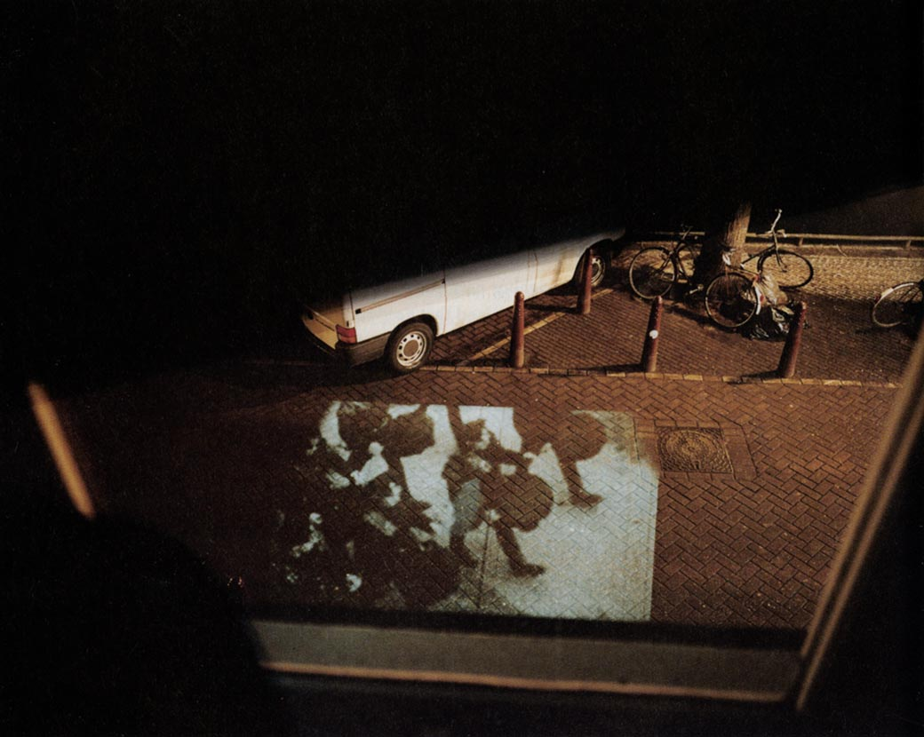

Shimon Attie, Passing Nazi Drum Corps at Prinsengracht 468. (The Neighbor Next Door, Amsterdam, 1995)

many incarcerations on the way to concentration camps and death. Here the national image of sheltering was being turned inside-out, the lens turned back on those for whom the "neighbor next door” had become more a self-aggrandizing image than a reality. The image of the sheltered was now displaced by moving images of what the sheltered saw: Dutch bystanders, collaborators, and Nazis. By reanimating the past of those supposedly rescued, Attie could reiterate the national myth even as he unlocked its hold on the past.

Q12. Stop! Examine the images associated with The Neighbor Next Door. Reflect on how they relate to question “B” below.

The Walk of Fame: Krakow, June-July1996

In his Krakow project, The Walk of Fame, Attie suggests that art itself can
check the excesses of art, that instead of blurring the line further between history and its later representations, art can redraw this line and that, through parody, it can discourage a society from unwittingly displacing history as it happened with history as it appears in the movies. He was inspired, he says, not by the ways Steven Spielberg's film Schindler's List might have passed itself off as history but rather by the potential confusion in tourists' minds wrought by an officially sanctioned tour in Krakow called “Retracing ‘Schindler’s List.’ ” ¹¹
In this tour, organized by Franciszek Palowski, a Polish journalist who had interviewed Spielberg for Polish television and later wrote a book on the filming of Schindler's List, tourists are invited to visit the sites of film-making in and around Krakow in order to learn more of the actual history of Schindler's list and its telling in cinema. As a guide, Palowski is careful to distinguish between the sites of history and the sites where Spielberg chose to film this history. Nevertheless, Attie fears that the mere possibility of such a tour throws "authentic historical sites, events and individuals into open competition with their celluloid copies in determining our understanding of history."¹² It is one thing to add the history of the film to the history of events, another to displace the history of events with the history of the film.
Moreover, Attie worries that "as actual history becomes conflated with cinematic fiction, it becomes more and more difficult to distinguish between the two.” ^{l3} In fact, underlying Attie's misgivings here seems to be not just the confusion in mind wrought by such a tour but the ways that such a tour is, in many ways, more appealing to tourists in the thrall of celebrity history than history itself. For when all is said and done, tourists may indeed prefer visiting the sites of their cinematic experience of the Holocaust to seeing the sites of others' actual Holocaust experiences. After all, their only “real” experience of the Holocaust is the “reel” experience of the movie. Having survived the film, in effect, they return as vicarious pilgrims to the cinematic sites, just as survivors of the camps return to the sites of their actual suffering. If the movie becomes our history of the Holocaust, then the movie sets become the places where “history is made.” And once we are invited to visit the sites of filming as if they were the places where “history is made,” it is too short a step toward confusing the history made in this film for history itself.
In some ways, this dilemma even parallels the impossible problem the director himself faced as he prepared on-site filming of Schindler's List. When Spielberg approached Polish authorities with the request to film scenes on their original sites at Auschwitz and Birkenau, he was initially granted permission; after all, other films such as Triumph of the Spirit and the television miniseries The Winds of War had been filmed in situ at Auschwitz, with significant economic benefits for the local population. The director seemed convinced at this point that a “true story” filmed at its historical location would somehow be perceived as more true than if filmed off-site. But in the years between these earlier films and Spielberg's project, an international council had been appointed to protect memory at Auschwitz from just this kind of incursion. Unbeknownst to Spielberg but well known to the new commission, fake gas chambers and papier-mache chimneys had already been left behind at Auschwitz-Birkenau by the other film crews, infecting the ruins of gas chamber complexes there with a terrible fiction. When word got out that Spielberg had been granted permission to film at Auschwitz-Birkenau, council members protested vigorously, and the council immediately rescinded permission. After delicate negotiations, Kalman Sultanik intervened with national authorities on behalf of the International Auschwitz Council, and Spielberg was invited to film nearby, though not on the site of the concentration camp. On film, of course, Spielberg's movie sets are at least as convincing as the authentic site could ever have been without a major overhaul short of complete reconstruction of the camp-which would have violated the integrity of the memorial as it stands.
Because he is not a documentary filmmaker, Spielberg did not need to hew to original sites of history for his fictional account any more than the novelist needs to rely on notarized testimony for dialogue. The aim was never to film authentic sites but to make the sites he filmed look authentic: this is what filmmakers do, and Spielberg did it brilliantly. In addition to building his own concentration camp set near the real one, Spielberg found a plethora of authentic-looking old squares and buildings in which to shoot his Krakow ghetto scenes. As its residents know well and its tourists happily discover, Krakow's great charm as a tourist center stems from the fact that it has never been bombed or otherwise damaged in Poland's many wars and occupations. Only new buildings made the authentic center of the Jewish ghetto at Zgoda Square unfit for shooting sequences that had actually taken place there. These scenes were shot instead on Szeroka Street, the center of the former Jewish district in Kazimierz.
We also learn from "Retracing 'Schindler's List’” that because the ghetto scenes at Zgoda Square in the Podgorze district were filmed in Kazimierz across the river, Spielberg had to reverse the direction of the march of ghetto Jews, so that they flowed over the bridge into his filmic ghetto in Kazimierz and not out of Kazimierz over the Vistula River into Podgorze, as they had originally. Also of cultural interest here is the plot of land Spielberg chose for his gargantuan movie set of the Plaszow concentration camp: the site of the former Jewish cemetery on Jerozolimska (Jerusalem) Street in Podgorze.
As late as April 1995, Attie's plan for an installation in Krakow looked entirely different. In a project then entitled Routes of Silence, the artist had hoped to mount slide projectors on the trams in Krakow that still run through what had been the Jewish ghetto there during the war, beaming images of the old ghetto back onto the present sites. In addition, he had planned to affix light boxes along the route to show "images from the ghetto, as well as images relating to Poland’s postcommunist struggle to be assimilated into the West and the challenges the country faces today with both old and new forms of racism.”¹⁵ But on his arrival in Krakow, he found the situation on the ground to be much more interesting, and more complicated, than his critique of Poland's wartime memory might have allowed. Though his original plan had been supported by both the city of Krakow and the local Goethe Institute, once the artist heard of “Retracing 'Schindler's List,” his project evolved from a critique of Poland's wartime memory into a critique of the dangers implicit in over-mediation itself. Unable to bear the confusion of movie and historical sites, Attie abandoned his own preconceived project and embarked on an alternative installation, one he hoped would expose the fascination for the filmic at the expense of the historical. As a result, the “Walk of Fame” may be as much an overall critique of Holocaust-by-mediation as it is of a specific displacement of historical by cinematic reality.
To this end, Attie installed twenty-four simulated five-point terrazzo stars, copies of the famous stars lining Hollywood Boulevard's "Walk of Fame:' on Szeroka Street, where Spielberg had constructed his ghetto to movie-set: What Attie calls “ground zero” for the conflation of movie history and historical fact. Instead of recalling the movie stars enshrined so famously on Hollywood Boulevard, however, Attie substituted the names of Jews who had actually been on Oscar Schindler’s list, abbreviating the first names so as not to offend the memory of actual victims. By remembering victims as if they were worth remembering solely because they had now become Hollywood stars, Attie parodically repeated this flow of history into celebrity, mocking it and thereby hoping to expose its insidiousness.

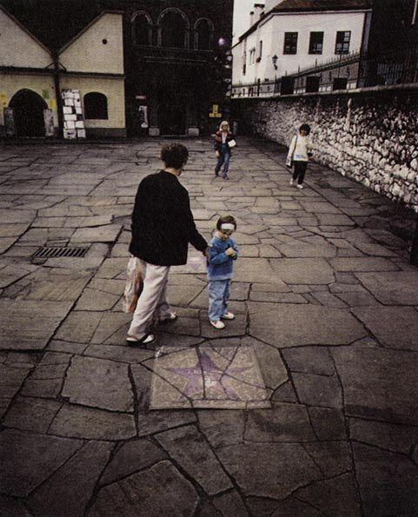

Shimon Attie, J. H. Borenstein. (The Walk of Fame, Krakow, 1996)

At the same time, Attie takes pains to explain that he did not direct this project against the individuals who survived Schindler’s list and the celebrity it has brought some of them; nor did he make Spielberg’s film a target of his counter-memorial installation. Rather, in his words, “its intention was to highlight and critically reflect the larger problematic eclipsing of historical fact by cinematic fiction:’ by which the unfurling movie’s reel is mistaken for the real.¹⁶

Q13. Stop! Think about the impact that movies have on memory. Think about Question “B” & Question “D”.

On display in Krakow during the months of June and July 1995, these purple stars were embedded into the square in front of the Old Synagogue and Jewish Museum, each with a small motion picture camera and a name like H. Blumentrucht or J. H. Borenstein. Riven by cracks that seemed continuous with the surrounding stones, they appeared old, worn, and permanently part of the square. In-stead of the memorial icon of a yellow star, these survivors were commemorated with the purple terrazzo stars of Hollywood celebrities, an echo of that moment at the end of Schindler's List when the actual survivors appeared with the stars who “played” them.
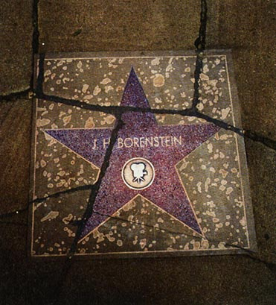

As an artist, Shimon Attie is all too aware of his own dependence on the art of others for his knowledge of the Holocaust. As a Jewish American born after the war, he knows the Holocaust only by indirection, by the efforts of survivors, historians, and artists to pass down their knowledge to him. But although he acknowledges this necessarily vicarious relationship to Holocaust history, he is still nettled by the possible consequences of what might be called the overmediation of events. He fears, rightly, that a generation after the Holocaust could still come to mistake their hypermediated experiences of the Holocaust for the Holocaust itself, that events will come to be displaced altogether by their representations.

Q14. Stop! How does Attie’s installation in Krakow inform and critique how we remember and experience the past? Think further about questions “B –D”.

This is, he acknowledges, a conundrum. For because these representations of the Holocaust are all that those removed from events will ever know of the genocide, what is to keep art from usurping the authority of historical actuality? Moreover, if artists and filmmakers insist on keeping the boundaries between their art and actual events as fuzzy as possible, all toward the aesthetic (but not necessarily historical) end of making their art seem as convincing and entertaining as possible, then what is to save the next generation from losing the ability to discriminate between what they know, how they know it, and what actually happened? Instead of a simple answer to this, the next generation's defining preoccupation, Shimon Attie has offered a series of installations that work through the dilemma itself, that examine the role we ourselves play in the gaping space between a site and its past, between its history and our memory of it.

Read over all four questions below. Use your comments as a guide to answer each question as fully as possible.

A) What is public space? (Return to Q2, Q7)

B) How do we remember? (Return to Q1, Q8, Q13, Q14)

C) How does art in the public space help us remember the past in the present? (Return to Q4, Q5, Q10, Q14)

D) How do we use the past to make sense of the present and impact the future?
Return to Q3, Q9, Q13, Q14)

CHAPTER THREE Sites Unseen Notes

1. Nora, “Between Memory and History:’ 19.
2. Attie, “Writing on the Wall Project;’ 9.
3. Ibid.
4. Attie quoted in Axelrod, “Time Exposures’ 40.
5. Attie quoted in Chazan, “Ghosts of the Ghettos.”
6. As related by the artist to the author in an interview. The exchange is also described by Attie in Writing on the Wall, 12.
7. Michael André Bernstein, “Shimon Attie,” 6.
8. As quoted from a handbill supplied to the author, courtesy of the artist (my translation).
9. See, for example, Ido de Haan’s work in Holland, a preview of which I received in a copy of “Invention of a National Trauma’ a paper delivered at “Memory and the Second World War,” the Netherlands State Institute for War Documentation, Amsterdam, 27 April I 995.
10. For more in this vein, see Young, “Anne Frank House’ 131—137.
11. As described by Attie in an unpublished project description for “Walk of Fame,” provided to the author.
12. Ibid.
13. Ibid.
14. As described in Palowski, “Retracing Schindler’s list,” a travel booklet published by Krakow’s Ministry of Tourism.
15. Protzman, “Artist Projects a Ghostly Past,” 10.
16. Attie, project description for “Walk of Fame.”

