**Currents: Water in African Art Exhibition photos (3 photos)**

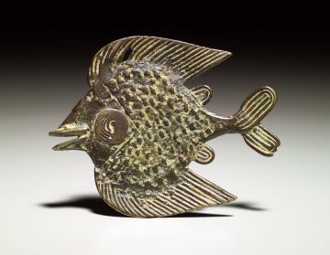

**Akan artist, Ghana and  Côte d’Ivoire**

**Weight**

**18th to late 19th century**

**Copper alloy**

**4.8 x 6.1 x 0.7 cm (1 7/8 x 2 3/8 x 1/4 in.)**

**Gift of Emil Arnold, 68-36-93**

**Although often identified with Akan peoples living in south-central Ghana, weights for measuring gold dust were used and traded throughout all of present-day Ghana and Côte d’Ivoire. For more than five centuries, smiths cast weights from wax models or directly from the actual creatures. The resulting objects are immensely diverse in form while set to exact measurement standards.Some weights’ forms were selected just for their beauty or to display the owner’s status. Many, however, evoke Akan proverbs, whose meanings vary with time and place—more than one interpretation can apply. Hence water creatures were popular weights, with their associations of fluidity, flexibility, and movement between worlds.**

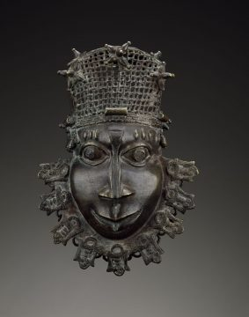

**Edo artist, Benin kingdom court style, Nigeria**

**Pendant (uhunmwunekhue)**

**Late 18th to mid-19th century**

**Copper alloy, iron**

**21.6 x 14 x 7 cm (8 1/2 x 5 1/2 x 2 3/4 in.)**

**Gift of Joseph H. Hirshhorn to the Smithsonian Institution in 1966, 85-19-5**

**Edo chiefs wear a copper-alloy pendant on their left hips when dressed in full court regalia. This tradition is documented in the dress of figures on palace plaques from the 16th century.This pendant depicts an Edo man, identified by the three raised scars over each eye. He is a person of rank, as shown by his cap of coral beads. The collar of mythical mudfish, emblems of transformation and survival, associates the wearer with spiritual power.**

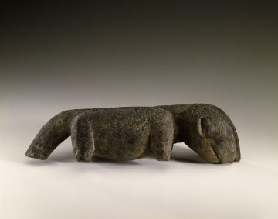

**Dogon artist,  Mali**

**Figure of a dog**

**Early to mid-20th century**

**Wood, encrustation**

**9.7 x 8.3 x 34.5 cm (3 13/16 x 3 1/4 x 13 9/16 in.)**

**Bequest of Alexandra I. Darrow, 93-9-1**

**This type of Dogon figure likely depicts a dog. According to oral history, when the Dogon arrived at the sandstone Bandiagara cliffs, they encountered the Tellem peoples who concealed the location of the wells and water holes. A dog returning to camp with wet paws saved the Dogon, allowing them to survive.**

**INTERNET AFRICAN ART PHOTOS (3)**

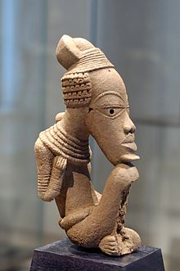

**Nok terracotta, 6th century BC–6th century CE**

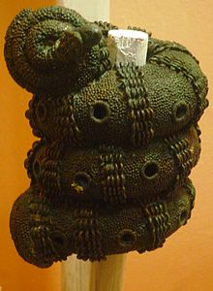

**Igbo 9th century bronze ornamental staff head, Igbo-Ukwu, Nigeria**

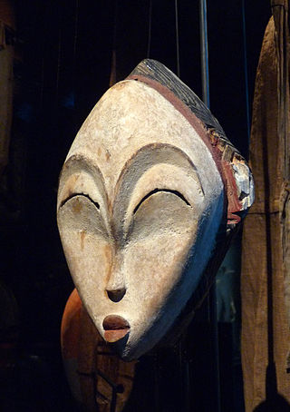

**Mask from Gabon**