Major Project: Curriculum Implementation

Maryam Alsqofi, Stephanie Sablich, Joseph Stephens

University of St. Francis

Major Project: Curriculum Implementation

The math department expressed concerns with the outdated curriculum. The current curriculum does not meet the Common Core State Standards nor the Mathematical Practice Standards. The math teachers expressed the need for a more rigorous curriculum that was relevant for the students. “Fewer than one in five teachers said their instructional materials were aligned to the Common Core, according to a national Education Week survey” (Petrilli, 2017). Our teachers related to the survey results because the current curriculum was not meeting the needs of the students. This discussion highlights the steps taken to research and implement an appropriate math curriculum.

# School Demographics

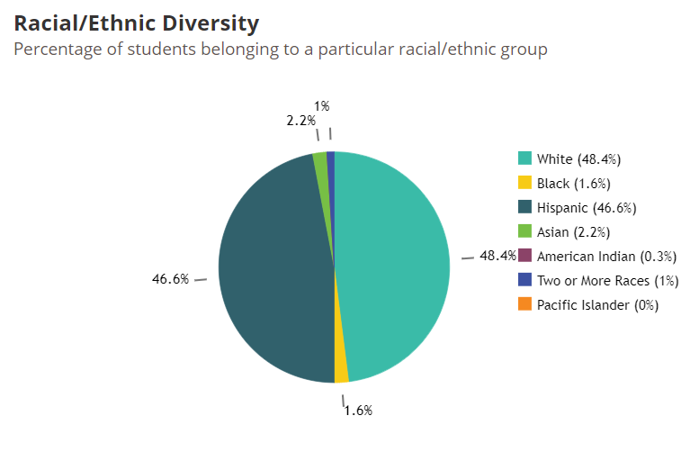It is critical for administrators to know and understand the environment of the school district to apply programs that correlate with the school’s vision. Our school district has 3,570 students in six elementary schools and one junior high school. The junior high school has 811 students. Figure 1 outlines the racial and ethnic diversity of the school district. Fourteen percent of the student population identifies as having an Individualized Learning Plan. Fifty-four percent of the population is low-income students. Thirty-two percent of the students’ home language is not English (Illinois Report Card, 2018).

Figure 1

As seen in Figure 1, over 45% of the district population identifies as Hispanic and thirty-two percent of students’ primary language is not English. Thus, the committee analyzed curriculums’ accessibility to different languages. For example, a curriculum was eliminated if only produced in English because it would not be conducive to the school environment and student learning. The chosen curriculum, Eureka, is available in English, Spanish, Arabic, Bengali, simplified Chinese, and traditional Chinese.

In this specific town, many parents have attended college in their past. With this being said, most parents in this school expect their child to be ready for college and to succeed in college. Since this is the expectation for most students, the new curriculum needs to be aligned with this in mind. Our school needs to prepare our students for college, and to be prepared for the SAT since most colleges tend to look at the SAT scores. As the curriculum committee explores new math curriculum, they need to keep in mind those two specific things. The new curriculum needs to prepare the students for college and the new curriculum needs prepare every student for the SAT in an effort to help the students succeed and be accepted to the college of their choice. In addition, the committee emphasized their focus on the rigor of the curriculums to develop the students’ problem solving skills in preparation for high school and in turn college.

# Implementation Steps

The curriculum up for review this year is the mathematics curriculum. This discussion will outline the steps we took to discover a mathematics curriculum that aligns to our school’s needs. The first step was to create a curriculum committee, which includes numerous stakeholders. For example, the committee will be comprised of the subject teachers affected (math) among different grade levels, department chairs, curriculum director, board members, counselor, administrator, and other school personnel. The committee met twice a month throughout the school year. The purpose of the committee was to research curriculums, assess the effectiveness of the curriculum, and pilot the programs. The objective of creating a committee is to delegate roles and distribute the leadership among the members.

Once the committee was installed, we identified the needs of the schools. In this case, we addressed that the math curriculum was outdated and needed to be revamped to ensure rigor and relevance. While researching, the committee needed to be cognizant of the school setting to ensure the chosen curriculum met the specific needs of the students. The math scores were just below meeting expectations, thus our area of focus was creating a more rigorous math curriculum.

To research the various curriculums, the committee was paired up and assigned a curriculum. The pairs used various credible sources to research the curriculums. They were cautious to rely only on the data from the textbooks’ website due to bias concerns. The committee was responsible for presenting the data and narrowing the search down to three curriculums. Once the three were determined, the curriculum director requested samples from each company. She also contacted neighboring schools and schools implementing the programs to assess their data and get their input on the programs. The curriculum director also contacted the companies inquiring about the cost of the programs and what was included. Specifically, she researched professional development opportunities offered.

After the curriculum addressed the three curriculums, they chose one series and piloted it. The pilot consisted of various teachers teaching the same five lessons. The teachers and students completed a survey about their impressions of the program. If the survey produced positive results, the committee would move forward with the implementation process. However, if negative results were produced, then the committee would pilot the second choice and conduct a post survey.

# Leadership Distribution

Responsibilities were distributed to the members of the committee. As compared to one person conducting the research, the members were paired up and assigned a curriculum to research. The pairs presented the data and information to the committee. From the presentations, the group eliminated curriculums that did not align to the district’s mission. The curriculum director was responsible for contacting the textbook companies and other schools. The teachers were responsible for piloting the programs in their classrooms. Student feedback was also involved in the process through the pilot and opinion surveys.

# Research

The committee chose to implement Eureka Math to meet the math needs of the district. Eureka Math is a kindergarten through eighth grade curriculum, which is critical in our district because we service students from kindergarten through eighth grade. The data strongly supported the effectiveness of the program. According to ED Reports (2018), “an independent nonprofit” that analyzes curriculums, Eureka Math scored high marks in every grade level. On a scale of 14, Eureka math received an overall score of 14 for each grade (13/14 for sixth grade). The program meets the expectations in focus and coherence, and rigor and mathematical practices. For kindergarten through fifth grade, Eureka Math met expectations for usability; however, it only partially met expectations in grades sixth through eighth grade (ED Reports, 2018). Finding a math program that met the Common Core State Standards was a major priority for the curriculum committee. Experts found that “Eureka was most aligned with Common Core” (Willams, 2015). Eureka math focuses on the importance of developing fluency in mathematics by aligning to the Common Core State Standards (Petrilli, 2017).

# Case Studies

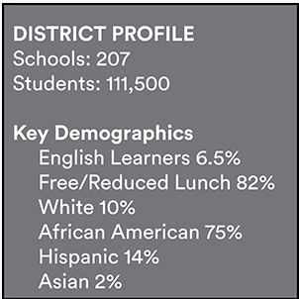Following Tennessee’s changes in mathematics standards, Shelby County educators grabbed the earliest opportunity to be among the first to develop and implement new mathematics curriculum throughout its 207 schools. According to the educators, the changes will see a more rigorous, high-end mathematics curriculum taught in schools. Throughout 2016-17 Eureka Mathwas rolled out in 18 schools for the pilot project which turned out to be a success. Both Thomasena Stuckett and Christine Bingham, respected educators, were very important in the success of the pilot. The two alongside many other positive contributors took a front-row seat to the pilot and propelled it to success (GreatMinds, 2017).

According to Stuckett, one of the primary roles of the entire project was to ensure the curriculum rigor was improved. The project was aimed at bringing students challenging content and Eureka Math ensured just that. Throughout the implementation phase, teachers were called to assume abilities that would enable them to customize and prepare lessons in a manner that prepares students for the new curriculum.

Professional development was identified as one of the most important aspects of the implementation process. Thus, over 800 PD sessions were added bringing the total to just above 1,000. It helped in unfreezing the underlying fear and reservations from teachers and parents both of who observed that Eureka Math was so different from how they learned mathematics during their time. Great Minds came in handy to help teachers learn how to deliver the new curriculum by providing online resources and coaching on the same. Parents were not left behind. They were kept up to speed with new developments and guidelines through newsletters and homework helpers. Moreover, they were occasionally invited to take Eureka Math tutoring classes, which helped them to see how useful it would be for their children.

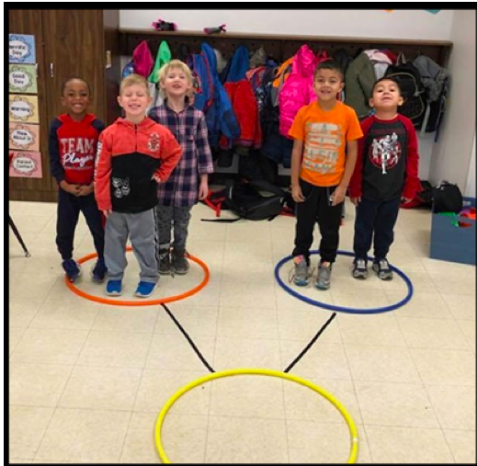Part of Eureka Math was to shift learning from a teacher-centered perspective to a student-centered perspective. This greatly improved student engagement. Also, it improved problem-solving skills for learners (see inset image of kindergarten students learning about number bonds). Although it took time for the tangible results to be noticed, educators encouraged teachers to be patient and give every learner an opportunity to grow at their own pace. Bingham observed that the Eureka Math was geared towards improving problem-solving and critical thinking both of which take time before improvement can be noticed in learners. Thus, it is normal for students not to show signs of improvement immediately because they will do so eventually given time.

Other than improving students’ mastery of mathematics, Eureka Math also presented to students an opportunity to practice and improve their writing reading abilities. This interdisciplinary benefit is highly desired since student success is achieved through growth in other areas of learning apart from mathematics. One thing about the new curriculum is that it empowers students to be enthusiastic about difficult problems. For example, instead of trying to avoid difficult problems learners under the new curriculum will find it more interesting to try and solve them.

Eureka Math has been officially rolled out in all the 207 schools and the results are encouraging. Students are getting more involved while at the same time finding mathematics all too interesting. The same curriculum has been replicated in other parts including North Dakota. Most teachers were reluctant to accept the curriculum but the pilot project did a lot in changing the perspective. Today, most of them are too happy to implement because they recognize its immense improvements.

# Conclusion

When implementing a new curriculum, it is critical to recognize the school district’s needs and culture. With that knowledge, a curriculum can be identified that meets the specific needs of the students. In our school, we first created a committee comprised of the various stakeholders in a school. The committee conducted research on numerous curriculums and narrowed it down to their top three choices. Of the top three, the committee narrowed their choice down to one by assessing the samples and contacting nearby schools using the same programs. The number one choice was then piloted amongst the subject teachers in a few grade levels. After the pilot, a survey was conducted to get the teachers and students’ opinion. The committee will present their findings to the board of education.

References

ED Reports (2015-2018). Math reports. Retrieved from: <https://www.edreports.org/math/reports/compare-k8.html>

Great Minds (2017). Shelby county expands Eureka math district wide. Retrieved from: <https://greatminds.org/math/blog/champions/post/shelby-county>

Illinois Report Card (2018). Burbank SD111. Retrieved from: <https://www.illinoisreportcard.com/District.aspx?source=studentcharacteristics&Districtid=07016111002>

Petrilli, M. F. (2017). A common core curriculum quandary.*The Education Digest, 83*(4), 56-59. Retrieved from <http://ezproxy.stfrancis.edu:2048/login?url=https://search.proquest.com/docview/1956467250?accountid=37708>

Williams, J. (2015, March 13). Inside Eureka Math: Does a popular Common Core math curriculum move too fast for young students? Retrieved July 18, 2018, from <https://hechingerreport.org/inside-eureka-math-does-a-popular-common-core-math-curriculum-move-too-fast-for-young-students/>