**Evaluation of Coca-Cola Advertisements**

Student name

University of Arizona Global Campus

BUS317

Prof name

XX January 20XX

**Introduction**

Coca-Cola is a soft drink as famous as coffee or tea and is associated with refreshment, happiness, and unity. Its marketing strategy is an excellent example of how multinational corporations coordinate to address different audiences in the global market and ensure that they retain their image integrity. This essay focuses on two Coca-Cola billboard advertisements: one from the USA and the second from India. These ads stand as a testament to how Coca-Cola has been able to marry international advertising with cultural appeal. The analysis will comprise four segmentation types, determine whether they apply to the advertisements, and review the creative strategies utilized. By engaging in this evaluation, it is possible to examine how Coca-Cola sustains its market dominance in the beverage sector.

**United States Billboard Advertisement**

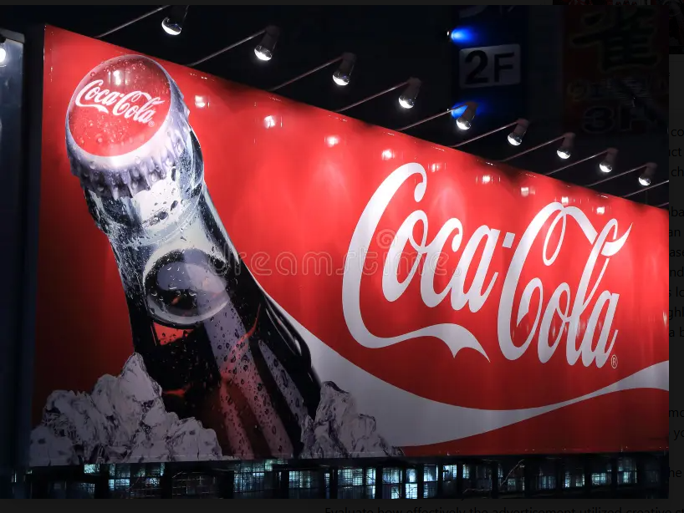

**India Billboard Advertisement**

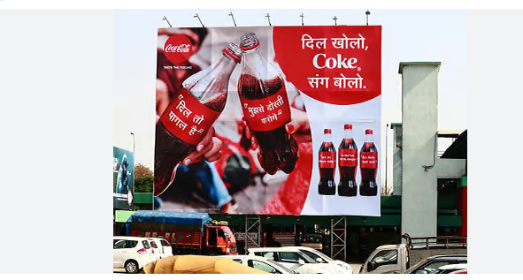

**The Four Types of Segmentation Strategies**

A critical component of any marketing strategy involves segmenting customers so that their needs can be addressed as per their categories. Coca-Cola's success can largely be attributed to its ability to employ the following four segmentation strategies:

**Demographic Segmentation**

Market segmentation strategy splits the market into smaller manageable parts using quantitative variables such as age, sex, income, education, and employment status. Coca-Cola aims its products especially at young adults and teenagers, as this target group enjoys fun and interpersonal communication associated with the brand. Another is the income level because Coca-Cola is comparatively cheap and, therefore, accessible to most consumers (Wang, 2021).

**Psychographic Segmentation**

Psychographics are concerned with the consumer's personality and their activities, preferences, and beliefs. Coca-Cola Company understands that consumers are not just looking for a drink but also a way of life. This way, the brand communicates with consumers who cherish happiness, celebration, or togetherness, aligning with the essence of Coca-Cola brand values (Wardana et al., 2023).

**Geographic Segmentation**

Geographic Segmentation is a targeted approach often used in marketing whereby efforts are directed toward certain geographical areas such as regions, specific countries, or cities. Coca-Cola ensures that its commercials fit the cultural structure and tastes of the society they are in. For instance, in India, Coca-Cola uses language and community aspects, while in the United States; it uses nostalgic appeal and refreshment aspects (Wang, 2021).

**Behavioral Segmentation**

Behavioral segmentation is based on behavior, where consumer behavior is considered, including usage rate, brand commitment, and occasions. Coca-Cola targets consumers during events like when eating meals, celebrating, or when one is just relaxing. It is done as part of its advertisements, which portray such situations to reinforce the connection with the brand (Wang, 2021).

**Segmentation in the advertisement**

**United States Billboard Advertisement**

The U.S. billboard may be classified under psychographic and behavioral segmentation. The choice of the piece of a recognizable symbol, such as the Coca-Cola bottle surrounded by ice, triggers feelings of nostalgia and enjoyment, which align with the Psychographic factors (Wardana et al., 2023). Behaviorally, it aims at consumers who relate Coca-Cola products with ideas such as refreshments during meals or when relaxing. Consequently, the logo's simplicity makes it appeal to everyone, thus continuing to affirm Coca-Cola as the world's most recognized brand.

**India Billboard Advertisement**

The Indian advertisement employs demographic, psychographic, and geographic segmentation (Wang, 2021). They support adaptation by using Hindi text and imagery from the region. The ad creates a social appeal that entails sharing Coca-Cola, hence calling for psychography of togetherness and fellowship. Regarding demographics, it caters to middle-income earners and the youth, a massive market in India. The cultural elements incorporated in the ad make it possible for Coca-Cola's message to impact the Indian audience profoundly.

**Evaluation of Creative Strategy**

**Problem the Advertising Must Solve**

Coca-Cola operates internationally and, therefore, must deliver a unified message while adapting to cultural differences. Therefore, to address this problem, the U.S. advertisement depicts Coca-Cola as a refreshing and delicious beverage that has stood the test of time; the Indian ad highlights the company's ability to help foster emotional bonds culturally (Arens & Weigold, 2022).

**Advertising Objective**

The U.S. ad aims to sell the product by evoking the urge for refreshment and presenting it as cold, crisp, and iconic. The target of the Indian ad is to create an emotional bond between Coca-Cola and celebrations and gatherings. Evaluating the two campaigns, both create brand awareness, targeting their markets for sales through appealing to sensory or social appeals (Arens & Weigold, 2022).

**Target Audience**

The American advertisement appeals to the urban audience with simple, high-quality products that recall a classic childhood (Arens & Weigold, 2022). It helps the company retain the faithful consumer base of the original Coca-Cola while introducing new generations to the brand as a staple. In this regard, the Indian ad targets middle-income families and young adults, the significant audiences in India. It resonates with the cultural themes of oneness, hosting, and fellowship. This way, working on various aspects of cultural appeal, Coca-Cola addresses different target groups and makes its messages comprehensible and persuasive in multiple markets.

**Benefit Statement**

The primary advantage of Coca-Cola is its ability to refresh and provide pleasure (Arens & Weigold, 2022). The U.S. ad emphasizes the tangibility of the product, especially the cold and tingling feeling attributed to Bireline. On the other hand, the Indian ad focuses on the social pleasure aspect of improving social experiences. Each commercial demonstrates how Coca-Cola is a product that not only quenches the physical thirst of consumers but also invokes the feeling of happiness, connection, and shared memories across different demographics.

**Support Statement**

The fact that Coca-Cola is a global company aids in endorsing its quality and reliability (Arens & Weigold, 2022). Therefore, the U.S. ad repeats this visually, with the bottle with the brand name sitting within a ring of ice, symbolizing the product's refreshment properties and agelessness. The Indian ad portrays close friends and families enjoying Coca-Cola, making the commercial even more convincing in supporting its assertion that the product can bring people together and is synonymous with happiness in meaningful moments.

**Brand Personality**

Coca-Cola represents joy, young spirit, unity, and positivity (Arens & Weigold, 2022). The U.S. ad achieves this in simplicity and the use of imagery that is reminiscent of a time gone by while not compromising the brand appeal. In contrast, the Indian ad employs vivid social contexts and a pleasurable and visually appealing social experience to signify these traits, which fits Coca-Cola's positive disposition across various cultural and emotional contexts.

**Special Requirements**

Both advertisements effectively engage with cultural and contextual concerns (Arens & Weigold, 2022). The Indian ad employs Hindi type and local imagery and remains cognizant of localized contexts, which makes it more relatable to Indian audiences. On the other hand, the U.S. ad features the iconic Coke bottle and gives a clear and memorable message independent of the locality.

**Effectiveness of the Advertisements**

Altogether, the advertisements are quite successful in achieving their primary goals. The U.S billboard is concise and focuses on the product itself, appealing to the audience, especially within the global market; the message is clear and timeless: Coca-Cola is a refreshing drink. The Indian billboard is well localized and effectively translates Coca-Cola's universal 'happy together' slogan to fit IC culture. These adverts depict how Coca-Cola can assimilate a global image with a localized approach, which forms the basis of its longevity as a worldwide brand (Arens & Weigold, 2022).

**Conclusion**

In conclusion, Coca-Cola's advertising tactics show how the company maintains compliance with global standards while incorporating local features. Subsequently, segmentation strategies, including demographic, psychographic, geographical, and behavioral, help the brand target specific audiences. The U.S. ad focuses on feeling renewed, while the Indian ad targets collective morality and unity. Both adverts are relevant in presenting the primary idea of Coca-Cola's value proposition and brand identity: its eternity. The ways Coca-Cola managed to reach consumers across the globe while at the same time addressing their varying cultures are the significant factors that justify its position as a global beverage company.

**References**

Arens, W., & Weigold, M. (2022). M: Advertising (4th ed.). McGraw Hill.

Wang, J. (2021, October). How Coca Cola and Pepsi use segmentation in the consumer product industry. In *2021 International Conference on Public Relations and Social Sciences (ICPRSS 2021)* (pp. 866-870). Atlantis Press.

Wardana, M. A., Masliardi, A., Afifah, N., Sajili, M., & Kusnara, H. P. (2023). Unlocking purchase preferences: Harnessing psychographic segmentation, promotion and location strategies. *Jurnal Informatika Ekonomi Bisnis*, 713-719.