**LinkedIn Profile Reflection Journal**

Name

Institution Affiliation

Course

Instructor

Date

**LinkedIn Profile Reflection Journal**

**Downfall of Having a Weak Profile**

A weak LinkedIn profile can give potential employers, recruiters, and other professional contacts a bad impression. One negative aspect is that it might lead to negative perceptions regarding professionalism and the level of care (Pama & Funk, 2022). Suppose a hiring manager or recruiter comes to my profile, and I have holes in my resume, or the information is obsolete. In that case, they will conclude that I am not a hardworking individual who values their career progression. Therefore, this can result in the following disadvantages: It is a common practice to search for qualified candidates, employment, networking, or partnership opportunities on LinkedIn. On the same note, having an incomplete profile risks reducing my credibility and effectiveness in establishing my identity in my field of work. From this platform, I have realized the importance of updating the profile and providing rich information that enhances credibility and reflects my attitude towards professional development.

**Improving My LinkedIn Profile**

The following is an outline of what I did to improve my professional brand: One significant change I made to my LinkedIn account was to modify the profile picture and the headline. Before, my profile did not contain a professional headshot, reducing its appeal and authenticity to anybody who could see my page. I replaced it with another brightly lit, professional-looking headshot to be more appropriate for my industry. I also modified my headline to incorporate my current position and essential skills to make my profile more informative and engaging to prospective contacts. These changes are beneficial in enhancing my visibility and presenting my story as a professional.

**Reflection on My Profile Improvement**

The first tip from the guideline in Building a Personal Brand on LinkedIn was to check for a photo, as profiles with photos usually attract more members than those without photos (Perlman, 2020). Therefore, this change helped me make my profile more attractive and increased my self-confidence in networking. Also, updating the headline crafted for the organization aligned my skill set with the position I am targeting. These small changes will also help me expand my professional standing and prepare for networking and job offers. I am now more encouraged to continue enhancing my digital profile since it is essential to influence how people perceive me and how they interact with me.

**Before improvement**



**After improvement**

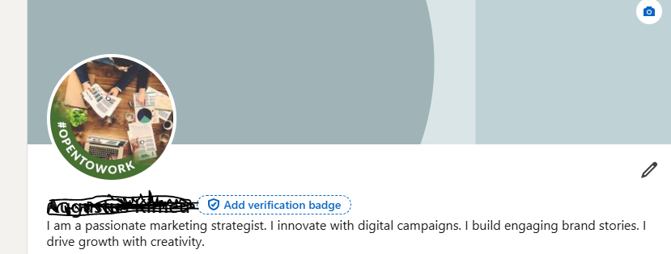

**References**

Pama, M. N., & Funk, S. (2022). *Impact of LinkedIn on the customer's perceptions related to the brand* (No. 308302). Thammasat University. Faculty of Journalism and Mass Communication.

Perlman, S. (2020, January 30). *What a bad LinkedIn profile says about you*. https://www.linkedin.com/pulse/what-bad-linkedin-profile-says-you-steven-perlman/