**Advertisement**

Name

Institution Affiliation

Course

Instructor

Date

**Advertisement**

**Question One**

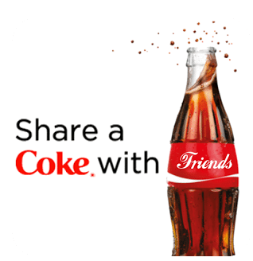

The Coca-Cola 'Share a Coke' campaign, which used names or phrases such as 'Friends' on the bottles, impacted how I viewed the company (Incitrio, 2014). The advertising strategy connected consumers emotionally since the product had their names or those of their loved ones. For consumers, these bottles create the public feeling that Coca-Cola is a part of something meaningful in a social context.

The campaign illustrates how advertising can significantly improve a company's competitive edge (Incitrio, 2014). Thus, by appealing to consumers' feelings, Coca-Cola succeeded in standing out among the numerous competitors in the soft drinks market. The 'Share a Coke' campaign encouraged people to consume Coke as a product; however, it positioned it more importantly as a symbol of linking people and memorable moments. Creating an emotional attachment to the product solidified the bond between the consumer and the company while encouraging folks to share this on their social media pages and making others advocates for these companies.

Coca-Cola effectively incorporated the campaign to target the youthful demographic group, boost merchandise circulation, and assert its dominance. The personalization and social sharing aspects made the campaign a viral success, highlighting that advertising based on popular human links can be an advantage in brand and competition (Incitrio, 2014).

**Question Two**

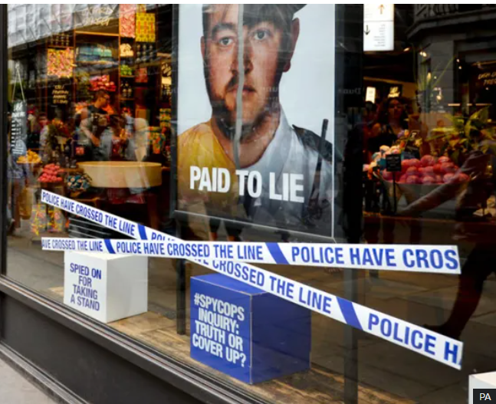

The #SpyCops campaign, employed by Lush cosmetics company and featuring phrases like “Paid to Lie” and the fake police caution tape “Police Have Crossed the Line,” is a reaction to undercover officers establishing deceptive relationships. Although it has the noble intention of creating awareness and pushing for changes, it creates ethical issues and social concerns (Belam, 2018).

**Ethical Considerations**

It promotes corporate accountability by supporting victims and demanding justice and fairness (Belam, 2018). Yet, generalizing police misconduct and misbehavior could offend individuals from law enforcement agencies. Therefore, this might overshadow the critical discussion necessary to achieve significant and sustainable changes.

**Social Criticisms**

Some critics have condemned the campaign as promoting the formation of an anti-police culture and its implication that all officers are corrupt while only targeting undercover officers (Belam, 2018). The campaign has also widened the gulf between the police and the public, inciting boycotts such as the #FlushLush boycotts. Although the campaign is well-meant, it exemplifies the dichotomy between corporate activism and social divides.

**References**

Belam, M. (2018, jun 1). Cosmetics retailer Lush criticized by police over “spycops” ad campaign. *The Guardian*. <https://www.theguardian.com/media/2018/jun/01/cosmetics-retailer-lush-criticised-by-police-over-spycops-ad-campaign>

Incitrio. (2014, December 22). *Coke’s “Share a Coke” Campaign: An Integrated Marketing Success*. Incitrio. <https://incitrio.com/cokes-share-a-coke-campaign-an-integrated-marketing-success/>