**Week 2: State Demographic Data**

Author(s)

Affiliation

Institution

Instructor

Date

**Gender Representation in the Criminal Justice System of Texas State**

This paper will majorly discuss the general demographic data of women in Texas’s criminal justice diversity. According to historical data, which covers the period from 2010 to 2019, Texas was able to register one of the top 5 most instances of female (women) imprisonment in the nation. It has been noticeable over the years that there are now a disproportionately large number of women behind bars in Texas (Goshin & Colbert, 2019). In reality, from 2010 to 2022, the number of women incarcerated in the Texas Department of Criminal Justice (TDCJ, the state's correctional system) climbed by 79%, while the number of men incarcerated increased by 41% during the same period.

The graph in ***figure 1.1*** below shows the women prison population trend from 2010 to 2022, approximately 10 years.

***Figure 1.1***: (TDCJ, 2022)

Based on the above graph, in 2010, there were about 3,300 women who charged in court of laws with various charges and were found guilty and faced a jailed term of not less than 10 years. This made up about 9% of all inmates, an increase from 6 % in 2009. In 2015, there were somewhat more women incarcerated than there were overall in Texas Criminal Justice and federal prisons nationwide (Goshin & Colbert, 2019). According to a TDCJ report from 2018, 78% of the prisoners were found to be mothers with not more than 5 months pregnant and facing different issues while in jail, this raised a lot of issues within the judiciary of Texas state. According to the graph above, even though there have been 22% fewer women arrested in Texas since 2014, there are currently 12,470 or more women in jails who are yet to face trial. This represents a 53% increase since 2014. Sadly, there are a lot of pregnant inmates in Texas' jail system. Texas correctional facilities had an average of 367 pregnant women jailed per month in 2017 than any other women compared to the rest of the countries in the world.

**Female (Women) Lawbreaking and Imprisonment Realities in Texas State**

***Figure 2.1***: (TDCJ, 2022)

According to the research done by the TDCJ (202), shows that majority of the women imprisoned between 2016 to 2022 were non-violent while about 37% were reported to be violent and needed the attention of the high court judges (Bronson & Sufrin, 2019). The pie chart above of ***figure 2.1*** shows this presentation since 2016 to 2022 in which 63% of the women were arrested but were reported to be non-violent as compared to men reported in the countries data in the same period.

**Drug Use and Psychological Health Issues Among Women incarcerated between 2015 -2022**

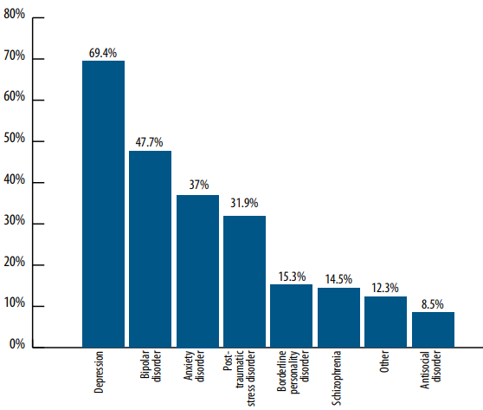

***Figure 3.1*:** (TDCJ, 2021)

In Texas jails, women indicated a higher prevalence of drug use condition than the male population, with roughly 69% of women who were classified as having an addiction to drugs, in contrast to 53% of men (Marston, 2020). This is shown in the graph in figure 3.1 above. Moreover, just 23% of women claimed to have received illicit drug therapy in TDCJ (Bronson & Sufrin, 2019).

**References**

Bronson, J., & Sufrin, C. (2019). Pregnant women in prison and jail don’t count: Data gaps on maternal health and incarceration. *Public Health Reports*, *134*(1_suppl), 57S-62S.

Goshin, L. S., & Colbert, A. M. (2019). The health of incarcerated pregnant women: Some much needed data and beyond. *American journal of public health*, *109*(5), 657.

Marston PhD, C. (2020). Free Battered Texas Women: Survivor-Advocates Organizing at the Crossroads of Gendered Violence, Disability, and Incarceration. *Verbum Incarnatum: An Academic Journal of Social Justice*, *7*(1), 3.