**PROJECT 3: IMPLICIT BIAS TESTS**

Author(s)

Affiliation

Institution

Instructor

Date

**My Implicit Bias Test Result**

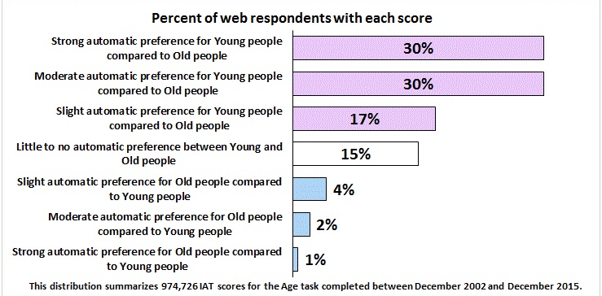

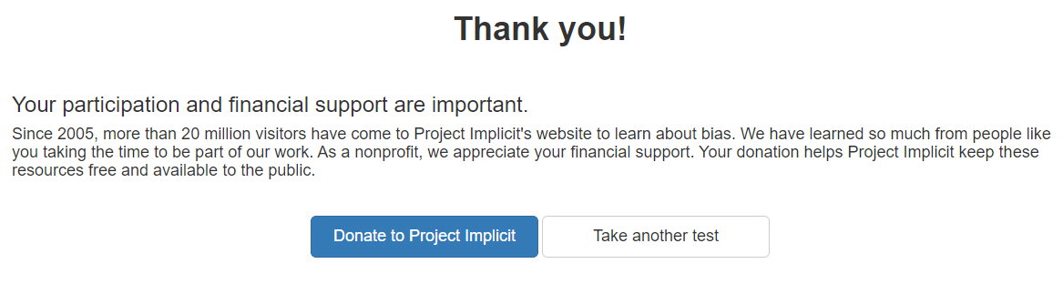

**Discussion after Result**

**Were you surprised by the results? Do you agree with the results?**

Based on the results, it is evident that the Implicit Bias Test was primarily created to measure any unconscious prejudices people may have against particular groups. The test's results show that I scored 30% on a strong automatic preference for young individuals over old ones, as well as the same proportion on a moderate preference in the same regard. Based on this situation, I cannot say that I am surprised by the outcome since this is who I am, and I agree with the outcome (Zaniboni et al. 2019).

**How can you use this knowledge of your personal biases to inform your management strategies?**

The knowledge in this test will help me recognize and accept when an organization has reached a decision by being conscious of my innate preference for young individuals. In this situation, I will be able to change my prejudice (Zaniboni et al. 2019). This will aid in preventing unconscious prejudice from directing all organizational behaviors. I will also be able to take elder workers' needs and opinions into account while developing team-building techniques. As a result, the workplace will be more inclusive and fairer, and the company will be able to provide people of all ages with equal chances.

**How can the identified biases impact team dynamics and collaboration on a team?**

Biases that have been identified in this implicit test, like a strong innate preference for young people over older ones, can significantly affect team relationships and engagement (Zaniboni et al. 2019). Older employees may experience disadvantage, marginalized and harassed as a result of these biases, which could have an impact on their service to the team, inspiration, and sense of membership.

**References**

Zaniboni, S., Kmicinska, M., Truxillo, D. M., Kahn, K., Paladino, M. P., & Fraccaroli, F. (2019). Will you still hire me when I am over 50? The effects of implicit and explicit age stereotyping on resume evaluations. *European Journal of Work and Organizational Psychology*, *28*(4), 453-467.