**Project Charter Development**

Author(s)

Affiliation

Institution

Instructor

Date

**Project’s Scope and Limitation**

The project will be ILS Inventory Management and Last Mile Delivery Services and it will be sponsored by the International Logistics Services. The project team will entail an operation expert by the name John Makara, business analyst, 2 Global technology expert, 1 Human resource manager and other 4 members. In an effort to sign up Walmart as a client, International Logistics Services (ILS) has purchased a warehouse and truck fleet in a new nation (Antonoglou, 2022).  The institution has a lot of concerns, including unsafe conditions and ineffective operations that cost money (Ranathunga et al., 2021). ILS plans to start seeing a net cash flow of $150,000 per year in Year 0 and has set aside $100,000 to address the current problems. The purchase price of the project will be at $400,000 with a salvage value of $400,000 in year 6 and beyond. ILS will be able to increase its global presence since it has abled to purchase and had an efficiency gains, as well as secure Walmart's business as a client.

The scope of this project is to improve operations at the recently acquired company by finding solutions to the problems it is currently experiencing. This problem involves exorbitant maintenance expenditures, outmoded equipment, and ineffective inventory management (Antonoglou, 2022).  In order to attain a triple bottom line, the initiative aims to increase resource efficiency, safety, and customer happiness. The project's time schedule and financial restrictions are the only real limitations affecting it and the project should be finished and completely implemented by the end of year 0.

**Business Case for the Project**

**How the Project will Enable Corporate Strategy?**

By assisting in the expansion of ILS's global footprint, boosting efficiency gains, and securing Walmart as a client, this initiative will support ILS's corporate goal. ILS will be able to boost resource efficiency, safety, and customer satisfaction by streamlining operations at the recently acquired company. As a result, ILS will be able to reach even more clients and offer services that are more dependable and constant (Chakraborty et al., 2021). The project will also assist ILS in achieving its triple bottom line of profits, potential clients, and social responsibility. This will have a long-term effect on the business and its clients, increasing financial stability and profitability.

**How the Project will Apply Corporate Social Responsibility (CSR) Values**

By ensuring that the project reflects the values of profitability, customers, and the community, ILS will apply corporate social responsibility (CSR) principles to it. This involves taking into consideration the project's environmental impact, the project's effect on workers’ safety, and the project's potential economic benefits for both the corporation and society (Wu et al., 2021). ILS will adopt safety policies and employee training to guarantee that these ideals are upheld, promote energy efficiency, and work to maximize profitability while having a beneficial ecological and social impact. ILS will work with regional stakeholders to guarantee that the project also benefits the neighborhood (Kloppenborg et al., 2019).

**NPV Calculation**

The NPV for this project is calculated in the excel spreadsheet and the result is attached in the appendices of this project plan in this paper. The result of the NPV when both using 10% and 8% rate are all positive value which shows that this project is worth an investment. Comparing the initial cost of the project, it is observable that the project will realize the return profit in less than 1 year.

**Milestone Schedule**

|  |  |  |  |  |  |
| --- | --- | --- | --- | --- | --- |
| **Project Code** | **Milestone** | **Starting Time** | **Schedule Deadline** | **Adapted Deadline** | **Actual deadline** |
| 1.1.1 | Establish project team that will run the project | 24 May 2023 | 31st may 2023 | - | 1 week |
| 1.2.2 | Conduct assessment of the current issue and develop an action plan. | 1st June | 14th June 2023 | 15th June 2023 | 2 weeks |
| 1.3.3 | Implement Safety Protocols to reduce accidents within the project. | 16th June 2023 | 20th June 2023 | - | 5 Days |
| 1.4.4 | Upgrade Equipment to reduce the energy waste. | 21st June | 5th July | 7th July | 2 Weeks |
| 1.5.5 | Proper inventory management. | 8th July 2023 | 8th August 2023 | - | 1 Month |
| 1.6.6 | Secure Walmart Business | 9th August 2023 | 9th September 2023 | - | 1 Month |

**Risks, Threats and Opportunity of the Project**

|  |  |  |
| --- | --- | --- |
| **Risks** | **Threats** | **Opportunities** |
| - The project may fall short of the financial return anticipated.  -The project might not finish as scheduled in the milestone.  - The project might not achieve its objectives for customer satisfaction and safety.  - Walmart might not agree to become a client of the project. | -Threats of rivalry from other third-party logistics companies.  -Modifications threats in consumer tastes and demand.  -Modifications to laws and regulations.  -Technology developments threats that may cause operations to be disrupted. | -A bigger proportion of the local market.  -Increased client satisfaction.  -Increased morale and employee retention.  - Cost savings from increased effectiveness. |

**References**

Antonoglou, V. (2022). *Last-Mile Delivery Scheduling Using Autonomous Delivery Robots* (Doctoral dissertation, Florida Atlantic University).

Chakraborty, S., Darbhe, K., & Sarmah, S. (2021). Attended home delivery in Indian public distribution system: an iterated local search approach. *Journal of Modelling in Management*, *16*(4), 1116-1137.

Kloppenborg, T. J., Anantatmula, V., & Wells, K. N. (2019). *Contemporary project management* (4th ed.). Cengage Learning.

Ranathunga, M. I. D., Wijayanayake, A. N., & Niwunhella, D. H. H. (2021, September). Solution approaches for combining first-mile pickup and last-mile delivery in an e-commerce logistic network: A systematic literature review. In *2021 International Research Conference on Smart Computing and Systems Engineering (SCSE)* (Vol. 4, pp. 267-275). IEEE.

Wu, Y., Ding, Y., Ding, S., Savaria, Y., & Li, M. (2021). Autonomous last-mile delivery based on the cooperation of multiple heterogeneous unmanned ground vehicles. *Mathematical Problems in Engineering*, *2021*, 1-15.

**Appendix**

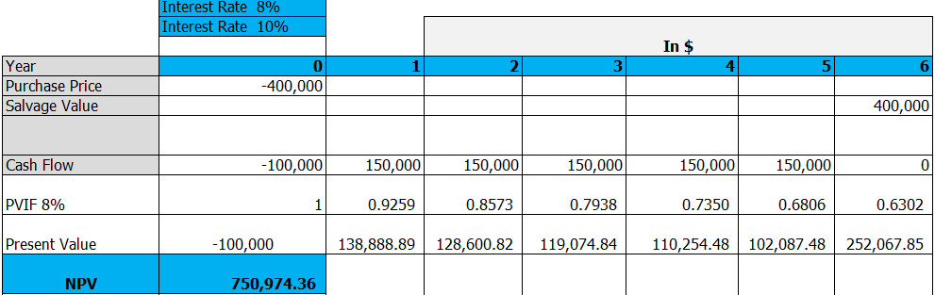

**NPV at 8% Interest Rate**

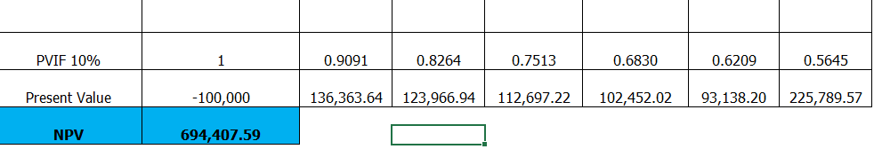

**NPV at 10% Interest Rate**