**Software Application (Product Catalog)**

Author(s)

Affiliation

Institution

Instructor

Date

**Class Diagram**

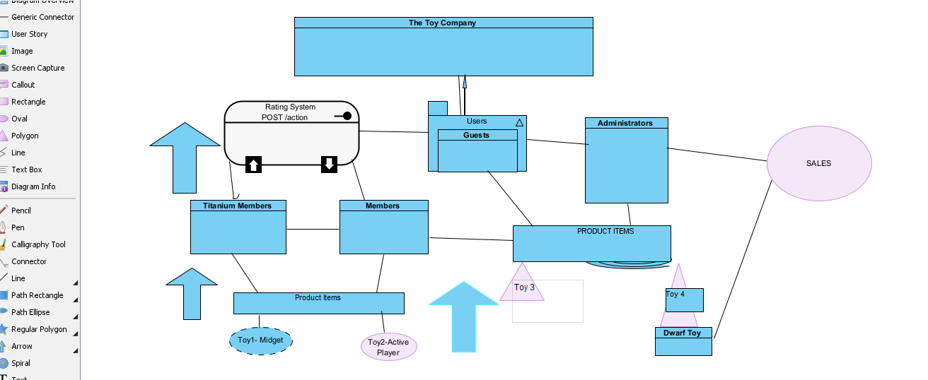

**Detailed Diagram**

**Product**

Dwarf Toy 3

$53

P**roduct**

Signet

Toy 4

$61

Wire Transfer Payment

Credit Payment

Cash Payment

**Rating System**

Administrators

Titanium Members

Guests

Members

**Users**

**Large Toy Company**

**Product**

Name- Toy 2

Weight- 6Kg Des- Active Player

Price- $85

**Product**

Name- Toy 1

Weight-10Kg Des-Midget

Price- $100

**Explanation**

The Name of the company for this class diagram is Toy Company and it is designed by the company management to order all types of Toys products by the users as presented above. The users include Guests, Titanium, Administrators and Members (Gosala et al., 2021). There is a rating system in which only the Titanium members and saved members can contribute to. Both Administrators and Guests will only Review the rating information but will never contribute to it.

According to the Class Diagram, Titanium and Members buys toy products with great qualities and of high prices as compared to those that are bought and used by Administrators and Guests. The Members and Titanium Members buy the products in cash and credit payment and once they have made the payment, they are being delivered the products in less than one hour by the Large Toy Company sales distributors depending on their residential areas (Chen et al., 2022). On the other hand, both guests and administrators do their transactions via wired transfer payment which is much secured compared to the cash payment. They can only buy dwarf and signet toys since these toys are the one most suitable for them as compared to midget and active play toys products.

**References**

Chen, F., Zhang, L., Lian, X., & Niu, N. (2022). Automatically recognizing the semantic elements from UML class diagram images. *Journal of Systems and Software*, *193*, 111431.

Gosala, B., Chowdhuri, S. R., Singh, J., Gupta, M., & Mishra, A. (2021). Automatic classification of UML class diagrams using deep learning technique: convolutional neural network. *Applied Sciences*, *11*(9), 4267.