**Python Coding Assignment**

Student’s Name

Institutional Affiliation

Course

Professor’s Name

Date

**Python Coding Assignment**

**Part A**

**The Code**

name = input ("What is your Name?: ") # user input  
age = int(input("What is your age?: ")) # user input  
#calculating born_year, considering 2022 as the current year  
born = 2022 - age  
print('Hello',name,'!','You were born in', born)

Inserting the above code will generate the following output. The name entered is Abhishek and age is 24 years. The code computed the year born and reports ‘Hello Abhishek! You were born in 1998.’

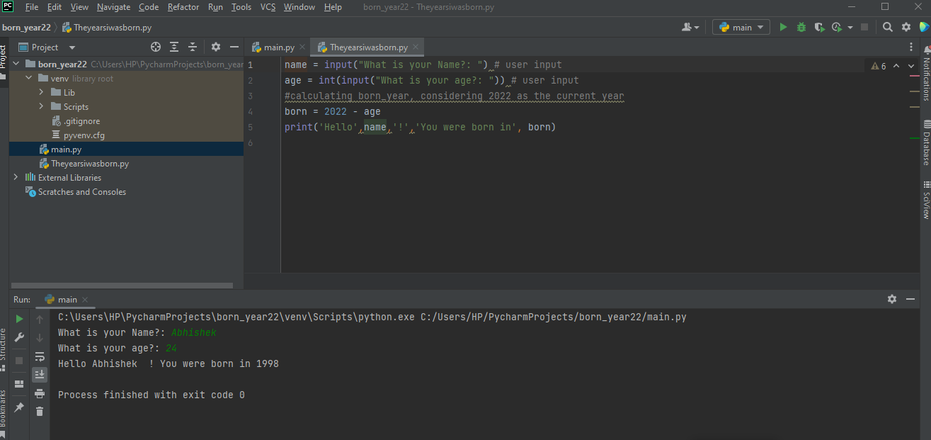

**Part B**

It is true that an IDE does not necessarily write a program, but it is a software system that combines various tools to facilitate code creation. Some of its characteristics include a source code editor, automatic code computation, debugger tool, and well-organized projects. With the source editor, it helps write a code that has language-specific autofill and synthesis highlighting checks and functions for different errors. The editor does this function as one writes the code, which is excellent in identifying variables, methods, classes, and others.

The debugger tool is also an excellent feature in IDE because it helps find and fix bugs in the code. One can use breakpoints to monitor the progress and control interpreters. Likewise, the automatic code completion feature is pertinent because it allows python to complete basic codes, including inbuilt functions and basic syntaxes. It can also assist a programmer to code fast and avoid simple errors that might happen, including spelling errors. Lastly, IDE is well organized, and one can arrange different projects effectively. In other words, projects are better arranged and maintained in this program. One also has an option of choosing different environments for every project. For instance, one can set any python version for a project (python 2.7 for project B or python 3.8 for project A).