Final QuestionsQuestions: Answer each question with **TWO scholarly** sources no more than 5 years old, must use in-text citation with each question.

1a. Access and review the “GCU Statement belowon the Integration of Faith and Work” document. GCU believes that the work of the Christian is to help restore brokenness in the community as well as in the family. How might a mental health worker with the Christian worldview approach working with a family in this country illegally? Explain what your state’s laws are regarding undocumented persons attending school, jobs, etc. Discuss the laws: Are you in agreement with them? Why or why not? Explain if working with persons who are in this country illegally would go against your ethics or not.

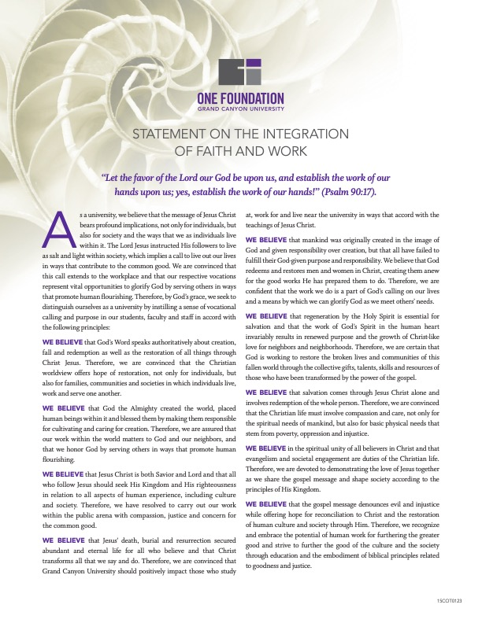

1b.As a mental health worker, it is important for you to know how to examine the various cultural dynamics within greater culture and be able to explain specific cultural implications when working with various populations

As you create your resource guide, what challenges regarding the content did you deal with? What population might be the most challenging for you to work with? Which population do you look forward to working with? Why did you choose these particular resources? What might be the specific cultural implications when working with various populations?

2a.For the “Meeting Observation” assignment, discuss how and why you selected the meeting. What mental health issues will be dealt with at this meeting? What is the target population? Explain the effects of the addictions on families of various populations. Recommend ways families can overcome crises.

2b. n *What’s Eating Gilbert Grape,*what was the family crisis they were dealing with? What were the life stressors present in this family? What was the potential trauma the family could face? How could a mental health worker’s knowledge about this potential trauma be used to inform possible interventions?

3a.Watch the "5 Ways to Listen Better" TED videobelow. Discuss the importance of effective communication skills in mental health work.  Describe empathic and active listening when working with a client. Provide an example of ineffective listening. How does effective communication fuel resiliency? Watch the “Brene Brown on Empathy” video. Compare and contrast empathic listening vs. sympathetic listening.

<https://www.ted.com/talks/julian_treasure_5_ways_to_listen_better>

3b.As a mental health worker, it is beneficial for you to know your state’s resources available to you and your clients as well as updated employment opportunities available for you. Access and explore the [SAMHSA](https://findtreatment.samhsa.gov/) website. Use the Locator Map tab and locate available resources in your community. Using the population you would like to work with, describe some resources you could refer your potential clients to. Next, research mental health employment opportunities in your community. Describe any career listings you might be interested in. Explain why it is important for a mental health worker to know which areas of employment he/she wishes to work in before seeking employment.