Discussion - Which is Best: Mean or Median?

Instructions
This week you will use the Bureau of Labor Statistics website to search for income data on the occupation you are seeking. Visit the following website: https://www.bls.gov/bls/blswage.htm (Links to an external site.)
The BLS has wage information for hundreds of jobs and data can also be found by state. There is much information here so take some time to browse around.
Once you arrive at the site, complete the following steps to gather the data you need to answer the discussion questions.
Part 1
- Search for information on your occupation by clicking on national wage data 800 occupations. This will take you to the Occupational Employment Statistics page.
- Scroll to the bottom of that page for a table listing the major and sub-job categories. Note in the first column there is an occupation code. For example, accountants and auditors have the code 13-2011 and are listed under banking and financial operations.
- Click on the job title to find earnings information. There you will find mean wages as well as percentiles and the 5-number summary.
- Compare the mean and median pays. For example, the mean pay for accountants was $78,800 and the median was $70,500.
- Record the information on percentiles, the 5-number summary, the mean and the median.
Part 2
- Above the data on the occupation page, you will find the following links:
  - National estimates for this occupation
  - Industry profile for this occupation
  - Geographic profile for this occupation.
- Select the geographic profile to view maps of the states.
- Scroll down to the map that presents mean wages by state using the color code.
- Compare the ranges of wages of the states based on the ranges presented.
- Identify the highest paying and lowest paying states.
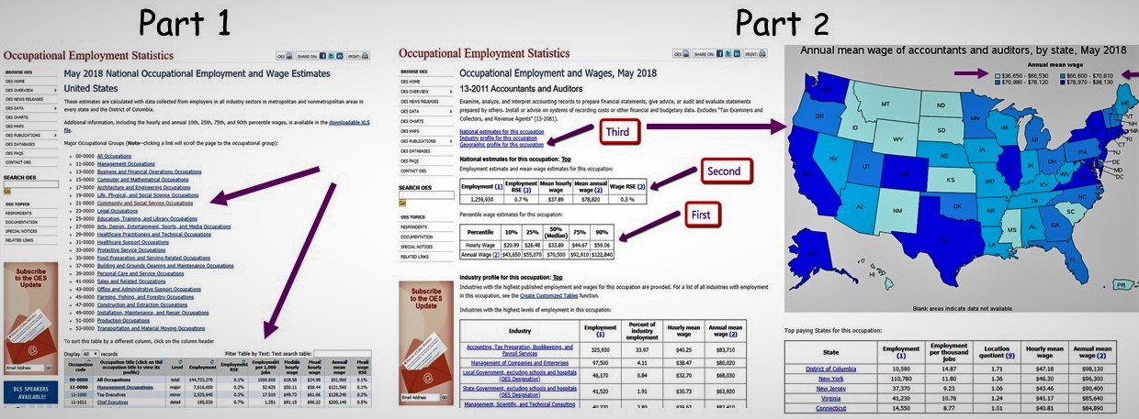
Step 3
Include the following in your discussion post:
- Share the information you found in steps 1 and 2.
- Discuss your interpretation of the statistics you recorded in Part 1.
  - Percentiles
  - Mean
  - Median
- How different are the salaries shown in the map of states?
  - What is the range for your state?
  - Would you move to another state based on this data?
  - What other statistics would you want to know before making that decision?
- What effect do the lowest paid and highest paid states have on the calculation of the mean and median for the United States?
- Suppose you were asked by a potential employer to request a salary. Which is the best measure to use to find “average” earnings for your occupation? Explain your answer.
- ourse Discussion Unit 3
Course Discussion Unit 3
Criteria | Ratings | Pts
This criterion is linked to a Learning OutcomeContent  MA320-CO1 | 10 pts Level 5 Post addresses all of the required prompt elements in the discussion. 9 pts Level 4 Post addresses all of the required prompt elements in the discussion - does not demonstrate a full understanding of course content and unit topic. 8.5 pts Level 3 Post is missing important elements, demonstrates a limited understanding of the topic and/or course concepts, offers limited validation of personal position. There is evidence of some supporting evidence; there is a reference to the research literature, text, course materials, or related examples. 7.5 pts Level 2 Post and responses are missing important elements related to the discussion and demonstrate a lack of understanding of the topic and lacks validation of position, and/or there is no use of supporting items of evidence. 7 pts Level 1 Post does not address discussion questions, and/or does not demonstrate an understanding of the topic and/or lacks validation of position with no use of supporting items of evidence. 0 pts Level 0 Post was not submitted, or there is no relationship between the post and the discussion prompt. | 10 pts
This criterion is linked to a Learning OutcomeAnalysis  PRICE-I | 10 pts Level 5 The analysis of the topic includes breadth and depth, is aligned to the unit topic, relates to the course content and personal analysis is supported by well-aligned references and examples. 9 pts Level 4 The analysis of the topic is justified, and aligned to the unit topic, and personal analysis is supported by well-aligned references and/or examples. 8 pts Level 3 There is a basic analysis of the topic, and personal analysis is supported by well-aligned examples. 7 pts Level 2 There is minimal evidence of analysis of the topic and/or personal analysis is not supported by well-aligned examples or references. 6.5 pts Level 1 There is no evidence of analysis. 0 pts Level 1 Post was not submitted or the analysis had no relationship to the topic and the discussion prompt. | 10 pts
This criterion is linked to a Learning OutcomeCollaboration  PRICE-E | 8 pts Level 5 Collaborates with fellow learners at the required level relating the discussion to relevant course concepts and extending the conversation by asking open-ended questions to move the conversation forward, and answers questions asked on the post by instructor and peers. 7 pts Level 4 Collaborates with fellow learners at a comprehensive level and relates the content to relevant course concepts but does not extend the conversation by asking open-ended questions. There are responses evident to questions asked by instructor or peers. 6.5 pts Level 3 Collaborates with fellow learners but does not respond at a comprehensive level, and/or does not extend the conversation by asking or answering questions, and/or makes little connection to course content. 5.5 pts Level 2 Does not collaborate with fellow learners regarding the peers' posts and/or makes no connection to course content and/or does not respond to peer and instructor responses, or the number of responses did not meet the requirement. 4.5 pts Level 1 Does not collaborate with fellow learners and instructor. 0 pts Level 0 Post was not submitted. | 8 pts
This criterion is linked to a Learning OutcomeWriting | 8 pts Level 5 Posts in this discussion are well written and well organized demonstrating excellence in scholarly writing. Mechanics (spelling and punctuation) and grammar are excellent. 6 pts Level 4 Posts in this discussion are well written and well organized scholarly material but have 1-2 different minor errors in mechanics and/or grammar. 4.5 pts Level 3 Posts in this discussion are basic examples of scholarly material but have 3 different errors in mechanics and/or grammar. 4 pts Level 2 Posts in this discussion are not clear and/or lack organization and/or have 4 or more different errors in mechanics and/or grammar. 2 pts Level 1 Posts in this discussion lack evidence of clear, organized scholarly writing. 0 pts Level 0 Post was not submitted | 8 pts
This criterion is linked to a Learning OutcomeAPA  PRICE-I | 4 pts Level 5 Posts in this discussion demonstrate appropriate in-text citations of sources and references in proper APA style. 3 pts Level 4 Posts in this discussion demonstrate appropriate in-text citations of sources and references but have 1-2 minor APA errors. 2.5 pts Level 3 Posts in this discussion demonstrate appropriate in-text citations of sources and references but have 3-4 minor APA errors. 2 pts Level 2 Posts in this discussion demonstrate appropriate in-text citations of sources and references but have more than 4 APA errors. 1 pts Level 1 Posts in this discussion do not provide either in-text citations or reference sources and/or have 4 or more APA errors. 0 pts Level 0 Post was not submitted. | 4 pts
Total Points: 40

