Unit 3 Discussion - Which is Best: Mean or Median?

Instructions

This week you will use the Bureau of Labor Statistics website to search for income data on the occupation you are seeking. Visit the following website: https://www.bls.gov/bls/blswage.htm (Links to an external site.)
The BLS has wage information for hundreds of jobs and data can also be found by state. There is much information here so take some time to browse around.
Once you arrive at the site, complete the following steps to gather the data you need to answer the discussion questions.
Part 1
- Search for information on your occupation by clicking on national wage data 800 occupations. This will take you to the Occupational Employment Statistics page.
- Scroll to the bottom of that page for a table listing the major and sub-job categories. Note in the first column there is an occupation code. For example, accountants and auditors have the code 13-2011 and are listed under banking and financial operations.
- Click on the job title to find earnings information. There you will find mean wages as well as percentiles and the 5-number summary.
- Compare the mean and median pays. For example, the mean pay for accountants was $78,800 and the median was $70,500.
- Record the information on percentiles, the 5-number summary, the mean and the median.
Part 2
- Above the data on the occupation page, you will find the following links:
  - National estimates for this occupation
  - Industry profile for this occupation
  - Geographic profile for this occupation.
- Select the geographic profile to view maps of the states.
- Scroll down to the map that presents mean wages by state using the color code.
- Compare the ranges of wages of the states based on the ranges presented.
- Identify the highest paying and lowest paying states.
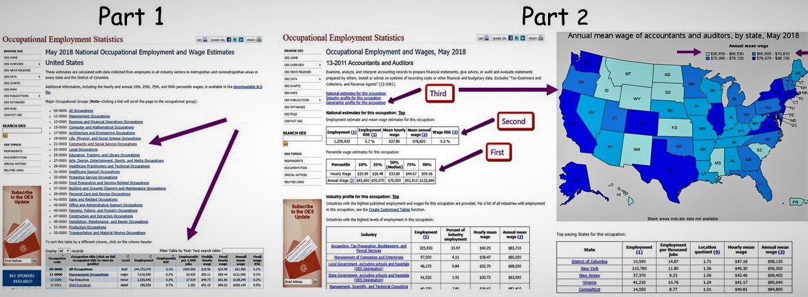
Step 3
Include the following in your discussion post:
- Share the information you found in steps 1 and 2.
- Discuss your interpretation of the statistics you recorded in Part 1.
  - Percentiles
  - Mean
  - Median
- How different are the salaries shown in the map of states?
  - What is the range for your state?
  - Would you move to another state based on this data?
  - What other statistics would you want to know before making that decision?
- What effect do the lowest paid and highest paid states have on the calculation of the mean and median for the United States?
- Suppose you were asked by a potential employer to request a salary. Which is the best measure to use to find “average” earnings for your occupation? Explain your answer.
Please review post and response expectations. Please review the rubric to ensure that your response meets criteria.
Please be sure to validate your opinions and ideas with citations and references in APA format.
Estimated time to complete: 2 hours

