Discussion: Unit 2, Due Wednesday by 11:59 pm CT

Unit 2 Discussion - Misleading Graphs
Can inaccurate graphs bias the interpretation of data? Graphs provide a visual representation of data meant to provide information. Here are three graphs that may present data in an inaccurate or misleading manner. Choose one graph for this discussion and answer the questions based on your chosen graph.
Graph 1 was used to display changes in the Unemployment Rate over 12 months
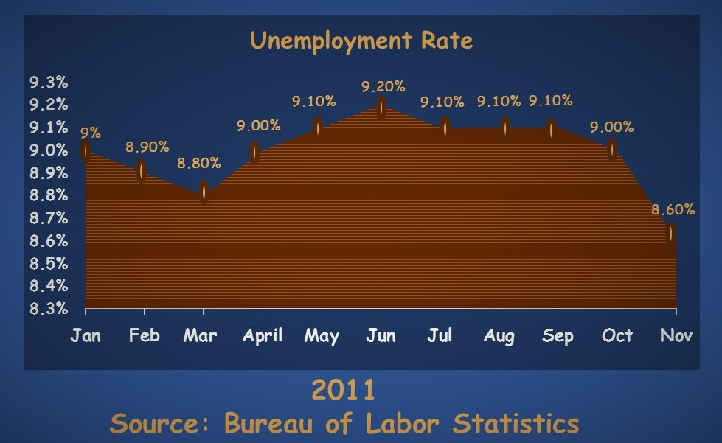
Graph 2 was used to display pizza topping preferences based on a survey of people living in the United Kingdom
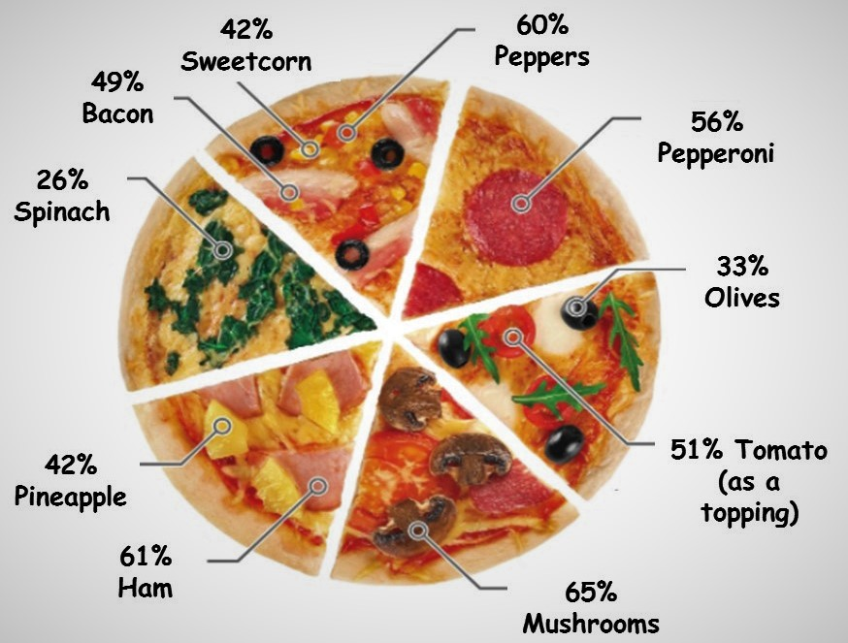
Graph 3 was used to display the number of complaints reported for six different airlines per the US Department of Transportation in February 2013.
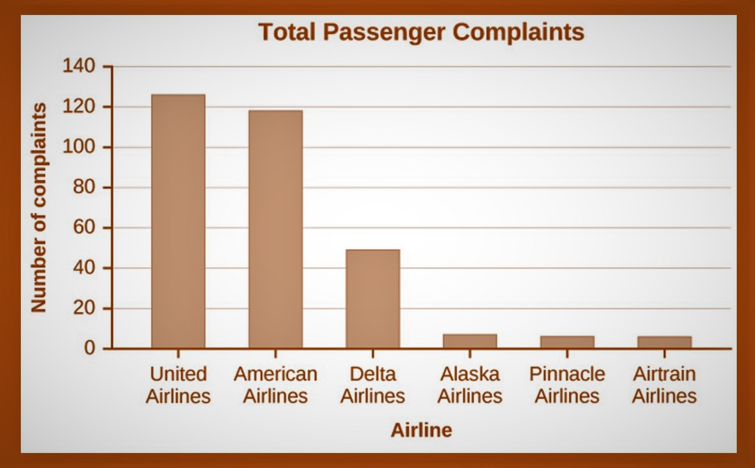

Instructions
For this discussion, you are to choose one graph, and complete these steps based on the graph you chose:

Steps
- State the graph you chose.
- Discuss how you interpreted the graph when you first saw it.
  - What did it tell you about the data represented?
  - Did you find it confusing?
- Now, study the graph. Use your understanding of the topics Graphs, Pie Charts, and Bar Charts to interpret what is being presented.
- Compare your first impression with your second more informed interpretation and answer the following:
  - Is the information presented in a biased way (that is, is it misleading?)
  - What information is being misinterpreted here? How?
  - What type of graph was used and was it used correctly?
  - How could you correct the graph so that it more accurately represents the data?
- Discuss why someone might intentionally use a graph to mislead?
Please be sure to validate your opinions and ideas with citations and references in APA format.
Rubric:
Course Discussion Unit 2
Course Discussion Unit 2
Criteria | Ratings | Pts
This criterion is linked to a Learning OutcomeContent  MA320-CO1 | 10 pts Level 5 Post addresses all of the required prompt elements in the discussion 9 pts Level 4 Post addresses all of the required prompt elements in the discussion - does not demonstrate a full understanding of course content and unit topic. 8.5 pts Level 3 Post is missing important elements, demonstrates a limited understanding of the topic and/or course concepts, offers limited validation of personal position. There is evidence of some supporting evidence; there is a reference to the research literature, text, course materials, or related examples. 7.5 pts Level 2 Post and responses are missing important elements related to the discussion and demonstrate a lack of understanding of the topic and lacks validation of position, and/or there is no use of supporting items of evidence. 7 pts Level 1 Post does not address discussion questions, and/or does not demonstrate an understanding of the topic and/or lacks validation of position with no use of supporting items of evidence. 0 pts Level 0 Post was not submitted or there is no relationship between the post and the discussion prompt. | 10 pts
This criterion is linked to a Learning OutcomeAnalysis  PRICE-I | 10 pts Level 5 The analysis of the topic includes breadth and depth, is aligned to the unit topic, relates to the course content and personal analysis is supported by well-aligned references and examples. 9 pts Level 4 The analysis of the topic is justified, and aligned to the unit topic, and personal analysis is supported by well-aligned references and/or examples. 8 pts Level 3 There is a basic analysis of the topic, and personal analysis is supported by well-aligned examples. 7 pts Level 2 There is minimal evidence of analysis of the topic and/or personal analysis is not supported by well-aligned examples or references. 6.5 pts Level 1 There is no evidence of analysis. 0 pts Level 0 Post was not submitted or there is no relationship between the post and the discussion prompt. | 10 pts
This criterion is linked to a Learning OutcomeCollaboration  PRICE-E | 8 pts Level 5 Collaborates with fellow learners at the required level relating the discussion to relevant course concepts and extending the conversation by asking open-ended questions to move the conversation forward, and answers questions asked on the post by instructor and peers. 7 pts Level 4 Collaborates with fellow learners at a comprehensive level and relates the content to relevant course concepts but does not extend the conversation by asking open-ended questions. There are responses evident to questions asked by instructor or peers. 6 pts Level 3 Collaborates with fellow learners but does not respond at a comprehensive level, and/or does not extend the conversation by asking or answering questions, and/or makes little connection to course content. 5 pts Level 2 Does not collaborate with fellow learners regarding the peers' posts and/or makes no connection to course content and/or does not respond to peer and instructor responses, or the number of responses did not meet the requirement. 4 pts Level 1 Does not collaborate with fellow learners and instructor. 0 pts Level 0 Post was not submitted. | 8 pts
This criterion is linked to a Learning OutcomeWriting | 8 pts Level 5 Posts in this discussion are well written and well organized demonstrating excellence in scholarly writing. Mechanics (spelling and punctuation) and grammar are excellent. 6.5 pts Level 4 Posts in this discussion are well written and well organized scholarly material but have 1-2 different minor errors in mechanics and/or grammar. 4.5 pts Level 3 Posts in this discussion are basic examples of scholarly material but have 3 different errors in mechanics and/or grammar. 4 pts Level 2 Posts in this discussion are not clear and/or lack organization and/or have 4 or more different errors in mechanics and/or grammar. 2 pts Level 1 Posts in this discussion lack evidence of clear, organized scholarly writing. 0 pts Level 0 Post was not submitted. | 8 pts
This criterion is linked to a Learning OutcomeAPA  PRICE-I | 4 pts Level 5 Posts in this discussion demonstrate appropriate in-text citations of sources and references in proper APA style. 3 pts Level 4 Posts in this discussion demonstrate appropriate in-text citations of sources and references but have 1-2 minor APA errors. 2.5 pts Level 3 Posts in this discussion demonstrate appropriate in-text citations of sources and references but have 3-4 minor APA errors. 2 pts Level 2 Posts in this discussion demonstrate appropriate in-text citations of sources and references but have more than 4 APA errors. 1 pts Level 1 Posts in this discussion do not provide either in-text citations or reference sources and/or have 4 or more APA errors. 0 pts Level 0 Post was not submitted. | 4 pts
Total Points: 40

