Scenario:

You are at the grocery store and want to buy some crackers, but you want to choose the healthiest option. You are considering two different brands and decide to compare the nutrition labels on the boxes. The image below shows what you see for Cracker A and for Cracker B.

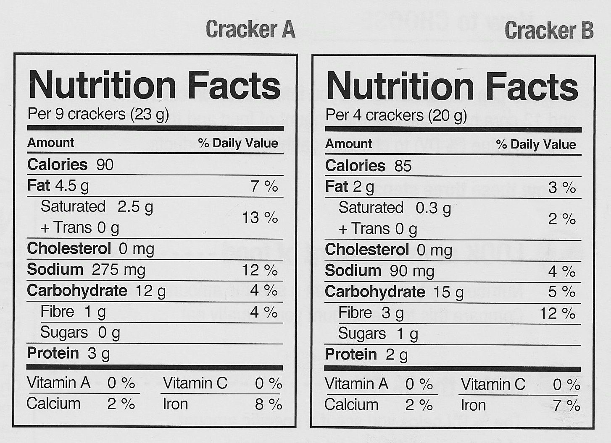

Instructions:

Apply what you have learned in the course, and answer the following questions using complete sentences that reflect proper spelling/grammar.

- What major differences do you see between the nutrients in these brands?

- What are the serving sizes for each brand? Why is it important to note serving sizes when comparing?

- Are either of these crackers low in sodium according to current recommendations? What are the current sodium recommendations for a food to be considered “low sodium?”

- Which cracker (“A” or “B” brand) should someone choose if they are trying to eat less fats (both saturated and trans fat), less sodium, and more fiber?

- In your opinion, which is the “healthier” cracker snack? Explain your reasoning.

