Strategic Recommendations Assignment
Student’s Name
Institution Affiliation
Course Name
Professor’s Name
Date

Strategic Recommendations Assignment
Question 1
Saudi Aramco, formerly the Saudi Arabian Oil Company, operates within the GCC region. It is a state-owned organization by the Kingdom of Saudi that deals with oil and gas. Formed in 1993, it has estimated reserves of over 200 billion barrels of crude oil and over 250 trillion SCF of gas. It is one of the largest energy firms today, with a projected valuation of more than $2 trillion. It also has an estimated workforce of more than 65 000 workers across the globe. It has kept a top position in its market and has severally appeared in the Petroleum Intelligence Weekly as a leader in petroleum products. Since the 90s, it has received recognition and is seen as one of the most influential oil and gas companies the world has ever known. This company’s significance for the Kingdom of Saudi and the world cannot be overestimated. Having exceeded several other suppliers, the Kingdom of Saudi is a major oil exporter to many countries. It has continued to reinforce its ties with many international firms, including organizations in America, Japan, and Europe. Between 2004 and 2005, it acquired about 15 percent in shares in Showa Shell, a Japanese firm. It has also established many joint ventures. For instance, it formed a joint venture with Sumitomo company. It is also a principal business associate for Japan’s energy industry.
Its corporate structure highly influences its goals, strategies, processes, and functions. It features a bureaucratic method to organizational structure. Such a structure is where a pyramid type of leadership epitomizes an organization’s management. Thus, Aramco’s structure uses formal approaches in each process and operation. It is pertinent to ensuring that Aramco achieves its objectives and organizational goals. The company also operates a bureaucratic structure to support its global functions. At Aramco, the level of centralization is also very high, which implies that various parts are closely monitored by different managers across multiple levels of the organization. The following chart shows the company’s corporate structure and the roles everyone performs (Saudi Aramco, 2022).
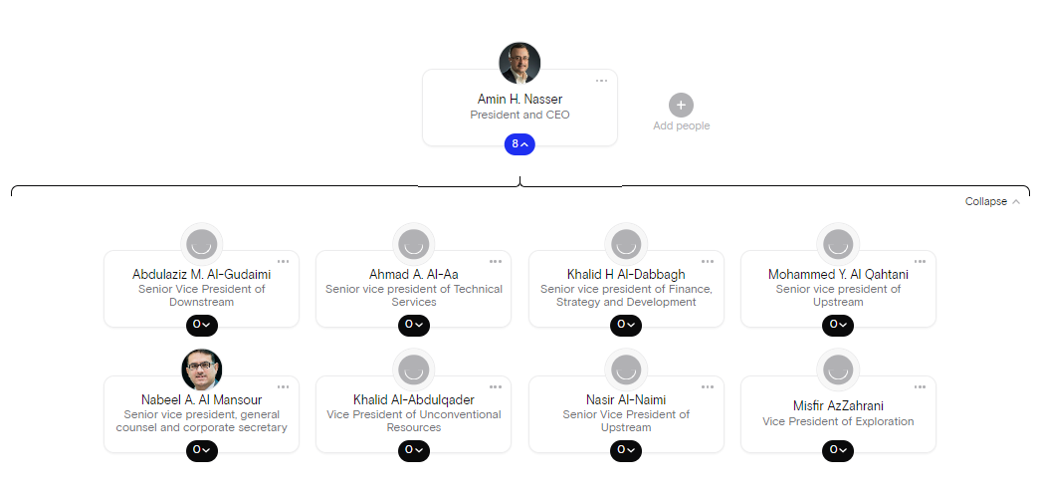
This chart shows Aramco conclusively uses a bureaucratic organizational structure. Also, the level of differentiation is similarly precise at this company because it has a complex setting in which different jobs are specialized. Besides, the presence of hierarchies, as shown on the chart above, guides each worker to focus on the firm’s best practices. The company has dispersed its units globally to support its business model. Hence, it is agreeable that its bureaucratic structure plays an integral part in supporting its business strategy (Saudi Aramco, 2022). In addition, its corporate structure members know different areas in the industry. As for Saudi Aramco (2022), these leaders embody the organization’s high culture and maintain its corporate values driving the firm’s goals. Together with the board of directors, they design policies, rules, and codes that guide workers’ behaviors.
Saudi Aramco covers a wide range of business portfolios. From transportation fuels to several other materials, its diverse and expanding product range creates value for its customers and the business, its partners, and shareholders. It manages Saudi’s unique hydrocarbon reserves while optimizing production and long-term value. Its products include harnessing the power of chemicals, gas, oil, refined products, retail fuels, and lubricants. The company also deals with power systems, where it promises reliable and practical solutions to support a highly dynamic power sector. The company has developed a reputation for unraveled reliability in supplying crude oil to different markets worldwide with oil. It is the 7th supplier of natural gas worldwide and the only provider in Saudi Arabia. The organization is a preeminent player in the world’s petrochemical sectors and is devoted to creativity, growth, and realization of hydrocarbon molecule potential (Saudi Aramco, 2022).
Question 2
A portfolio matrix is a vital technique that can help an organization make the right choices and decisions about its products. With the right product portfolio, a company can achieve its goals and remain competitive in the short- and long-term. It also helps organizations attain the right mix of innovative and established products to optimize the overall value. Any firm must be aware of its financial health. No organization has all products in profit. Thus, it means that some product lines might be loss-makers. The idea is to minimize losses and generate more profits. Besides, portfolio analysis likewise helps a business remain in sync with its vision, goals, mission, and objectives. According to Wrigley et al. (2020), portfolio matrices remain essential in visually defining the potential of products to ensure profitability. Provided the competitive nature of consumer goods, companies need to use accepted models to ensure adequate resource allocation to diverse strategic business areas and units. Wrigley et al. (2020) highlight that portfolio matrices remain valuable tools in analyzing business areas and suggesting different resource allocation approaches based on industry growth and firms’ relative market shares or strengths.
The recommended portfolio matric for Saudi Aramco is the Boston Consulting Group (BCG) matrix. This model offers significant recommendations for strategic and organizational resource allocation design. It also provides vital recommendations for strategy design within a multi-business environment. BCG’s central idea is that strategies must be designed or made to differ significantly from one business unit to another as a function of growth and the relative competitive position of a unit and a firm’s overall resource base. Different strategies are suggested depending on where business units fall on the grid. For instance, if one unit falls within the cow area, more resources should be utilized or allotted to guard the market share and invest heavily in product modification to remain abreast with customer preferences.
Question 3
The BCG matrix described above can analyze Saudi Aramco’s portfolio of strategic business units, assets, reserves, and product offerings according to their cash-creating abilities. It can also help analyze the company’s relative market share and growth levels. This matrix includes four vital categories: potential future earners, stars, cash cows, and dogs. The starts category represents the increasing product positive cash flows while the cash cow denotes the cash-rich. Lastly, the dogs’ category represents the reducing cash flows. This model offers a growth-share matrix portfolio organization and planning. It was designed by Bruce Henderson, whose Boston Consulting Group had thrived in the 70s. In addition, this model is based on the idea that an organization’s business units can be grouped into four classifications based on their combinations of market growth and share relative to their most significant competitors. This model also maintains that market growth is often a proxy for market attractiveness, while its relative market share is a proxy for competitiveness. Therefore, this growth-share matrix maps a company’s unit positions in vital business profitability determinants. The following figure shows this matrix and its relative market share categories (Wrigley et al., 2020).
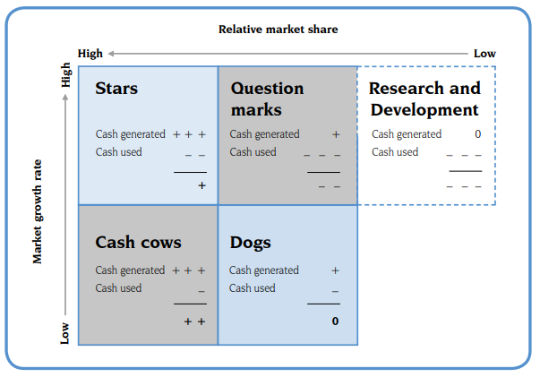
This figure shows that a BCG matric offers a graphical representation for a firm to evaluate its business and portfolio based on its related market share and growth rates. The stars area represents an organization’s business units having a higher market share within a fast and rapidly growing market. In a cash cow market, the industry is slowly increasing. A business in the dog’s category means having a low or weak market share, declining market growth, and minimal profit-generating opportunities. The model further assumes that a rise in relative market share results from increased cash generation. This assumption is often valid, and an expanded market or industry share means that the business is growing. It also suggests that a company is developing a cost advantage. Also, a growing market share demands investment in assets and resources to increase capability and result in cash utilization. Here, the position of a firm on this matrix can show its cash generation and use capacity.
The logic behind this model is that cash required by fast-growing business units might be gained from the firm’s other business units, which are more mature and make more cash. Also, by striving to become the market leader in a rapidly growing industry, the company units should move along the experience curve and gain a cost-benefit. Thus, Saudi Aramco has four strategic choices when analyzing the BCG matric. The first choice is ‘build,’ where the organization uses funds or money from other products to invest in question marks and stars. This cash should be harvested from cash cows. It is about moving the excess funds obtained around other product lines, mainly those with growth potential. The second choice is ‘hold,’ where the firm might plow back or reinvest profits. It is particularly relevant to question marks and stars. The third choice is ‘harvest,’ where it can milk funds out of the cash cows and utilize it to build the question marks. The last option is ‘divest,’ which can be relevant in areas where Saudi Aramco wants to discontinue its operations and product lines that no longer generate profits.
Question 4
Generally, a diversification strategy is vital in expanding an organization’s operations by adding products, markets, and production lines to existing ones. The reason for diversifying is to allow the business to enter new business lines which are different from current activities. It is a form of a growth strategy that enables an organization to venture into several other profitable markets or industries. Such growth often promotes or improves a company’s effectiveness. It entails venturing into new markets with new products. A large market share might lead to increased economies of scale. Besides, marketing and production synergies also contribute to increased efficiencies in resource use, reduction in wastages, and reduced rates of change-over-time (Homburg et al., 2015). According to Georgieva (2018), linkages between lines often allow businesses to exploit synergies that, in turn, lead to the long-term performance of the company.

References
Georgieva, K. (2018). Diversification and Firm Performance in the Digitalization Era. Examining the Role of Internal Capabilities and Board Capital.
Homburg, C., Krohmer, H., & Workman, J. P. (2015). Strategic Consensus and Performance: The Role of Strategy Type and Market-Related Dynamism. In Global Perspectives in Marketing for the 21st Century (pp. 221-221). Springer, Cham.
Saudi Aramco. (2022). Corporate management. Retrieved from https://www.aramco.com/en/who-we-are/our-corporate-governance/corporate-management.
Saudi Aramco. (2022). Products: Our diverse and expanding range of products creates value. Retrieved from https://www.aramco.com/en/creating-value/products.
Wrigley, C., Nusem, E., & Straker, K. (2020). Implementing design thinking: Understanding organizational conditions. California Management Review, 62(2), 125-143.

